Inspection Details
Inspection date |  | Management Representative
Inspection area/s |  | Staff Representative/s

Please report building & facility maintenance issues that are NOT a safety hazard directly to EBE maintenance@une.edu.au. There are prompts within the checklist as a guide.

* Keep Safe refers to online Incident and Hazard Reporting System

Work Environment – Inside and Outside/Offices and Workshops |  |  | Yes | No
Visible damage to infrastructure such as walls, ceilings, floors, doors and fixed heating is reported directly to EBE maintenance@une.edu.au
Work areas clean
Bins available and emptied regularly
Domestic waste is disposed of appropriately in bins supplied, to prevent health issues relating consumption by rodents or insects
Hording is not evident
Floors clean, dry and free of refuse
Floor coverings (including mats at doorways) do not pose any trip or health hazards
Stairs clean, dry and free of refuse
Walkways and stairs clear of obstructions
Stairs have handrails
Floors/footpaths/work areas of an even surface
There is adequate working space
UV protection is provided for outdoor tasks routinely performed by staff
Adequate safety signage is in place
Exposure to moving machinery/plant/equipment is eliminated or controlled
Exposure to falling objects (from shelves or elevated work platforms) is eliminated or controlled
Noise levels are controlled so that workers do not have to shout to be heard
Are there any moisture/rainwater leaks causing mould or a slip hazard?
Ventilation is adequate/comfortable for Workers in all seasons
Airborne contaminants/odours are controlled
Restricted areas are secure
Hazardous areas clearly defined
Vehicle traffic areas and loading docks are clear and functional.
Safety hazard Identified |  | Control Measure | * Keep Safe No.

Lighting |  |  | Yes | No
Is there adequate lighting for tasks performed?
Is task lighting required?
Are light covers in place and clean or otherwise report to EBE maintenance@une.edu.au
Are light bulbs requiring replacement reported to EBE maintenance@une.edu.au
Is there any glare from lighting or windows that makes workspaces difficult to work in?
Safety hazard Identified |  | Control Measure | * Keep Safe No.

Electrical Safety |  |  | Yes | No
Are all UNE supplied assets registered with the School or Directorate and have current electrical test and tag (retest date is still current)?
Are personal electrical appliances approved for use on campus by UNE and the item recorded with a current test & tag on the School or Directorate electrical test & tag register.
Plugs, cables, sockets, switches in good condition
Extension leads and power boards in a safe operating condition and free of damage
Power boards are suitable for situation, and each socket is individually switched to prevent arcing (double adaptors not recommended). No piggy backing power boards.
Electrical leads positioned to avoid tripping and damage risks
Mobile electrical devices such as battery chargers are checked and free of damage including all laptops, tablets and phone chargers
All static power connections are free of dust build up
Safety hazard Identified |  | Control Measure | * Keep Safe No.

Storage Areas |  |  | Yes | No
Storage is adequate storage so there is no clutter or hording in workspaces
Designated storage areas are fit for purpose
Storage racks — secure and bolted
Storage areas clear of rubbish
Storage areas are adequately ventilated
All e-bikes and other such mobility devices are parked outside or stored in the designated area W034 McClymont building or Wright College Bellevue Campus
Safety hazard Identified |  | Control Measure | * Keep Safe No.

Manual Handling |  |  | Yes | No
Repetitive movement tasks are eliminated, or other controls are in place
Over reaching/strained positions are eliminated or other controls are in place
Heavy lifting is eliminated or other controls are in place
Heavy objects are stored at approximately waist height if possible
Trollies are available for transporting heavy items (and the trolley is in good working order with surfaces suitable for trolley use)
Safety hazard Identified |  | Control Measure | * Keep Safe No.

Lifting Equipment |  |  | Yes | No
Is all required lifting equipment on an up-to-date lifting equipment register and maintained
Chains, slings and blocks in good condition and within inspection date
Chains, slings and blocks stored neatly
Pendant controls clear and legible
Overhead travel areas/paths clear
Safety hazard Identified |  | Control Measure | * Keep Safe No.

Plant, Tools and Equipment |  |  | Yes | No
Is there a SWMS or SOP in place for all mobile and fixed plant?
Correct selection and use for workers tasks (observed at time of inspection)
In good, clean working condition
Stowed adequately when not in use
Adequate equipment/plant/machinery guarding in place
Necessary PPE is available and in good working order
All Batteries are stored in cool dry areas according to manufacturer guide and Australian Standard AS/NZS 5139 away from combustible materials and emergency paths
All expired or damaged batteries must be recycled via UNE e-waste channels following manufacturing safety data and Australian Standard AS/NZS 5377
Safety hazard Identified |  | Control Measure | * Keep Safe No.

Staff Amenities |  |  | Yes | No
Toilets/washrooms accessible and clean
Washroom consumables available for good hygiene practices
Meal areas accessible, comfortable, clean and hygienic
Refrigerators and food storage areas are clean and free of expired food
Safety hazard Identified |  | Control Measure | * Keep Safe No.

WHS Notice Boards |  |  | Yes | No
Are there WHS notice boards* in the workspace that all staff can see?
Is the SafeWork NSW ‘If you get injured at work’ poster on each WHS notice board?
WHS notice boards should be clearly delegated as such, with no other materials on the board.
Safety hazard Identified |  | Control Measure | * Keep Safe No.

First Aid Facilities |  |  | Yes | No
First Aid kit easily accessible and signposted
First Aid supplies within their use by date
Are there adequate** trained first aid personnel in the work area?
First Aid Officers displayed with contact numbers
There is a first aid kit that can be easily carried to assembly points in the event of evacuation
** As a rule of thumb, there should be 1 First Aider for 50 occupants in low-risk environments and 1 First Aider for 25 occupants in high-risk environments and should take account of staff absenteeism and after hours utilisation of work areas.
Safety hazard Identified |  | Control Measure | * Keep Safe No.

Emergency Preparedness |  |  | Yes | No
Are evacuation plans:
- Prominently displayed where staff and visitors will see?
- Accurately positioned so the map corresponds to position?
- Up to date (reflect floor plan, taking renovations/modifications in to account)?
Warden details are up to date and displayed on the WHS notice board
Is there a designated Assembly Point and is it known by staff?
Have you confirmed with the emergency wardens they have had their training in the last twelve months?
Has there been an evacuation drill conducted in the last 12 months?
Exit signs are lit and directions to exits are in place
Exit doors easily opened from the inside
Emergency exits, fire extinguishers and hoses unobstructed
Extinguishers in place, clearly marked for the type of fire, and serviced 6 monthly
Emergency exits and stairs are free from obstructions
Safety hazard Identified |  | Control Measure | * Keep Safe No.

Chemicals and Other Hazardous Substances |  |  | Yes | No
Are there any chemicals/substances that are not for typical domestic use or greater than typical domestic size?
If yes, are these chemicals registered in ChemWatch*?
All substances are clearly labelled https://www.safework.nsw.gov.au/__data/assets/pdf_file/0016/50083/Labelling-of-workplace-hazardous-chemicals-COP.pdf
Gas cylinders clearly labelled, chained and separated during storage, and at least 3m away from ignition sources
Gas cylinders are transported appropriately with manual handling aides
All chemicals/hazardous substances are appropriately stored and separated where necessary
There are adequate waste disposal methods available and used
Appropriate signage is in place
Safety showers are available and are operational
Safety Showers are subject to regular testing and within 12-month date
Spill kits are available, adequately sized based on potential containment needs and maintained
Bunding volume is sufficient based on ChemWatch inventory and bunding integrity meets requirements
*ChemWatch is managed by Safety Advisor, Hazardous Substances and can be contacted on rhelfer@une.edu.au.
Safety hazard Identified |  | Control Measure | * Keep Safe No.

Welding and Cutting |  |  | Yes | No
Welding shields provided in welding areas
All leads, hoses, fittings, regulators undamaged
Flashback arrestors meet Australian standards & are replaced every 12 months or current annual testing records by a competent person are available
This must be confirmed for all oxy-acetylene & flammable gas applications
Correct fire extinguishers nearby
Flammable materials/substances protected/isolated
Safety hazard Identified |  | Control Measure | * Keep Safe No.

Psychosocial Health |  |  | Yes | No
Workloads are reasonable and manageable
Employees are given adequate breaks and rest periods
Is there evidence of stress, burnout or fatigue among employees
Are bullying, harassment or inappropriate behaviours addressed promptly
Do employees feel safe to report concerns
Are support services ( EAP) available and communicated
Are roles and expectations clearly defined
The work environment is respective and inclusive
Employees are recognised and appreciated
Overtime is monitored and controlled
Health and wellbeing policies are clearly communicated
Safety hazard Identified |  | Control Measure | * Keep Safe No.

Other
Safety hazard Identified |  | Control Measure | * Keep Safe No.

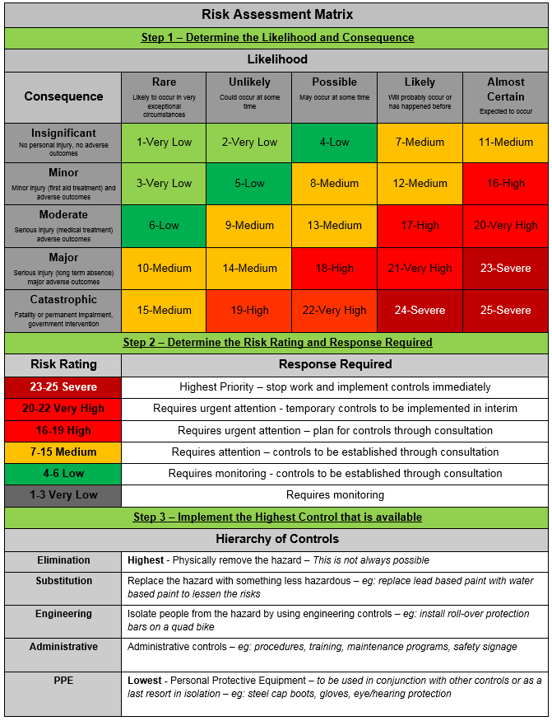

Sign Off
Sign off from workplace inspection participants indicates agreement with the contents of this document. Sign off is also required by the person responsible for the control measures and subsequent review of control measures (to ensure they are adequate and effective in their intent).
Name | Signature | Date

Management Review
The relevant manager must review this risk assessment and ensure control measures are reasonably practicable and implemented, specific to the work environment under their control.
Review | Response
Are planned control measures reasonably practicable?
Are planned control measures sufficient to mitigate risk (based on your knowledge, experience and review of this workplace inspection)?
Are there any changes to planned control measures?
Are further controls required in the future?
Is a formal risk assessment required?
Name | Signature | Date

Records Storage Instructions
This completed form must be sent to SAVE4ME email: save4me@une.edu.au with the following naming convention in Subject line < A16/3850/10 > - < Workplace Inspection Checklist 2026 > - < Directorate /School > –< Area of Assessment > - < Building Name and Number >.

