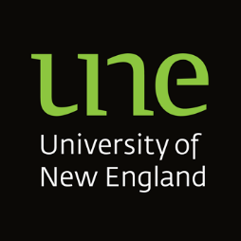
AUTHORITY TO ACT AND RELEASE INFORMATION

To: Student Success
University of New England
Armidale NSW 2351

I, [INSERT STUDENT’S FULL NAME, DATE OF BIRTH, ADDRESS, and STUDENT NUMBER] hereby authorise and appoint [INSERT FULL NAME, RELATIONSHIP TO YOU, DATE OF BIRTH, ADDRESS, TELEPHONE, EMAIL] to act on my behalf, make and respond to enquiries with UNE, provide documents, files and information and receive files, documentation or information relating to my enrolment in [COURSE PARTICULARS].
The reason for making this arrangement is [INSERT AND ATTACH ANY RELEVANT PAPERS].
This authority remains valid from the date of this Authority until [insert date] or when revoked by me in writing, whichever is the earlier.

DATED:

Signature …………………………………………..
Printed Name …………………………………………..

ACCEPTANCE BY NOMINEE
I accept that I must act in accordance with this Authority and in the best interests of [INSERT STUDENT’S NAME]. I accept that any personal information I am given access to is protected under legislation. I agree to access, use or disclose the information only as authorised by the person to whom the information relates. I agree that my appointment as a nominee may be revoked or suspended by UNE, including if I do not comply with my responsibilities and obligations.

DATED:

Signature …………………………………………..
Printed Name …………………………………………..

