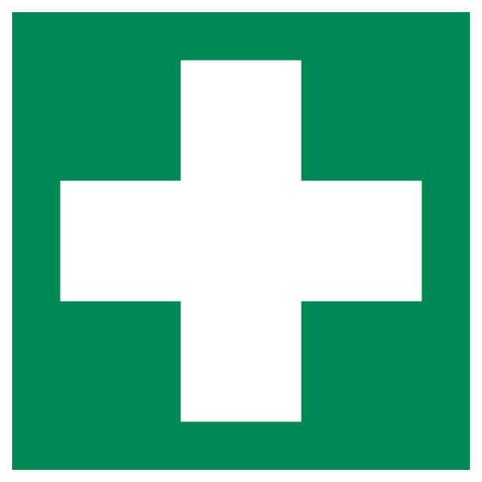

The First Aider for this area is: Insert name/s

Insert picture/s

The location of the closest First Aid Kit is: Insert Location/s

In emergencies please call 000 and UNE Security on 2099

All incidents, regardless of how minor, MUST be reported to your supervisor and HRS using the online reporting portal, SkyTrust, found on ‘Safety Hub’.

