UNE RESEARCH SERVICES
Grant Funding Support
Email: grants@une.edu.au

GRANT PROCEDURES FOR UNE RESEARCHERS
Let the Grants team know as soon as possible that you intend to submit a grant application.
Why?
- Each year, the Australian Government grants universities funding for research and research training dependent on our yearly research income and outputs.
- If we don’t know about your projects, we cannot report on them and we/you miss out on additional government funding.
- You are not covered by UNE insurance if you do not declare the project, especially for travel.
- You cannot use grant information on your promotion applications if UNE has no record of your work.
- The Grants team can provide compliance advice and assist with polishing your application, so the sooner you contact the team, the stronger your application should be.

What is Research?

Research is defined as the creation of new knowledge and/or the use of existing knowledge in a new and creative way so as to generate new concepts, methodologies, inventions and understandings. This could include synthesis and analysis of previous research to the extent that it is new and creative. This definition of research is consistent with a broad notion of research and experimental development (R&D) as comprising ‘creative work undertaken on a systematic basis in order to increase the stock of knowledge, including knowledge of man [human-kind], culture and society, and the use of this stock of knowledge to devise new applications’.

BEFORE the grant application is submitted:

- The Project Approval Form (PAF) needs to be completed and emailed to the Grants team grants@une.edu.au. The PAF captures all the necessary details to record research/project activities and comply with mandated government reporting and auditing requirements.
- The complete final application, in the format requested by the funding body, also needs to be emailed to the grants team, usually 1 week before the due date of submission. Normally, the Grants team will submit the application to the funding body. Researchers submitting the application directly to the funding body should cc grants@une.edu.au.
AFTER the grant application is successful:
- The funding body usually sends the draft agreement to the Grants team which will liaise with the UNE Legal Office and the lead investigator in the execution of the agreement. The agreement is signed by UNE, not the investigator.

- Before the agreement can be executed, the Legal Office asks that the Request for Legal Approval (RLA) Form be completed and signed by the lead investigator and the Dean of the Faculty or Delegate. The RLA confirms that both have read, and agree with, the terms and conditions in the agreement, paying particular attention to the terms on Intellectual Property and accessing the project research data. The Legal Office cannot proceed to have the agreement fully executed until it receives the signed RLA. Delays in receiving the relevant approvals and finalising the agreement can be significant and may have adverse repercussions for the project funding and/or start date.

- If a successful project needs ethics approval this should be obtained before the Agreement is signed. (If this is not possible, please discuss options with the Legal Office). Please download the latest ethics approval form via the Research Services’ Ethics and Grants website: http://www.une.edu.au/research/ethics-and-grants

- Reporting: Once the agreement has been fully executed by the Legal Office, the Grants team will set up milestone report reminders for the lead investigator on the project, as per the contract. Milestone reports may need to be submitted to the funding body by the Grants team. If the lead researcher is submitting the report directly to the funding body, please cc grants@une.edu.au so the report can be recorded and the milestone reminder closed off. If a payment/invoice is attached to the milestone report, the lead researcher should notify the Grants team which will then follow up with UNE Finance.
GRANT CATEGORIES

There are four main categories of research grants, determined by the Australian Government Department of Education and Training.
Category 1

Australian Competitive Grants
These are schemes/grant programs listed on the Australian Competitive Grants Register (ACGR). The ACGR lists schemes that provide competitive research grants to higher education providers (HEPs).
Category 2

Other Public Sector Research Income
These include:
- Non-category 1 Australian Government
- State or Territory Government
- Local Government
- Government business enterprises
- Co-operative Research Centres where UNE is not a participant
Category 3

Industry and Other Research Income
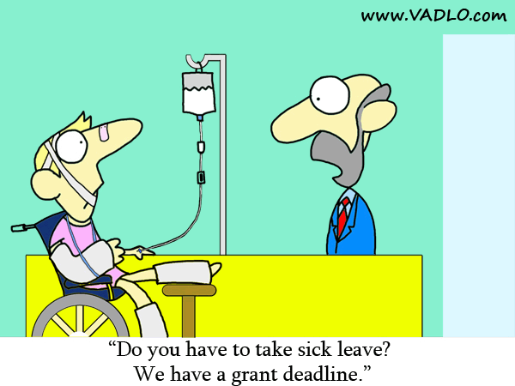
These include:
- Australian Contracts, grants, donations, bequests and foundations
- International A: Competitive, Peer-reviewed research grant income
- International B: Other Income

Category 4

Co-operative Research Centre (CRC) Income
These include research income derived from:
- Australian Government grants to CRCs
- Non-HEP members of CRCs
- External parties contributing to CRCs

The income UNE receives from research grants is a metric used in the allocation of the Australian Government’s Research Block Grants (RBG). Grants from the schemes listed on the Australian Competitive Grants Register are classed as ‘Category 1’ and attract greater government funding than those in Category 2 and 3. All Category 2 and 3 grant funding, apart from travel grants and student projects or scholarships, is subject to the 20% DVCR Research Sustainability Fee.

So…

what is the 20% DVCR research sustainability fee??

The 20% DVCR Research Sustainability Fee represents the true cost of research to UNE, i.e., the gap between approx. 30c in the dollar UNE gets back from the Australian Government for Category 1 funding and approx. 10c in the dollar from Category 2 and 3 funding. The 20% ensures that the research is not conducted at a loss to UNE. The fee covers those things like insurance, room use, phones and so on.
You need to include the fee in your application budget so you are not left short-changed. You can do this by adding a line in your budget – “UNE DVCR Research Sustainability Fee” or “Direct Research Costs”. All universities charge their own determined amount so it is standard practice.
An appeal for a waiver of the fee can be made to the Deputy Vice-Chancellor (Research) but you need a very strong case for it to be approved. All fee-waiver appeals must be submitted via grants@une.edu.au and retrospective requests will only be considered under exceptional circumstances. Not including the fee in your application budget and requesting a waiver once it is successful is not a strong case.

FUNDING OPPORTUNITIES

Subscribe to our regular UNE-Research funding opportunities email which is very easy and takes only a couple of minutes.
Don’t just rely on our emails! UNE researchers and students also have access to Research Professional – a comprehensive funding opportunities database to which UNE subscribes.
EFFICIENCY TIPS

The Grants team prefers a ‘heads-up’ that project approval forms and applications are coming through. If we have no other information when they land in our inbox, and if requirements are unclear, they may not be actioned until later if we are very busy.

To save delays in getting applications submitted, or agreements signed, please explain in the email that accompanies the approval form:
- What is attached
- Whether the application should be submitted by Research Services and the details for doing so
- Whether the application requires DVCR signature
- If there are any documents missing and an explanation of when we can expect to receive them

Grant Application Timeframes
When you contact us | What we can achieve
 | Full compliance checking
 | Extensive feedback and advice on application and funding rules
 | Institutional certification ensured
 | Application submission ensured
 | Full compliance checking
 | Feedback and advice on application and funding rules
 | Institutional certification ensured
 | Application submission ensured
 | Limited compliance checking
 | Limited advice on funding rules – only major eligibility issues will be addressed
 | Cannot guarantee institutional certification
 | Cannot guarantee application submission if required in hard copy
 | No compliance checking
 | Cannot guarantee institutional certification
 | Cannot guarantee application will be submitted
 | Application cannot be considered and will not be submitted
* Deadline refers to the funding body’s closing date for applications
** The day the application is due
NOTE: During busy periods (i.e. major funding rounds, graduation/major university events), preference will be given to Category 1 grant applications so you need to let us know about your application EARLY.

Research Services Grants Team
grants@une.edu.au

Grant Administration

Dr Kath Dougall ext. 3262
Ms Libby Magann ext. 3875
Mrs Briahna McGregor ext. 2398

Grant Development

Dr Fiona Utley ext. 2475 or futley2@une.edu.au

Definition from the ARC’s Glossary of terms for research impact which is available: http://www.arc.gov.au/research-impact-principles-and-framework
For further information on each category, please refer to the latest HERDC Specifications.

