Inspection Details
Inspection date |  | Management Representative
Inspection area/s |  | Staff Representative/s

Work Environment – Inside and Outside/Offices and Workshops |  |  | Yes | No
Work areas clean
Floors clean, dry and free of refuse
Floor coverings (including mats at doorways) do not pose any trip or health hazards
Stairs clean, dry and free of refuse
Bins available and emptied regularly
Fixed Cigarette bins (on the outside of your building/s) are in good working order (fixed properly, no damage)
Cigarette bins are emptied regularly
Cigarette bins are at least 4 metres from doors and are not located near easily combustible materials
There is adequate ‘no smoking signage’
Walkways and stairs clear of obstructions
Floors/footpaths/work areas of an even surface
There is adequate working space
Stairs have handrails
UV protection is provided for outdoor tasks routinely performed by staff
Airborne contaminants/odours are controlled
Adequate safety signage is in place
Exposure to moving machinery/plant/equipment is eliminated or controlled
Exposure to falling objects (from shelves or elevated work platforms) is eliminated or controlled
Noise levels are controlled so that Workers do not have to shout to be heard
There are no moisture/rain water leaks
Ventilation is adequate/comfortable for Workers in all seasons
Restricted areas are secure
Hazardous areas clearly defined
Hazard Identified | Risk Score | Control Measure | Residual Risk Score

Computer Workstation Ergonomics |  |  | Yes | No
WHS F019 Computer Workstation Ergonomic Checklist has been promoted for use by all staff
Hazard Identified | Risk Score | Control Measure | Residual Risk Score

Manual Handling |  |  | Yes | No
Repetitive movement tasks are eliminated or other controls are in place
Over reaching/strained positions are eliminated or other controls are in place
Heavy lifting is eliminated or other controls are in place
Heavy objects are stored at approximately waist height if possible
Trollies are available for transporting heavy items (and the trolley is in good working order with surfaces suitable for trolley use)
Hazard Identified | Risk Score | Control Measure | Residual Risk Score

Work From Home |  |  | Yes | No
Are there any staff whose primary place of work is off campus (‘working remotely’), or staff that work from home, under the supervision of the Manager responsible for this Checklist?
If yes, have relevant staff completed WHS F031 Off Campus Workplace Inspection Checklist in the last 12 months?
Hazard Identified | Risk Score | Control Measure | Residual Risk Score

Lighting |  |  | Yes | No
Is there adequate lighting for tasks performed?
Is task lighting required?
Are light covers in place and clean?
Do any bulbs need to be replaced?
Is there any glare from lighting or windows that makes work spaces difficult to work in?
Hazard Identified | Risk Score | Control Measure | Residual Risk Score

Storage Areas |  |  | Yes | No
Adequate storage facilities so there is no clutter in work spaces
Designated storage areas are fit for purpose
Storage racks — secure and bolted
Storage areas clear of rubbish
Storage areas are adequately ventilated
Hazard Identified | Risk Score | Control Measure | Residual Risk Score
WHS Notice Boards |  |  | Yes | No
Are there WHS notice boards* in the work space that all staff can see?
Is the SafeWork NSW ‘If you get injured at work’ poster on each WHS notice board?
* WHS notice boards should be clearly delegated as such, with no other materials on the board.
Hazard Identified | Risk Score | Control Measure | Residual Risk Score

First Aid Facilities |  |  | Yes | No
First Aid kit easily accessible and signposted
First Aid supplies within their use by date
Are there adequate* trained first aid personnel in the work area?
First Aid Officers displayed with contact numbers
There is a first aid kit that can be easily carried to assembly points in the event of evacuation
* As a rule of thumb, there should be 1 First Aider for 50 occupants in low risk environments and 1 First Aider for 25 occupants in high risk environments and should take account of staff absenteeism and after hours utilisation of work areas.
Hazard Identified | Risk Score | Control Measure | Residual Risk Score

Emergency Preparedness | Yes | No
Are evacuation plans:
- Prominently displayed where staff and visitors will see?
- Accurately positioned so the map corresponds to position?
- Up to date (reflect floor plan, taking renovations/modifications in to account)?
Is there a Building Warden for each building (with Deputy) and is there at least one Floor Warden on each floor?
Warden details are displayed on the WHS notice board
Is there a designated Assembly Point and is it known by staff?
Have the emergency wardens had training of any sort in the last twelve months?
Has an evacuation drill been conducted in the last 12 months?
Exit signs and directions to exits are in place
Exit doors easily opened from the inside
Emergency exits, fire extinguishers and hoses unobstructed
Extinguishers in place, clearly marked for the type of fire, and serviced 6 monthly
Emergency exits and stairs are free from obstructions

Hazard Identified | Risk Score | Control Measure | Residual Risk Score

Electrical Safety - Testing and Tagging |  |  | Yes | No
All portable electronic appliances/devices have been tested and tagged in the last 12 months
All stationary electronic appliances/devices have been tested and tagged in the last 5 years
In workshops, all electrical appliances/devices have been tested and tagged in the last 6 months
In residential areas, all electrical appliances/devices have been tested and tagged in the last 2 years
Hazard Identified | Risk Score | Control Measure | Residual Risk Score

Electrical Safety - Inspection |  |  | Yes | No
Plugs, cables, sockets, switches in good condition
Extension leads and power boards in a safe operating condition and free of damage
Power boards are suitable for situation and each socket is individually switched to prevent arcing (double adaptors not recommended)
Electrical leads positioned to avoid tripping and damage risks
Mobile electrical devices such as battery chargers are checked and free of damage including all laptops, tablets and phone chargers
All static power connections are free of dust build up
Circuit breakers installed
Safety switches installed and tested
Hazard Identified | Risk Score | Control Measure | Residual Risk Score

Chemicals and Other Hazardous Substances |  |  | Yes | No
Are there any chemicals/substances that are not for typical domestic use or greater than typical domestic size?
If yes, are these chemicals registered in ChemWatch*?
All substances clearly labelled
Gas cylinders clearly labelled, chained and separated during storage, and away from ignition sources
Gas cylinders are transported appropriately with manual handling aides if required
All chemicals/hazardous substances are appropriately stored and separated where necessary
There are adequate waste disposal methods available and used
Appropriate signage is in place
Safety showers are available and are operational
Safety Showers are subject to regular testing
Spill kits are available and maintained and bunding is sufficient
*ChemWatch is managed by FMS. Please contact FMS help desk at ef-maint@une.edu.au and request a spot check based on a sample size of at least 10% of chemicals in your work area that are non-domestic in nature or domestic in nature but larger than domestic quantities.
Hazard Identified | Risk Score | Control Measure | Residual Risk Score

Tools and Equipment |  |  | Yes | No
Correct selection and use for workers tasks (observed at time of inspection)
In good, clean working condition
Stowed adequately when not in use
Adequate equipment/plant/machinery guarding in place
Necessary PPE is available and in good working order
Hazard Identified | Risk Score | Control Measure | Residual Risk Score

Welding and Cutting |  |  | Yes | No
Welding shields provided in welding areas
All leads, hoses, fittings, regulators undamaged
Correct fire extinguishers nearby
Flammable materials/substances protected/isolated
Hazard Identified | Risk Score | Control Measure | Residual Risk Score

Lifting Equipment | Yes | No
Is there a lift equipment maintenance schedule
Chains, slings and blocks in good condition
Chains, slings and blocks stored neatly
Pendant controls clear and legible
Overhead travel areas/paths clear

Hazard Identified | Risk Score | Control Measure | Residual Risk Score

Staff Amenities |  |  | Yes | No
Toilets/washrooms accessible and clean
Washroom consumables available for good hygiene practices
Meal areas accessible, comfortable, clean and hygienic
Lighting sufficient
Hazard Identified | Risk Score | Control Measure | Residual Risk Score

Other
Hazard Identified | Risk Score | Control Measure | Residual Risk Score

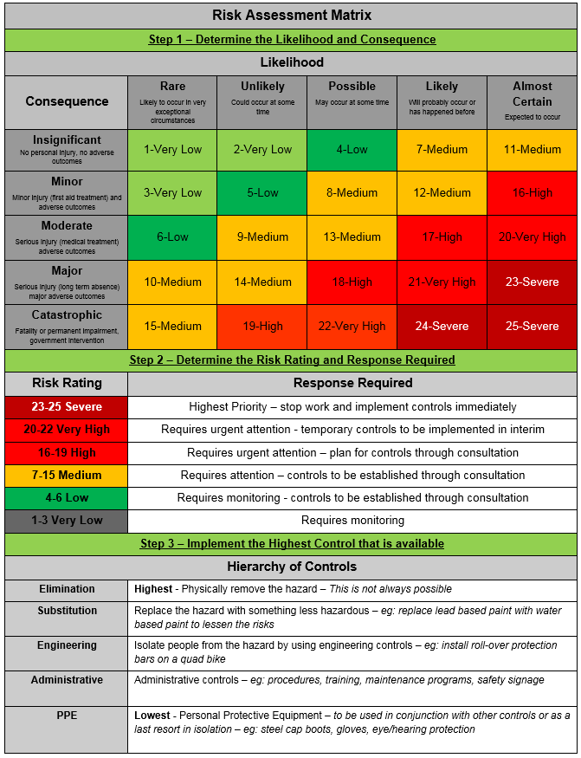

Sign Off
Sign off from workplace inspection participants indicates agreement with the contents of this document. Sign off is also required by the person responsible for the control measures and subsequent review of control measures (to ensure they are adequate and effective in their intent).
Name | Signature | Date

Management Review
The relevant manager must review this risk assessment and ensure control measures are reasonably practicable and implemented, specific to the work environment under their control.
Review | Response
Are planned control measures reasonably practicable?
Are planned control measures sufficient to mitigate risk (based on your knowledge, experience and review of this workplace inspection)?
Are there any changes to planned control measures?
Are further controls required in the future?
Is a formal risk assessment required?
Name | Signature | Date

Records Storage Instructions
All completed forms are to be sent to whs@une.edu.au for records retention in TRIM Container A16/3850. Only the HR Team is able to view records in this container.

