The Emergency Wardens for this area are:

Area/Floor Warden/s (identified by yellow vest and/or cap): Insert name/s
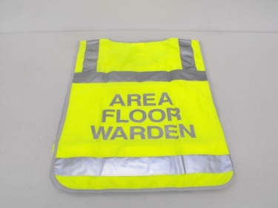 Insert picture of individual/s here

Building Warden (identified by red vest and/or cap): Insert name/s
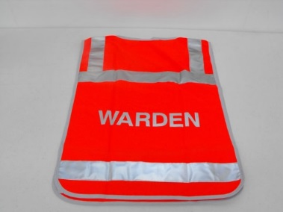 Insert picture of individual here

The Chief Warden for UNE is the Chief Operating Officer, Jo Scanlan. Ground Controller during a critical incident is identified by white vest and/or cap.
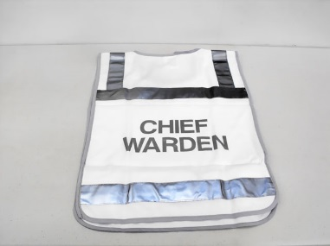

In emergencies please call 000 and UNE Security on ext. 2099

All incidents, regardless of how minor, MUST be reported within 24 hours. Please go to www.une.edu.au/safety to report.

