Initial Proposal Workflow

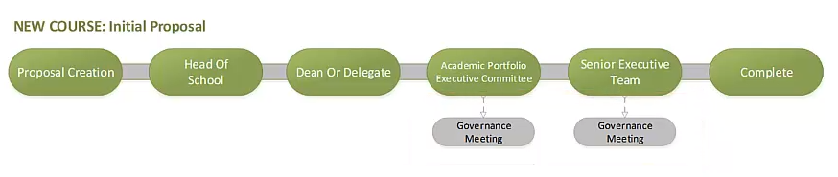

Attach this form to your initial proposal in CourseLoop

Concept and Financial Projection Proposal
Proposed Title:
Course Owner
Faculty
School
Discipline
Contact Information
Name
Email
Summary:
Brief paragraph outlining the scope and activities to be undertaken, and why this is a good idea. If there are any timing issues this should be included here.
Broad Level |  | Intake |  | Mode |  | Intensive Schools | Accreditation
Sub-degree  Undergraduate/Hons  Postgraduate Coursework  Postgraduate Research |  | Trimester 1  Trimester 2  Trimester 3 |  | Online  On-Campus  Delivery locations outside Armidale campus?  Please specify: |  | None  Mandatory  Non-mandatory | Mandatory  Preliminary  Provisional  Full  Identify accreditation costs in Financial Projections e.g. site visits, specific staffing and facility requirements.
Market Analysis
What is the opportunity in the market?
What are competitors offering?
What unique element can UNE bring?
Do we have any competitive advantage?
What market research supports this finding?
Implementation
Development
How many new units are required?
How will they be developed?
Staffing
How will staffing be established?
Marketing
How will the course be marketed?
Facilities
Are any new facilities, equipment or library resources required?
Partnerships
Are there partnership arrangements required for delivery?
Financial
Primary Market(s) | Fees and Charges |  |  |  | Opportunities
CSP  Dom Fee-Paying  International  Other | Primary funding cluster(s) for CSP, proposed fees for fee-paying |  |  |  | Are there opportunities for non-award (e.g. commercial delivery, short courses)

Financial Projections
 | Year 1 | Year 2 | Year 3 | Year 4 | Year 5 | Year 6 | Year 7
Load and Income
Commencing EFTSL
Continuing EFTSL
Revenue from course fees
Other Revenue
Establishment Costs
New facilities / equipment
Initial Marketing
Library Resources
Staff Recruitment
Courseware Development
Accreditation / Licensing
Operating Costs
Academic Staff
Casual Academic Staff
Administrative Staff
Accreditation / Licensing

Assumptions
How has the commencing load forecast been determined?
What continuation rates have been assumed?

NOTE: Complete the Full Proposal in CourseLoop.
A Full Proposal is the Academic Assessment for the new Course. This will be submitted via the following workflow.
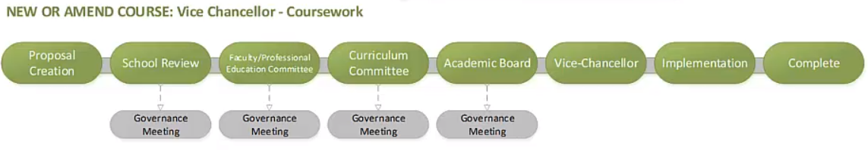
Curriculum Committee who will not endorse a new course without the Initial Proposal being approved via the Initial Proposal workflow at the top of this document.

