Safe use of ducted fume hoods
Inhalation is a major route of entry of chemicals into the body. Chemical fumes and vapours can directly enter our bloodstream and small particles can lodge in the alveolar region of our lungs. A properly designed and operated fume-hood reduces exposure to hazardous fumes, vapours, gases and dusts.

A fume-hood confines hazardous airborne material by diluting it with a large amount of air, drawing it through an exhaust system and then expelling the air in vents located on the roof of the building. Proper use of the fume-hood sash can also shield the worker from an uncontrolled reaction. Fume hoods are inspected and tested to assess performance standards, but it is up to the user to use a fume-hood safely.
- Purpose

This guidance has been prepared to provide information about the safe use of fume cupboards at the University of New England. While much of it will also be relevant to the use of recirculating laminar flow or biohazard cupboards, specialist advice should be sought for their use.

2. References and additional resources
- NSW Work Health and Safety Act 2011
- NSW Work Health and Safety Regulation 2017
- AS2243.8: Safety in laboratories. Part 8. Fume cupboards
- University of Melbourne: Safe use of ducted fume cupboards
- Australian National University: The safe use of a fume cupboard
- University of Wollongong: Use of the laboratory fume hood
- Dynaflow guidelines for working in fume cupboards

3. Responsibilities

  - Heads of school, managers, supervisors
Laboratory managers, department managers and/or supervisors responsible for the use and maintenance of fume cupboards should:
• ensure that all staff using ducted fume cupboards receive training and information on safe use;
• ensure that associated procedures and guidelines are followed by staff or students using ducted fume cupboards;
• ensure that fume cupboards that do not meet airflow requirements are removed from service and tagged out of service; and
• ensure the relevant FMS forms and processes are completed prior to inspection, maintenance or repair work on a fume cupboard commences.

Fume exhaust emissions (measured at the stack) shall be sufficiently diluted or scrubbed to prevent the emission posing a risk to health, safety or the environment.

Emissions must be below the mass emissions of the air pollution regulations or the concentration given in occupational exposure standards, or if these do not exist, these emissions should be kept to a practical minimum. With flammable vapours and gases the emissions should be below 10% of their lower explosive limit.

  - FMS
FMS undertake the following activities related to ducted fume cupboards:
• ensure ducted fume cupboards are tested according to AS 2243.8 twice yearly;
• ensure that test results are available to the responsible person in the local area as required; and
• ensure that the test results are recorded on the fume cupboard in a visible location as soon as possible after testing (see example below).

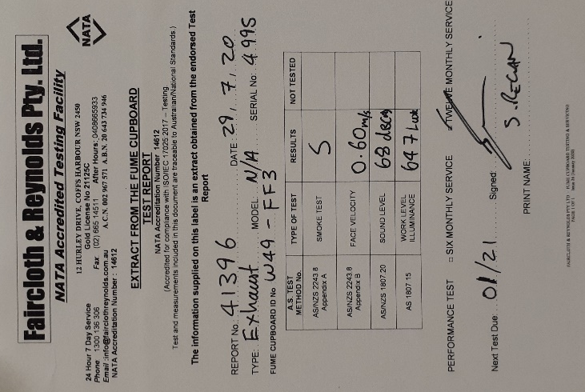

  - Staff, researchers, students Laboratory personnel are required to design and construct their experiments to minimise hazardous emissions.
Employees using fume cupboards should:
• ensure that all procedures and guidelines are followed when using ducted fume cupboards;
• before using a fume cupboard for the first time:
o ensure the fume cupboard twice yearly testing is current;
o locate where the fan failure warning alarm is and what it will sound like;
o locate the fire damper or emergency stop (if fitted) for use in the event of a fire; and
o locate the nearest phone, fire extinguisher/blanket, shower and eyewash station, and be familiar with the local area emergency procedures; and

• regularly maintain the fume cupboard by:
o removing the contents of the cupboard and washing the walls and work bench;
o keeping sinks and drains clear of refuse and checking them regularly;
o labelling all containers in the fume hood appropriately; and
o ensuring waste bottles in the fume hood are capped when not in use and are disposed of regularly.

- Guidelines
  - Fume hood function and usage
A fume cupboard is essentially a ventilated box with one side being moveable to provide an adjustable opening. It provides air extraction to remove any fumes produced within the box. It is designed to have laminar flow through the front opening, i.e. the flow is to be even and non-turbulent through the open face of the cupboard.

To obtain even flow through the face of the fume cupboards baffles are generally installed at the back of the cupboard. These baffles are set to extract the air from two or more locations across the back of the fume cupboard. If the openings provided by the baffles are blocked by items stored in the cupboard then the air low through the face of the cupboard can become uneven.
Whenever anything is placed within the fume cupboard it introduces turbulence into the cupboard which may affect the containment and extraction of fumes. If a fume cupboard is not set up and used appropriately, fumes may escape out of the sash opening of the fume cupboard towards the user, especially with heavier vapours such as formaldehyde or chlorinated solvents.

Fume cupboards draw air out of the rooms they are installed in. Therefore there needs to be an adequate volume of air available or the fume cupboard will not be able to draw a sufficient volume of air to function properly.

Where the room is small or there are a large number of fume cupboards an additional supply of air, other than the normal room ventilation, may be required. This additional air is known as the make-up air.

If the make-up air supply is not adequate or the make-up air is switched off then a fume cupboard may not be able to achieve the required face velocity. Alternatively if there is no make-up air and the room ventilation is switched of, there may be insufficient air volumes for the fume cupboards to achieve the required face velocity.
Incoming air can be deflected off an item placed in the fume cupboard at enough speed to escape from the back into the room. A person standing in front of the fume cupboard increases the probability of fume entering the lab.
The base of the fume cupboard must be kept clear to allow effective ventilation of the work area.

The use of the screen will result in turbulence directly behind the screen. If the area behind the work area is not kept clear there is a high potential for a 'dead spot' to be created which will increase the potential for fumes to escape.

  - Fume hood function and usage
Operation
Before use
- Ensure that the fume cupboard is appropriate for the task. The use of certain biological materials, perchloric acid and perchlorates, large volumes of acids etc. require special features or scrubbing.

- Ensure the fume cupboard is operational and there is an airflow. Listen and feel for air movement - this should be obvious with the sash in its lowest position.
Note: The fan switch for the fume cupboard turns the fan on immediately. However, a fume cupboard goes through a pre-use purge of up to 5 minutes (varies with make and model) before switching on the power to the electrical sockets and gas. Do not start work until this pre-use cycle is complete.

- Check for obvious surface contamination. Clean if necessary, to avoid adverse reactions with the chemicals in use.

- Ensure that there is enough space to conduct work safely.

- Position equipment, apparatus, and materials in the centre and back of the
cupboard to minimise disturbance to airflow. Where practical, place required item within the cupboard before starting operations.

- The WHS legislative framework requires the control of risks and exposure as far as is reasonably practicable. The following should be considered:
- Reducing the quantities of the substances used;
- Reducing the amount of substance released into the airflow e.g. use a condenser, watch glass cover bubblers etc.; and
- Using a slower reaction rate.

During use
- Avoid sudden rapid movements in front of the cupboard. These can cause turbulence that may draw the airborne hazardous material out of the cupboard.
- Position the sash position to the operators advantage:
- Fully open to provide access for setting up equipment.
- Partially open to a comfortable work height when handling the material inside the cupboard.
- Lowered as far as is practicable, when the process is in operation and intervention is no longer required.

- Any accidental spill of chemicals shall be cleaned up as soon as it is safe to do so.

- If hot plates are used, these should be placed at least 10 cm from the side
of the cupboard to avoid damage to the cupboard structure.

After use
- Dispose of laboratory waste as per UNE waste guidelines.

- Clean and decontaminate the fume cupboard, if necessary.

- Lower the sash to minimise the waste of tempered air. A fume cupboard should remain on for at least 20 minutes after the process/activity has finished and hot plates have cooled. This is to ensure that all airborne contaminants have been exhausted. Some cupboards may need to be left on, but at their optimal setting.

Note: Modern fume cupboards have a post-use purge cycle, so that once the fan is switched off, the electricity to the sockets and gases are switched off, but the fan continues to run (for up to 20 minutes - varies with make and model).

- Note any maintenance and unusual situations within the fume cupboard. Escalate as appropriate or follow the applicable FMS maintenance process.

  - Considerations for standard operating procedures
When producing standard operating procedures (SOP) the following points should be considered and where applicable included in the procedure.

1. Ensure that work/ an item is at least 10 cm from the leading edge of the fume cupboard. The larger the item, the further back it needs to be within the fume cupboard to overcome turbulence.
2. Ensure items are not stored in the fume cupboard. This is particularly important where a Perspex screen or lead bricks are used for radioisotope work.
3. Minimise the number of items stored within the fume cupboard.
4. Ensure items placed in the fume cupboard do not block the baffles and produce regions of zero or low flow. This is particularly relevant with larger items (e.g. ovens).
5. Minimise traffic past the front of the fume cupboard as this can cause turbulence resulting in fume escape.
6. Use fume cupboards with a non-porous bench surface for work with radioactive material (i.e. not terracotta tiles).
7. Ensure windows that may create draught in the vicinity of the fume cupboard are closed. Where make-up air or ventilation is insufficient for optimal fume hood operation, expert technical advice shall be sought prior to implementing any compensating measures.
8. Ensure doors within 1m of a fume cupboard are kept closed during the use of fume cupboard. Where make-up air or ventilation is insufficient for optimal fume hood operation, expert technical advice shall be sought prior to implementing any compensating measures.
9. Where applicable, ensure the make-up air supply and room ventilation are on whenever the fume cupboard is in use.
10. Ensure power boards and other spark producing sources are outside the hood.

5. Do’s and Don’ts of fume hood usage
Do | Don’t
- Work within 10cm of leading edge  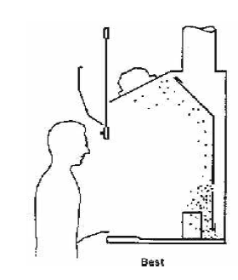 | - Work near leading edge  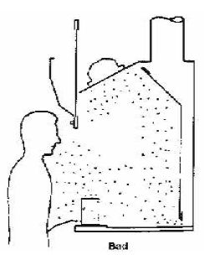
- Lower sash as soon as possible and maintain as low as possible during work (sash also acts as safety shield) | - Prevent sash from closing or place large bulky items in hood  