Insert BU Name
Business Continuity Plan insert year
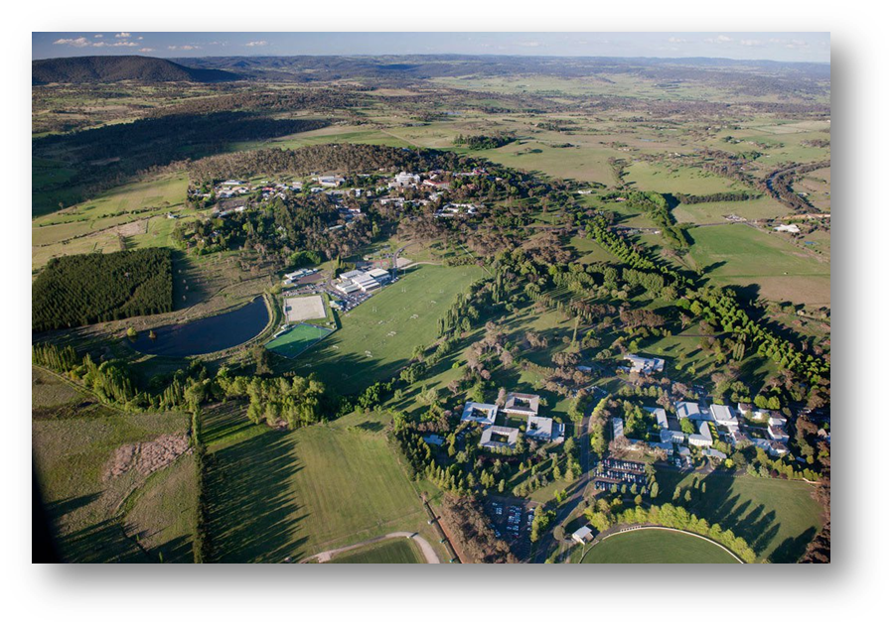

Table of Contents
Document Review 4
Document Change Control 4
Distribution List 4
Abbreviations & Definitions 5
Introduction 6
UNE’s Business Continuity Plan (BCP) and Impact Statement 6
Purpose 7
Objectives 7
Use of the BCP 7
Assumptions 8
Limitations 8
Distribution 8
Validation & Testing 8
Methodology 8
Identify and Assess Business Processes and Functions 8
Conduct a Business impact Analysis (BIA) 9
Business as Usual Planning (BAU) 9
Maximum Tolerable Outage (MTO) 9
Test & Maintain the BCP 9
Emergency Control Organisation (ECO) 9
ECO – Roles & Responsibilities 9
ECO Organisational Chart 11
Emergency Response Structure 12
Notification & Declaration Process 13
Notification 13
Assessment 13
Declaration 13
UNE Activation & Notification Levels 14
Emergency Operations Centre 15
Media Protocol 15
General Statement to the Media 15
Appendix A: Emergency Contact details 16
Fire, Ambulance or Police: 16
Security Services for all Emergencies (24 Hours) 16
Appendix B: Organisational Chart 18
Appendix C: Business Impact Analysis 19
Business unit: Insert BU Name Here 19
Corporate Risk Impact Ratings (UNE Corporate Risk Management Rule – Framework) 20
Appendix D: Business As Usual Planning 21
Within UNE for short term (< 1 week) 21
Outside UNE for short term (< 1 week) 21
Within UNE for Long Term (>1 week) 22
Outside UNE for Long Term (>1 week) 22
Contacts 23
Appendix E: Rehearse, Maintain & Review 24
Training Schedule 24
Appendix F: After Action Review Template 25
After Action Review 25

Document Review

Whenever this document is reviewed and or amended, details are to be recorded on this page.

Document Change Control

Revision # | Change Description | Date | Author
1 | Initial document release as per draft | 23/11/2016 | Theron King
1.1 | Amended as per Residential Systems suggestions: Extra BAU for Residential | 14/03/2017 | Theron King
1.2 | Amended as per Risk and Audit suggestions: Trim and document control | 16/03/2017 | Theron King
1.3 | Document registered in Work Health and Safety Management System (WHSMS) and ‘Document Control’ applied. | 20/11/2017 | Jodi McAlary

Distribution List

Copy Number | Name | Location
001 | Business Continuity Officer – Electronic Copy | HRS - Safety
002 | ORPC Members – Electronic Copy | Various – ORPC Administrator to distribute
002 | Emergency Operations Centre – Hard Copy | Printery
003
004

Abbreviations & Definitions

Term | Abbreviation | Definition
Adaption | Adaption | The Universities capability to cope with uncertainty, change and associated stresses, and adjust to change
After Action Review | AAR | An After Action Review is a structured review or de-brief process for analyzing what happened, why it happened, and how it can be done better by the participants and those responsible for the project or event.
Business as Usual | BAU | The normal execution of standard functional operations within an organisation.
Business Continuity | BC | A state of continued, uninterrupted operation of a business in all contexts.
Business Continuity Plan (s) | BCP | This process leads to a clearly defined and  documented plan which sets out the procedures, resources and  systems necessary to continue or restore the activities of an  organisation should unpredicted business disruption occur. The BCP is  used as a communication and decision support tool and is executed in  response to a business disruption.
Business Impact Analysis | BIA | A management level analysis which identifies the impacts of function loss on the organisation. The BIA provides management with data upon which to base risk mitigation and continuity planning decisions
Business Interruption Event | BIE | An event that by its duration exceeds the Maximum Acceptable Outage and / or has an adverse impact on business objectives and requires the implementation of the BCP or sub plans
Business Process Assessment | BPA | A management tool designed in the identification and assessment of criticality of business process and functions.
Business Unit | BU | A part of the University that operates separately under the umbrella of UNE
Critical Business Activity | CBA | May be defined as primary business functions that must continue in order to support your business.
Emergency Control Organisation | ECO | The entity responsible for UNE’s incident and emergency activities during the Reaction, Response and Recovery Phases.
Emergency Operations Centre | EOC | A central point of reference to co-ordinate the response to a business interruption event. Is established at the discretion of the ORPC.
Emergency Event | Emergency Event | An event due to an actual or imminent occurrence (such as fire, explosion, flood, earthquake, pandemic, etc. ) which:  - Endangers or threatens to endanger the safety or health of staff or visitors to the organisation  - Destroy or damages, or threatens to destroy or damage, property of the organisation  - Has the capacity to disrupt operations to the extent that it impacts on business objectives.
Emergency Management Plan | EMP | The written document of the emergency arrangements for a facility generally made during the planning phase. It includes the agreed emergency roles, responsibilities, strategies, systems and arrangements.
Full Time Equivalent | FTE | An FTE of 1.0 is equivalent to a full-time worker or student, while an FTE of 0.5 signals half of a full work or school load.
Maximum Tolerable Outage | MTO | The maximum period of time that UNE can tolerate the loss of capability of a critical business function, process, asset or IT application
Organisational Resilience Planning Committee | ORPC | ORPC is responsible for the development and review of a strategic framework to ensure the effective continuance of the University of New England’s operations in the event of a major crisis or potentially catastrophic event.
Risk Management | RM | The culture, processes and structures that are directed towards realising potential opportunities whilst managing adverse effects.

Introduction

UNE’s Business Continuity Plan (BCP) and Impact Statement
The University of New England (UNE) is a complex organisation with a large body of people potentially on campus at any one time and has responsibility for significant property within the Armidale District. Furthermore, like all other tertiary institutions, UNE’s staff and students are mobile within Australia and internationally.
The UNE’s priorities in any emergency situation are as follows:
- To save life and avoid any further injury;
- To preserve its assets and operations;
- To minimise impact on the local community and environment;
- To return to business as usual as soon as practical.
While most minor emergency incidents would routinely be handled by Safety and Security or Health & Safety staff as part of their daily business, there will be occasions where the escalation of an incident or even a long term incident necessitates the activation of the Universities Emergency Management Plan (EMP) and Business Continuity Plan (BCP).
This planning will reduce the lag time from the initial response to a critical incident to being able to resume ‘business as usual’ practices here at The University of New England.

Purpose
UNE has adopted a comprehensive and integrated approach to the development of a BCP. The purpose of the Plan is to build organisational capabilities to support the continued achievements of critical business objectives in the face of uncertainty or disruption.
UNE recognises that this BCP in isolation does not build capability; it provides the approach to establishing effective capability. Whilst the Plan is important, it is an outcome of the more important planning and analysis process, and is a blueprint to kick-start the response to a business interruption process.
This Plan identifies the required facilities, technical infrastructure, key responsibilities, and processes that will be required to position UNE to be able to respond and recover from a business interruption event.
In identifying business continuity the focus is on the building of resilience and response capabilities within critical business functions as identified by UNE. Treatment options for non-critical functions may also be identified and documented. This allows UNE to have a whole of organisation view when responding to interruption events, as the nature of these events can change rapidly.

Objectives
The objective of UNE’s BCP is to provide a mechanism that enables the Emergency Control organisation (ECO) to:
- Identify Business Functions that are critical to UNE in meeting its business objectives
- Develop resumption plans based on criticality of business functions rather than geographic location
- Build resilience with UNE’s operational framework
- Identify and document roles and responsibilities of key staff positions
- Minimise the impact of function loss on internal and external stakeholders.

This Plan provides a framework for staff to enable them to implement an agreed response process.
In assessing the business continuity risks of UNE it became evident that given the structure of the University, the following inherent advantages were identified:
- Multitasking of staff
- Ability to transfer staff and tasks to other facilities
- The ability to call on adjoining Business Units (BU’s) for assistance in service delivery.

In the event of a business interruption event, these advantages would suggest the business impact is a reduction in capacity rather than a loss of capability in a particular area.

Use of the BCP
This Plan should be used in the event of a business interruption event that may impact on the ability of UNE to deliver business objectives. Staff with responsibilities for impacted areas of the business should use the BCP and any relevant sub plans to ensure a consistent and agreed course of action is implemented.

Assumptions
The BCP is intended to provide guidance to UNE employees to assist continuity of service for critical functions, where those employees are not normally responsible for managing the specific function affected. Where the UNE employee who is normally responsible for managing the specific function is available, it is assumed that this document will serve as a check document to reduce the possibility of an omission of important actions.

Limitations
It is not the intent of this document or process to develop Information Technology Disaster Recovery Plans (ITDRP). This process will however identify from a business perspective the business requirements for Information Technology resources that support the delivery of business critical function. This information could then be used to inform the development of an ITDRP.

Distribution
The intended distribution of this Plan is to:
- Organisational Resilience Planning Committee (ORPC)
- Emergency Control Organisation (ECO)
- Within the BU.
The Plan is to be reviewed annually.

Validation & Testing
Business Continuity Management is a process, not an event. Once the BCP has been developed, commitment to a pre-planned, annual test and review is required by the Organisational Resilience Planning Committee (ORPC) to ensure BCP procedures remain viable into the future.
The testing should include all aspects of the BCP, but not necessarily all in the one review. Major components should be reviewed regularly. Information such as contact lists, or areas that are constantly undergoing changes, should also be validated annually.
In addition to the annual test and review of the BCP, any significant changes to UNE’s operations should also trigger a review of the BCP. Version control of the BCP should be maintained.

 | Activity for Review | Accountability | Timeframe
1 | Business Continuity Plan (Overarching Plan) | ORPC | Monitor annually and action as required
2 | Business Continuity Plan Exercise | BU’s in co-ordination with the HRS Health and Safety Team | Desk top exercise simulation exercise each 2 years

Methodology
Business continuity encompasses the identification and risk management of UNE’s business processes. It involves a stepping process that seeks to identify, assess control and monitor UNE’s business functions. This Plan has been developed with consideration given to AS3745:2010 - Planning for Emergencies in Facilities.
These steps include:

Identify and Assess Business Processes and Functions
Identify business processes and functions within each individual department, then determine which functions are critical to the BU and those which require further planning to ensure the ability to respond in the face of a business interruption event. It would be worth at this point referencing the set objectives of your BU so that your response is in line with your core functions.

Conduct a Business impact Analysis (BIA)
A BIA is conducted on those functions identified as critical within the business process assessment. Central to ensuring the ongoing viability of the business in an interruption event is the identification of critical business functions, the processes and assets (people and property) that support the delivery of these critical functions and the impact of the loss of the functions on the business are analysed within the Business Impact Analysis. An Excel Spreadsheet (Appendix C) will be supplied for you to fill out.

Business as Usual Planning (BAU)
The BAU identifies the responsibilities of staff, with particular emphasis on directional setting and effective and timely communication to stakeholders. This is a flexible document in which the BU can plan for disruption of its critical functions by identifying, planning and developing redundancies for business processes but it does not attempt to identify and plan for every contingency or outage that could occur. An Excel spreadsheet (Appendix D) is supplied.

Maximum Tolerable Outage (MTO)
MTO is the maximum amount of time a system or resource can remain unavailable before its loss starts to have an unacceptable impact on the goals or the survival of an organisation. Integral to the BCP is the determination of the MTO of a particular business process. The loss of a critical business function for a period greater than the MTO will generally result in the ECO coming together to direct, oversee and support the emergency, continuity and recovery response phases.

Test & Maintain the BCP
The BCP will be reviewed annually by the Business Unit in liaison with the Health and Safety Team within HRS, to ensure that it reflects the current practices of the organisation. Testing of the scenarios will provide assurance that the plan(s) remain effective. Appendix E has a training schedule spreadsheet and Appendix F has an After Action Review Spreadsheet to complete after each drill/training session.

Emergency Control Organisation (ECO)

ECO – Roles & Responsibilities

The ECO is established to provide a management mechanism that can ensure reporting lines and responsibilities are clear when the BCP is activated. The focus of the ECO is to manage the business interruption event from a corporate perspective while providing guidance and support to the Managers on site. This process is facilitated by the development of pre-determined courses of actions (sub-plans) thus allowing the ECO to focus on the strategic or whole of business response to the business interruption event. Each position in the ECO is to have an alternative member identified and trained in the role. The ECO contacts list will be updated annually.
The ECO has functional roles in Emergency Planning, designated Emergency situations, and the Recovery stage.
- The ECO members have Pre emergency planning and reporting function which include some members attending ORPC meetings to deal with emergency identification, reporting to the UNE Council, and organising the functions of the emergency response teams.
- The second function of the ECO is the emergency control function which is the decision making function in an emergency event. Selected ECO members will be in control when an emergency event is declared at a UNE site, in a designated emergency operations centre, and will control the emergency response teams. The emergency response teams are part of the ECO.
- Role of Specialists in the ECO will be advised whether needed in an emergency to give advice in the control room on their area of expertise if needed. E.g. Residence officer, Chemical specialist, International officer.
- Selected members of the ECO will be involved in debriefing in the recovery phase following an emergency event.
- The makeup, training, and development of the emergency response teams are under the control of the Chief Warden. These emergency response teams are made up of specially trained staff who are on the ground when an emergency situation is called, and give information to and take directions from the ECO members in the Control room.
The membership of the ECO is aligned to the continuation of their role at UNE, and will review its membership on an annual basis.

ECO Organisational Chart

Role in EOC | Position at UNE
Chief Warden | Chief Operating Officer  PDVC
Emergency Coordinator | Emergency Planning Coordinator  Manager Safety & Security
Media Officer | VC  PVC External Relations
Administration Officer | COO Executive Officer  VC Administration Assistant
Communication Officer | VC Advisor  Corporate Communications Officer
HRS Officer | Director HRS  Deputy Director HRS
Student Wellbeing Officer | PVCA  Director Student Administration Services
IT Officer | Director IT  Associate Director IT Infrastructure Services
Logistics Officer | Associate Director IT Client Services  Manager IT Service Delivery
Facilities Officer | Director FMS  Deputy Director FMS

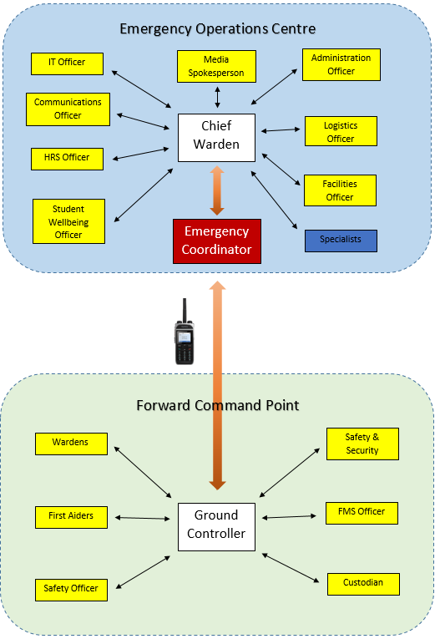
Emergency Response Structure

Notification & Declaration Process

Notification
On first becoming aware of a possible critical incident, the relevant function manager is required to assess the situation and if the event is likely to exceed the agreed MTO, then the Chief Warden should be notified immediately by phone and where possible, with a follow up email or personal briefing detailing the key issues including:
- Nature of the incident – time informed etc.
- Describe business elements impacted
- Facility / equipment impacted
- Staff impacted / required
- Any response actions implemented
- Any media involvement / interest
- Any immediate support requirements

Elements of the BCP can be implemented at the local level, where appropriate to address and immediate response requirement even if the event is expected to be resolved within an acceptable period.

Assessment
On receipt of a notification that will impact business continuity the Chief Warden will:
- Formally note details
- Notify the other members of the ECO
- Confirm the details of the incident and appropriate media strategies
- Conduct preliminary impact assessment (on facility and technology infrastructure)
- Determine if the Emergency Operations Centre (EOC) needs to be opened

Declaration
The Chief Warden is to review the preliminary information and if considered necessary declare a Critical Incident based on UNE’s Activation and Notification Levels for a Critical Incident (see below).
Declaration will allow for:
- Formal activation of UNE’s Emergency Response Plans
- Closure of part/all of campus
- Suspension of business activity
- Activation of the BCP*

*NB: As per the University’s Emergency Management Plan, it is the responsibility of the Chief Warden to enact the BCP should it be required.

UNE Activation & Notification Levels

 | IMPACTS
RESPONSE LEVELS |  |  | HARM TO PEOPLE | HARM TO ENVIRONMENT | ASSET DAMAGE | LOSS OF BUSINESS CONTINUITY | DAMAGE TO REPUTATION | POLITICAL INTEREST
 |  | Level 1 | Illness or injury of a minor nature  Significant near miss | Minor environmental impact able to be dealt with by SSO  Environmental nuisance (noise etc.) | Minor damage to facilities or equipment able to be dealt with by UNE personnel | Minor disruption to departmental operations | Campus community awareness of issue, little media interest | Peaceful demonstration/gathering on campus able to be managed by UNE personnel
 | Level 2 |  | Single or multiple injuries requiring immediate hospitalisation affecting daily operations | Moderate environmental harm able to be dealt with by UNE personnel  Minor hazardous spill | Accident or damage to facilities or equipment which could affect daily operations | Disruption affecting significant amount of campus operations for more than 1 day | Local or regional concerns which have the potential to escalate | Demonstrations or unrest involving political interest groups which can be managed by UNE personnel
Level 3 |  |  | Life and/or property at risk  Large area affected (Armidale/New England/State)  Single or multiple serious injuries or fatalities  Mass illness requiring external help | Serious environmental harm requiring external agencies support  Hazardous chemical spill/gas release  Environmental impact affecting neighbouring area | Significant damage to structures, facilities or equipment which seriously affects daily operations | Loss of whole campus operations for multiple days | Significant national or international media interest/activity | Demonstrations or unrest involving political interest groups which require external agencies support

Emergency Operations Centre
The Emergency Operations Centre is opened if deemed appropriate by the Chief Warden on the declaration of a Critical Incident. The resourcing and opening of this centre is the responsibility of the ECO.
The EOC is a centre for coordination of operations and support, during an emergency. In the context of a University, an EOC is the location where the designated staff of the institution gathers during an emergency to coordinate both the operational and strategic response, and to manage the subsequent recovery process. It is a facility in which the Chief Warden through the ECO can ensure the timely provision of support to the affected UNE community by either;
a) Planning for an impending event,
b) Monitoring an operation, or
c) Coordinating support to an ESO when required.
There are two EOC’s at UNE.
a) Primary Centre
b) Secondary Centre

Media Protocol
Due to the nature of the media, the timeliness of reporting in these circumstances is critical. Prompt reporting to, and liaison with the ECO is in the best interests in terms of allowing for the preparation of an appropriate response.
NB: All media enquiries are to be forwarded to the ECO Media Officer.

General Statement to the Media
In the event of a major incident, particularly after hours, there may be a period of time elapsed before the designated media spokesperson is in a position to respond to media enquiries. Should any staff member be approached by media representatives for a comment they are only authorised to make the following statement:

“I am sorry, but I am not authorised to make any statement at this time. The Emergency Control Organisation and Chief Warden are currently being briefed on the situation and someone will be available to talk to you shortly.”

There is no such thing as an “off the record” comment.
Provide the ECO with the journalist’s details, and any other relevant information, including how the journalist came to contact you.

Appendix A: Emergency Contact details

Fire, Ambulance or Police:
000 (Prime emergency call service number)
112 (International standard emergency number)
106 (Emergency relay service for the hearing or speech impaired with a TTY/textphone)

Security Services for all Emergencies (24 Hours)
University of New England 6773 2099
Facilities management Services 6773 2065
IT Services 6773 5000
Media and Public Relations 6773 2551
Health and Safety 6773 1715

Provide the Following:
1. Name and location of the Facility
2. Number of injured persons and the nature of injury
3. The type and scale of emergency including a brief description
4. Hazards involved (e.g. substances)
5. Telephone contact number (for any return calls - Usually a mobile number for the person making the call)

Other Emergency Contact Details
State Emergency Service  132 500 | Water/Sewer:  6770 3600 (Armidale Regional Council)
Essential Energy (Electricity):  132 080 | Telstra (Phones):  132 203
Elgas (Gas):  131 161 | SafeWork NSW:  (BH) 131 050  (AH) 9214 9220

[Business Unit Name] Emergency Numbers
 | Name | Location | Phone Number(s)
Head of Business Unit:
Wardens
First Aid

Appendix B: Organisational Chart
Insert a copy (such as a .jpg or bitmap or similar) of the high-level organisation chart for your Organisational Unit (not the whole of UNE).
The Org Chart needs to capture the Organisational Unit's "Executive" and their direct reports, preferably with their titles - it is not the complete structure of the Organisational Unit.

Appendix C: Business Impact Analysis
As part of the BCP Business Units will undertake a Business Impact Statement which will use the information in your Risk Management Plan to assess the identified risks and impacts in relation to critical activities of your business and determine basic recovery requirements.

Business unit: Insert BU Name Here
Critical Business Activities may be defined as primary business functions that must continue in order to support your business.
Critical Business Activity | Description | Impact Rating  [1. Severe, 2. Major, 3. Moderate, 4. Minor, 5. Insignificant] See next page | Impact of losses  [ Describe losses in terms of health & safety, revenue, cost, students, staff, service delivery, reputation, organisation, legal/statutory]] | Maximum Tolerable Outage  [< 4hrs, 1 day, 2 days, 1 week, 2 weeks, > 1 month etc.] | Vital Records/Artifacts  [List vital paper records, specimens, historical relics, works of art, musical equipment, specimens, animals or equipment]

Corporate Risk Impact Ratings (UNE Corporate Risk Management Rule – Framework)

Rating | Definition
1.Severe | The impact from the consequences of corporate risk, if they were to occur, would result in the BU’s Critical Business Activity being unachievable.
2. Major | The impact of the consequences of the corporate risk, if they were to occur, would render a significant proportion, or component, of the BU’s Critical Business Activity being unachievable.
3. Moderate | The impact of the consequences of the corporate risk, if they were to occur, would significantly obstruct the BU’s Critical Business Activity.
4. Minor | The impact of the consequences of the corporate risk, if they were to occur, would significantly delay or impair the BU’s Critical Business Activity.
5.Insignificant | The impact of the consequences of the corporate risk, if they were to occur, can be managed by the University so as to not impede the achievement of the BU’s Critical Business Activity

Appendix D: Business As Usual Planning
Identify in the table below a temporary office accommodation you can quickly access in an emergency situation. Two sites within UNE and two sites outside UNE for both short term and long term situations.

Within UNE for short term (< 1 week)
Rank | Type  [UNE site – Lecture theatre, laboratory, residence etc.] | Address  [Building number and name] | Equipment Available  [List all the equipment available at the site – computers, furniture, photocopiers, phones, paper] | Resources Needed  [List all the resources you will need in order to use this site as a temporary office – Software, backup, staff, beds, catering, buses/transport, counselling and any other equipment not already available at the location] | FTE  [Full time equivalent staff needed to return to BAU] | Service Agreement in place?  [Yes/No]

Outside UNE for short term (< 1 week)

Rank | Type | Address | Equipment Available | Resources Needed | FTE | Service Agreement in place?

Within UNE for Long Term (>1 week)

Rank | Type | Address | Equipment Available | Resources Needed | FTE | Service Agreement in place?

Outside UNE for Long Term (>1 week)

Rank | Type | Address | Equipment Available | Resources Needed | FTE | Service Agreement in place?

Contacts
List all contacts to enable you to continue BAU as listed above including Interdependencies [Suppliers/Contractors (external inputs), Service Provider Support (Internal inputs) and Dependents (Outputs)]
Contact Type | Organisation Name | Contact Name | Title | Address | Phone

Appendix E: Rehearse, Maintain & Review
It is critical that you rehearse your plan to ensure that it remains relevant and useful. This may be done as part of a training exercise and is a key factor in the successful implementation of the plan during an emergency.
• A training schedule must be prepared for all people who may be involved in an emergency at the site.
• Pay attention to staff changes.
• If you change your organisational structure or suppliers/contractors this must be amended on your plan.

Training Schedule
Training Date | Training Type | Comments

Appendix F: After Action Review Template
The climate surrounding an AAR must be one in which the participants openly and honestly discuss what transpired, in sufficient detail and clarity, so everyone understands what did and did not occur and why.
Most importantly, participants should leave with a strong desire to improve their proficiency.
- An AAR is performed as immediately after the event as possible by the personnel involved.
- The leader’s role is to ensure skilled facilitation of the AAR.
- Reinforce that respectful disagreement is OK. Keep focused on the what, not the who.
- Make sure everyone participates.
- End the AAR on a positive note.

After Action Review
Business Unit: Date:
What was planned?

What actually happened?

Why did it happen?

What can we do next time? (Correct weaknesses/sustain strengths)

Who needs to know? Does the BCP need to be updated?

Records Storage Instructions
The completed Business Continuity Plan must be recorded in TRIM Container A17/1752 utilising a TRIM license in your School/Business Unit.

