
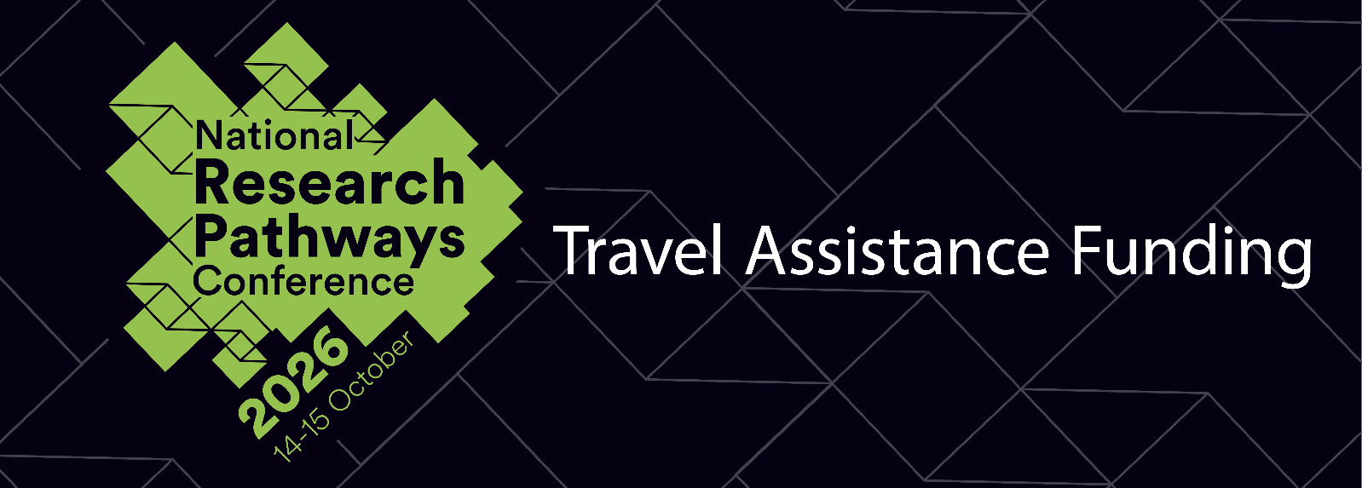
2026 Research Pathways Conference
“Building Inclusive & Equitable Research Communities”
For UNE Candidates Only
(to be submitted with the Abstract Application)
Personal Details

Title:  (i.e. Dr, Mr, Mrs, Ms, Miss) | Family name: | Given name(s):
UNE Student ID Number

2026 Travel Financial Assistance Funding

The Graduate Research School is offering travel assistance funding of up to $600 AUD to help support eligible HDR Candidates with travel to the 2025 UNE Research Pathways Conference.
Eligibility Requirements:
- Recipients must be a registered presenter at the UNE Research Pathways Conference 2025;
- Reside 100km or more outside of Armidale NSW;
- Travel from within Australia only;
- Provide a clearly costed budget for expenses;
- Provide a short justification for the request;
- Book their travel through Campus Travel;
- Be able to provide receipts if required.

Applications close Sunday 26 July, 2026.

Budget

Please provide your travel expenses below. This should be itemised (eg. Accommodation x 2 nights @ $120 per night; Train ticket from Sydney to Armidale return $100, etc).
Please note all airfares must be booked through campus travel. Visit the HDR Travel Guidelines website for more information on this process.
Please note:
- This travel funding assistance is for travel and accommodations only, there is no food allowance.
- In line with Accommodation prices in Armidale, maximum claimable accommodation cost is $150 per night. There is accommodation conveniently located on campus at the colleges which can be booked HERE.
- Regarding private vehicle use:
(84) Travellers may only seek approval to use a private motor vehicle for travel on University business in exceptional cases where:
- scheduled University transport is not available, or the relevant delegate deems scheduled University transport to be unsuitable or inappropriate;
- scheduled public transport is not available, or the relevant delegate deems scheduled public transport to be unsuitable or inappropriate;
- a University vehicle is not available, or the relevant delegate deems a University vehicle to be unsuitable or inappropriate; and
- a hire vehicle or taxi is not available, or the relevant delegate deems a hire vehicle or taxi to be unsuitable or inappropriate.
(85) Where private vehicles are utilised, the University’s insurance policy does not cover the vehicle. Owners are liable for any damage that occurs to the vehicle. Owners should check with their insurance provider to ensure personal policies apply to vehicles utilised for work purposes.
(86) Use of a private vehicle can only be authorised by the Executive Dean of Faculty, Director or Senior Executive, or nominated deputy approver prior to travel.
For full details regarding private vehicle use please read the UNE Travel Policy thoroughly.

 | Description (travel and accommodation) | Amount in AUD (approx.)
1 |  | $
2 |  | $
3 |  | $
4 |  | $
5 |  | $
6 |  | $
TOTAL |  | $
A supplementary attachment may be included as the Budget Estimate Statement if more space is required.

Eligibility Statement

Please outline how the Travel Assistance Fund would assist and support your current research at UNE and enhance your research career:

Please include all requested information.

I confirm that all the details in this application are true and correct.

Signed Date / /

Application must be submitted online by Sunday 26 July, 2026:
via the rpc@une.edu.au email

