Humanities, Arts & Social Sciences Research Seminar

9.30-10.30am Friday 16 August 2019

Clemente Marconi presents

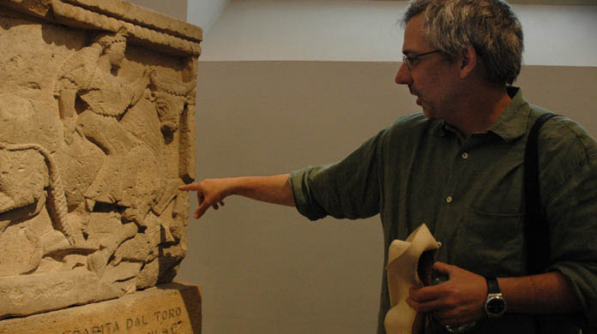

Photograph of Clemente Marconi provided by the Australian Archaeological Institute at Athens

The archaeology of colonial encounters in Western Sicily

This lecture discusses the relationships between Greeks and indigenous populations in Western Sicily during the Archaic period, in light of the progress of archaeological research in the past two decades. These recent archaeological investigations have uncovered significant new evidence concerning indigenous sites in the heartland of Sicily. These new discoveries are contributing greatly to our understanding of the development of material culture at indigenous sites, as a result of larger social and cultural changes. These changes depended partly on interaction with the Greek settlers on the coast, which generated different forms of response to Greek culture, including adoption, adaptation, and resistance. The progress of our understanding of indigenous material culture is also having a significant impact on our interpretation of the archaeological record, particularly indigenous pottery, from the Greek centres. This is particularly the case for Selinus and Himera, two centres for which a systematic reappraisal of the evidence for indigenous material culture is producing a new picture of the complex relationships with the indigenous hinterland, from the time of foundation all the way down to the early fifth century BCE. The situation found in Western Sicily is compared with that in Eastern Sicily, highlighting, besides the similarities, also significant differences between the two areas.
The 2019 Australian Archaeological Institute at Athens Visiting Professor, Clemente Marconi, is the James R. McCredie Professor in the History of Greek Art and Archaeology at the Institute of Fine Arts of New York University and is Professor of Classical Archaeology at the Università degli Studi in Milan. Professor Marconi was educated at the University of Rome La Sapienza and at the Scuola Normale Superiore in Pisa. His main research interests are ancient Greek and Roman art and archaeology, with a focus on Greek art and architecture of the Archaic and Classical periods. Since 2006, Professor Marconi directs the Institute of Fine Art–NYU’s excavations on the acropolis of Selinunte in Sicily. Professor Marconi has published extensively on a very wide range of themes relating to Greek and Roman art and architecture.
Oorala lecture theatre, Oorala centre
Followed by morning tea - all welcome
Enquiries to: Karin von Strokirch - kvonstro@une.edu.au

