This plan is enacted when a GAS/FUMES/EXPLOSION/FIRE situation is declared in a place of entertainment, and the level of risk to personal safety, property or environment is an immediate risk to escalate. This plan relates to the response of staff and students to a critical incident and supports the Emergency Management Plan (EMP) that exists for the individual buildings.

Places of entertainment like Lazenby Hall, The Stro and A1 Lecture Theatre require explicit organisation because of the potential for large numbers of people to be congregated in a relatively small area. The Custodian (person in control of the event) shall act as the Warden and is responsible for evacuation. The procedures need to be orderly to minimise crowding in aisles and doorways.
The University has no ability to fight a fire beyond automatic sprinkler systems or first response measures such as hose reels and portable fire extinguishers. Firefighting can only be carried out by Fire and Rescue NSW. Whether they are available, delayed or unable to attend, the priorities for the University are as follows.

Immediate Actions:
Protect your own life
In the absence of any direction from the University, use your best judgement to remove yourself from danger by evacuating to the designated assembly area or a safer place.
Protect the life of your fellow student or staff member
Ring ‘000’ and Safety and Security 6773 2099.
Alert others in your immediate area to the danger, and act together for the benefit of everyone. Try to identify the safest escape route.
Evacuate
- Evacuate the building as instructed to do so by a Warden.
- Wardens will be the primary vehicle for ensuring everyone is out of danger through visual checks upon exiting (between seats, in toilets, lighting and film rooms), and a situational awareness of who would generally be in the building and where.
- Walk quickly and calmly to the assembly area.
- Close doors and windows as you exit - do not lock doors.
- Leave lights on.
- Do not use the lifts.
- Remain in the assembly area in groups until instructed to leave by a Warden, Emergency Response Team (ERT), Emergency Control Organisation (ECO) or Fire and Emergency Services personnel.
- Do not re-enter the building until informed that it is safe to do so by the ECO or Fire and Emergency Services personnel.
Lecture Theatres
- It is the responsibility of the lecturer/tutor to ensure that their class is evacuated to the buildings emergency assembly area and to maintain control of the students during an emergency until released by the Fire Warden, safety and security, the ERT or the ECO.
Entry and Exits
Calculating Flow Rates
Flow rates can be calculated as rate of flow per unit of width (UEW) = 500mm.
Basic flow rates
Flat without stairs: 60 persons/minute/UEW.
With stairs: 40 persons/minute/UEW

Fire fighting
The University does not expect staff or students to fight a fire unless you have no alternative, your exits are blocked and your personal safety is compromised. If so, then ensure;
- It is safe to extinguish the fire.
- That you always use the correct fire extinguisher if you do attempt to extinguish the fire.
- Control the spread of fire. This is primarily a Fire Service function. However, there are limited actions that can be taken in the absence of an adequate fire service response.
- Remove loose combustible material between buildings.
- Close windows in adjacent buildings.
- Extinguish or remove embers and debris when they fall.
- Apply water to surrounding area.

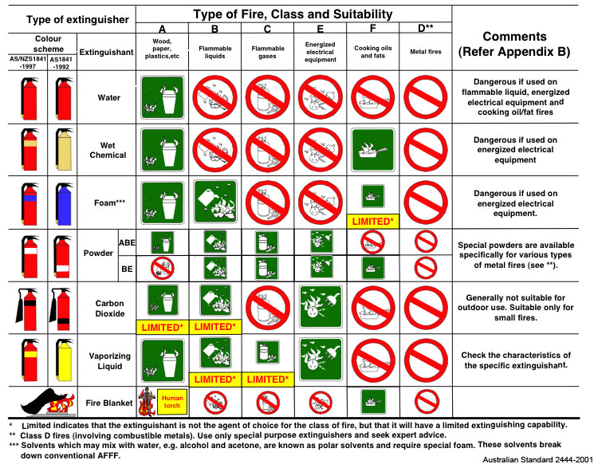

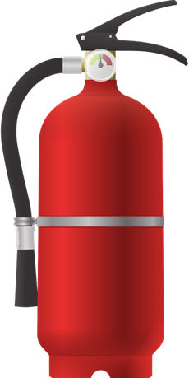
How to use a fire extinguisher:
Pull the pin at the top of the extinguisher
Aim low pointing the extinguisher nozzle at the base of the fire
Squeeze the handle to release the extinguishing agent
Sweep from side to side at the base of the fire until the fire is extinguished

Recovery
Salvage - The Fire Service may undertake salvage operations to limit the damage from water and smoke. However, they are not obliged to do anything that the building owner cannot do for themselves. Engaging with the Fire Service early to arrange staff or commercial operators to clean up and salvage equipment and resources can improve the outcome.
- Use tarpaulins etc. to cover important equipment where water is still present.
- Use aqua vacs and pumps (FMS/Cleaning Contractor) to remove excess water.
- Arrange supervised access, when safe to do so, to allow staff to recover personal effects e.g. mobile phones, car keys. In some circumstances retrieval of items from affected buildings will not be possible.

