
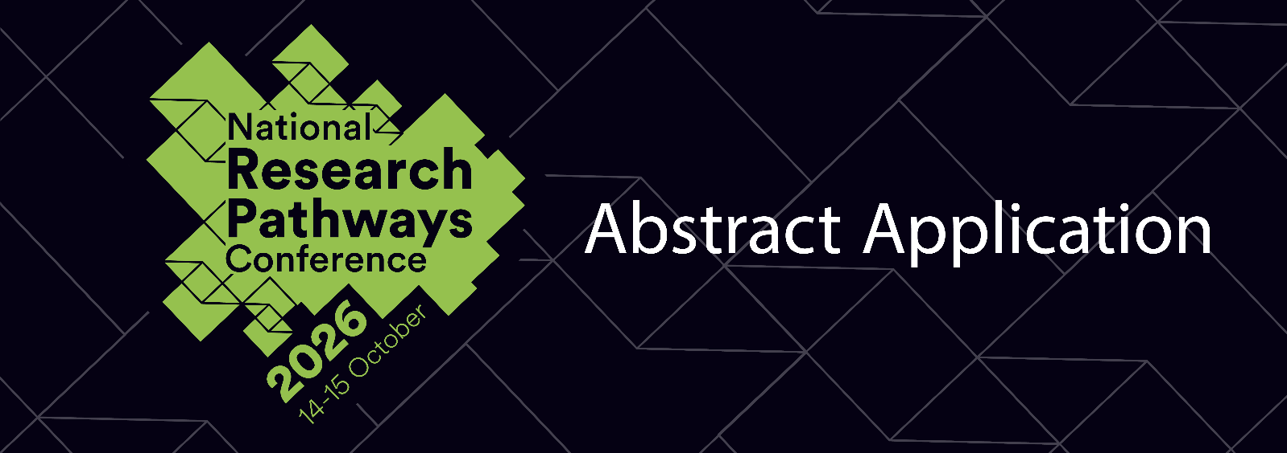2026 Research Pathways Conference
“Building Inclusive & Equitable Research Communities”
Personal Details

Title:  (i.e. Dr, Mr, Mrs, Ms, Miss) | Family name: | Given name(s):

University name:
If UNE, please provide student number:

Current Mailing Address:
Full Address:
Postcode:
Mobile:
Your student email address:

Candidature Details
Higher Degree Research (HDR) Candidature details:
HDR Course Name (eg. Doctor of Philosophy): | Select course
Specify course if not listed:
Discipline:
Year of Study (not applicable option): | Select Year of Study
Mode of Study (not applicable option) | Select Study Mode
Thesis Title:
Principal Supervisor:
Co-Supervisor(s):

Conference information

Do you plan to attend the conference in person or online?  Please complete registration HERE | □ In person | □ Online
Are you applying for GRS Travel Assistance Funding?  UNE students only | □ Yes (please complete additional form) | □ No

Biography (max. 100 words)

Abstracts Submission

Use the provided checklist (abstract assessment criteria) to guide you in the preparation of your abstract.
Academic merit | ()
- Clear research question/ issue can be identified
- Relevant contextual/ background information is provided
- If relevant, the method, data collection, and analysis procedures are well-designed, ethical and appropriate to the question addressed
- Conclusions are justified in relation to the data and/or analyses
- Significance of the research is clearly stated
- Original contribution to knowledge is clearly demonstrated
- References have been provided (as appropriate)
- Keywords have been included
- Funding sources have been declared
- Overall, the abstract is:
- Concise (checked for typos, grammatical errors and proofread)
- Within the word limit (150 – 250 words)
- Title is no more than 10 words in length
- Accessible to all readers
Contribution to the conference | ()
The abstract clearly identifies:
- Which theme the research contributes towards*
- How the research contributes to the conference
Relevance to conference attendees | ()
- Research is current in the relevant field(s) of study
- Research is likely to interest a number of conference attendees
- The abstract is written in an engaging and accessible way for an educated general audience
*Abstracts that do not directly contribute to the conference theme will still be considered if they meet the assessment requirements and has relevance to the conference audience.
Please note: Submissions should be made to rpc@une.edu.au and abstracts will be assessed by the Research Pathways Conference Abstract Committee.

Abstract Title
First author¹, Second author², Third author³

¹ Institution details
² Institution details
³ Institution details

Abstract

Keywords (minimum 3, maximum 5):

References (optional)

Please include all requested information.

I confirm that all the details in this application are true and correct.

Signed Date / /

Application must be submitted online by Sunday 26 July, 2026.:
via the rpc@une.edu.au email

