Humanities, Arts & Social Sciences Research Seminar

Note time change 2pm Friday 20 September 2019

Graham Maddox presents

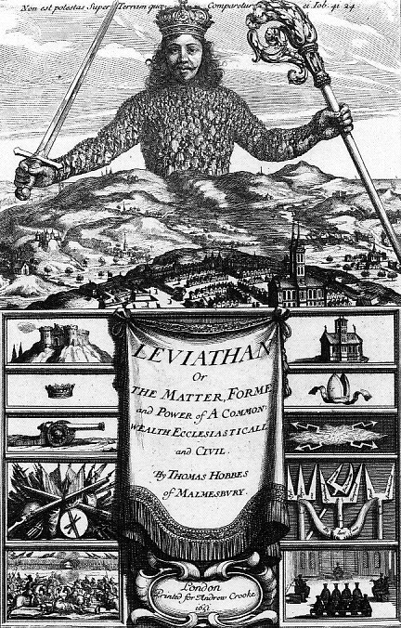

Frontispiece of Thomas Hobbes Leviathan 1651,
https://www.college.columbia.edu/core/content/frontispiece-thomas-hobbes’-leviathan-abraham-bosse-creative-input-thomas-hobbes-1651

Rome as a Model of Republican Liberty

The theory that liberty is best served by reference to citizenship in ancient Rome centres on the recourse parliamentary writers of the English Civil War and the Interregnum had to Roman republican example. These pamphleteers and essayists, among whom John Milton was prominent, drew upon classical writers -- particularly Livy, Cicero, Sallust, Seneca, and especially Roman law -- to claim that true freedom depends on having no master. Their polemic was directed at the royal prerogative of Charles I, but their claims have questionable implications for government itself. Certainly their construction of Roman freedom has been subject to intense criticism.

Graham Maddox is emeritus professor of Politics at the University of New England. His latest book is Stepping Up to the Plate. America, and Australian Democracy, MUP 2016.

Note venue change A3 lecture theatre, Arts building
Followed by afternoon tea - all welcome
Enquiries to: Karin von Strokirch - kvonstro@une.edu.au

