Write the Project Title Here

- We are doing a research study to find out which tests are better for checking children’s learning skills.
- A research study is a way to learn more about people.

- If you want to join in, you will be asked to take some tests.
- You might be asked to try to remember some things, or to do some puzzles, or to say what you think about something.
- It could take a while but you can take breaks if you need to.
- You can change your mind anytime if you don’t want to do the tests.
- When we finish doing the tests, I will write a report for your family and teachers.

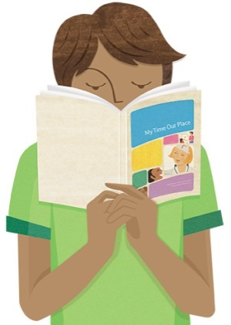
- We hope that this report will help your teachers and school understand how to help you learn.
- We will also write another report about whether these tests are helpful for children.
- This report will be shared at the university but we will not use your name in this report.

Thanks a lot for reading this and for any help that you give us with this study.
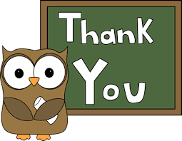
Ellie Simpson (esimpson@myune.com.au)
Pam Williams (pwilliams@une.edu.au)
Daisy Dunn (ddunn@une.edu.au)

This information sheet is for you to keep

