- Overview
- Use this guideline to assist with conducting a Level 1 Incident Investigation, recording the investigation and closing out of the incident in SkyTrust.
- WHS P007 - Incident / Hazard Reporting and Investigation Protocol provides the strategic direction on investigating Level 1 Incidents.
- A Level 1 incident is an incident that is not notifiable to the regulator and of a less serious nature, these incidents are to be investigated generally by the supervisor of the person reporting or involved in the incident.
- SkyTrust has a number of training modules in Investigation located on SkyLearn by accessing the ‘SkyLearn’ icon on the top right of the screen.
- When an incident is reported by a staff member or student on SkyTrust a notification will be sent to their supervisor. It is responsibility of the supervisor to conduct the investigation.
- This relates to investigating incidents reported by staff and students.

- Scope
- This guideline, the Incident Investigation Level 1 & SkyTrust Close-Out Guideline is to be utilised by University staff who are allocated the task of conducting an incident investigation.
- This guideline is only to be used for Level 1 Incident Investigations.

- Guideline
- Investigation Process – What to do and What information to gather
The steps in the table below are recommended to conduct an investigation, these processes would be completed and all information then uploaded and recorded in the SkyTrust Incident Investigation. Steps are a guide to assist and not all may be relevant or require in depth attention.

What to Do | What Information to Gather
Speak to the injured person or person reporting the incident | - First ask them if they are ok and offer any support  - Details of the injury, treatment required or future treatment required  - Ask them what happened – gather a chronological account of the incident – confirm exact location, time, date etc  - Details of any witnesses  - Details of any relevant training they have (eg: injury occurs while using a power tool, is the person trained and authorised to use that power tool?)  - Other factors that were involved  - Previous similar incidents  - Makes some notes if required and upload to the documents in the investigation  - Questions asked of the person involved - This would be recorded in the ‘Interview’ section of the investigation and there are pre-populated questions in the section already which you can use to gather this information.  The questions are:  - What do you think caused the incident?  - Was Equipment Failure a factor?  - Was human error a factor?  - What do you think could be done to prevent this type of incident occurring again?  - Could you fully describe the work and conditions in progress leading up to the incident?  - Could you fully describe the incident sequence from start to finish?  - Did you notice anything unusual prior to, or during the incident (sights, sounds, smells etc.)?  - What was your role in the incident sequence?  - What conditions influence the incident (weather, time of day, equipment malfunctions etc.)?  - How did people influence the incident (actions, emergency response etc.)?  - Please list other possible witnesses:  - Any other comments about the incident?
Speak with any witnesses | - Ask them what they saw or heard  - Make some notes if required and upload under Documents to the investigation  - This could be done using the same interview questions and recorded the same way in the Interview section.
Visit the location of the incident | - Make observation of the location where the incident occurred  - Take photos  - Make notes if required and upload under Documents to the investigation
Obtain other documents if required | - Obtain any training records if applicable (eg: training records to confirm the person was authorised to use the power tool)  - Upload under Documents to the investigation
Identify any causes of the incident | - Using the 5 x ‘Why’s’ you can identify the Root Cause/s of the incident, this can be done multiple times and recorded in the Root Cause Analysis section.
Determine any Remedial or Corrective Actions | - After reviewing the information gathered make any determinations on what action/s are required. Record these in the Actions section, more than one action can be created and allocated to individuals. If you implement an action that you complete yourself you must ensure the action is completed in the system.
Sign the investigation | - When the investigation is completed use the Signatures Section to sign off as complete. You can use the mouse to sign the box for signature.
Ask WHS for help | - If you get stuck or need assistance contact the WHS Team for help

- Investigation Process – Open the Incident
If an employee or student you supervise enters an incident report in SkyTrust, you will either get an automatic email notification or one will be forwarded to you from the WHS team. When you receive this email there are several steps to follow based on your responsibility to ensure a safe work environment for all personnel in the area under your control.

Step 1:
Click on the blue hyperlink at the bottom of the email.
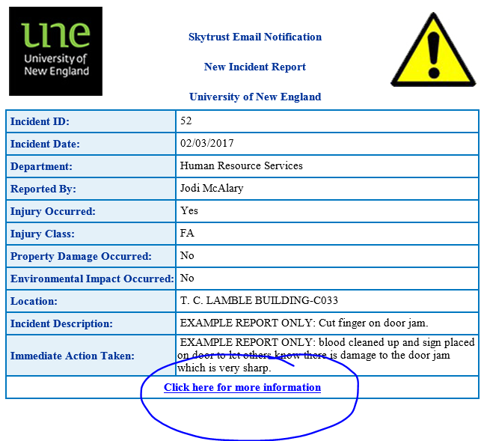

Step 2:
You will be prompted to login. Your username is your whole email address (no alias) e.g. <name>@une.edu.au
If you haven’t set your password yet you will need to do this by clicking on the “I forgot password” link. You will get an email to enable you to set your password. After your password is set, please click on the blue hyperlink in the email notification again and login.

Step 3: (Optional)
The full incident report will open in an ‘edit’ mode. If you have further details to add, please do.
Please ensure risk scores are entered for ‘actual’ and ‘potential’ consequences by clicking on the relevant risk score box. You will see below that risk scores do not have to be applied for all types of consequences if they are not relevant. Please leave blank if you are unsure or would like help from the WHS Team.

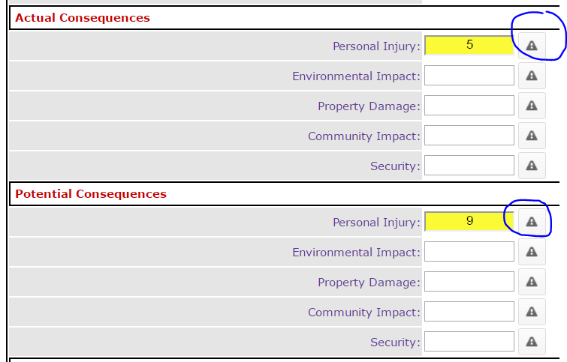

Step 4: (optional)
To see all details of the injury, click on the ‘edit’ button under ‘Injury Details’. Add more information if necessary and press ‘Update injury’.

Step 5: (optional)
To add any images or other documents to the report click on ‘Add document’

Step 5:
Click on ‘Modify Incident’ to save your updates.
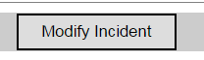

Step 6: (Optional)
You will now have the option to print or PDF the full report.
You will also notice the status of the report/investigation is ‘open’. All UNE supervisors are responsible for ensuring they close all incident reports sent to them.
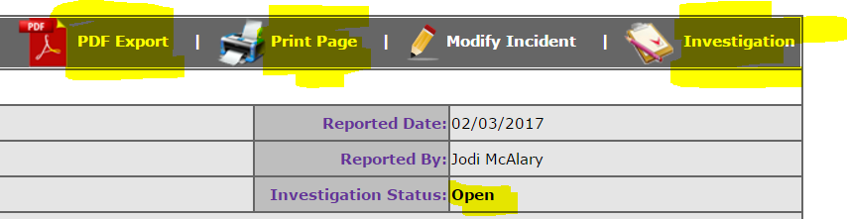

- Investigation Process – Uploading and recording your information gathered in the investigation onto SkyTrust
In SkyTrust there are Investigation Training Guides located in SkyLearn the icon on the top right of the screen. These guides assist in uploading and recording your investigation information in the Incident.
The basic steps are outlined below.

Step 7:
Click on ‘Investigation’ (shown in image above).

Step 8:
Click on ‘Edit Investigation’.
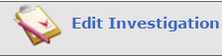

Step 9:
Add any outcomes or follow up to the incident in ‘Investigation Notes’. Select dates for ‘investigation due date’.

Step 10: IMPORTANT
When there is no more information to add to the incident report or investigation, change ‘Investigation Status to ‘closed’. Also update the ‘Investigation closed date’. Insert your name in ‘Lead Investigator’.
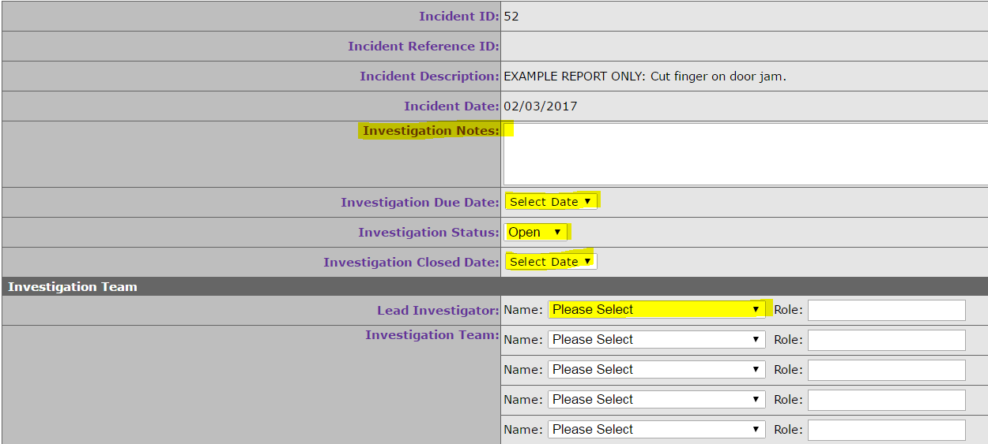

Step 11:
Enter details of Causal factors as shown below.
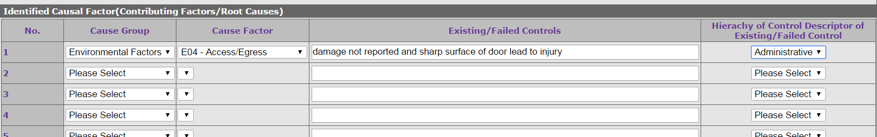

Step 12:
If there are no required corrective actions, click on ‘Modify’.
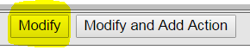
This will save all of your ‘investigation’ details and close the incident. Nothing further is required.

Step 13: (optional)
If there are identified corrective actions or follow up required, you can still close the incident report and investigation (as per instructions above) and create a ‘corrective action’.
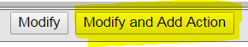

Step 14: (optional)
Fill out corrective action details and click on ‘send action’.
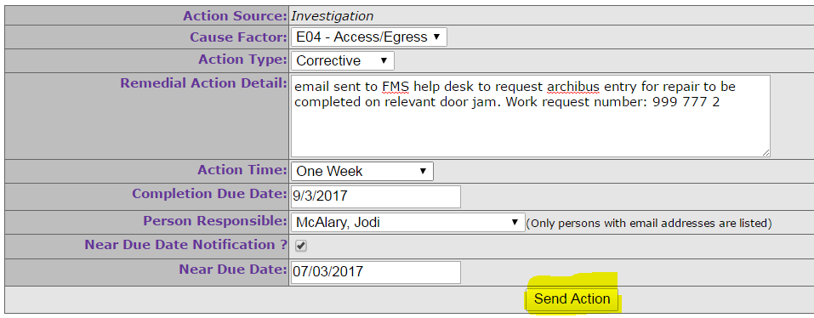

Step 15: Corrective Action Follow Up for ‘Responsible Persons’
The ‘Person Responsible’ will get an email notifying them of the corrective action. This person is able to click on the link in the email to view the full details of the corrective action, including a summary of the report that the corrective action has originated from.
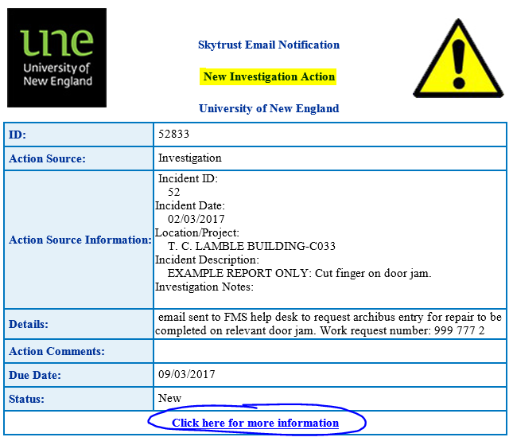

The ‘Responsible Person’ must update the action item and indicate when complete. See image below.
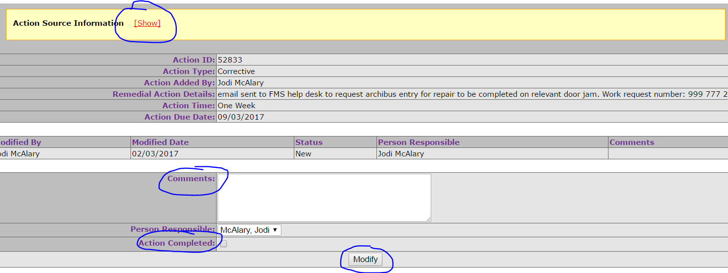
A summary of all corrective actions that have been allocated to you can be found on your homepage of SkyTrust.
