This plan is enacted when a GAS/FUMES/EXPLOSION/FIRE situation is declared in an office and/or teaching environment, and the level of risk to personal safety, property or environment is an immediate risk to escalate. This plan relates to the response of staff and students to a critical incident and supports the Emergency Management Plan (EMP) that exists for the individual buildings.
The University has no ability to fight a fire beyond automatic sprinkler systems or first response measures such as hose reels and portable fire extinguishers. Firefighting can only be carried out by Fire and Rescue NSW; whether they are available, delayed or unable to attend, the priorities for the University are as follows.
Immediate Actions:
Protect your own life
In the absence of any direction from the University, use your best judgement to remove yourself from danger, either by taking shelter-in-place within your building or by evacuating to a safer place.
Protect the life of your fellow student or staff member
Ring ‘000’ and Safety and Security 6773 2099.
Alert others in your immediate area to the danger, and act together for the benefit of everyone. Try to identify the safest escape route.
Evacuate
- Evacuate the building as instructed to do so by a Warden.
- Walk quickly and calmly to the assembly area.
- Close doors and windows as you exit - do not lock doors.
- Leave lights on.
- Do not use the lifts.
- Remain in the assembly area in groups until instructed to leave by a Warden, Emergency Response Team, Emergency Control Organisation (ECO) or Fire and Emergency Services personnel.
- Do not re-enter the building until informed that it is safe to do so by the ECO or Fire and Emergency Services personnel.
- For lecture theatres/laboratories: It is the responsibility of the lecturer/tutor to ensure that their class is evacuated and to maintain control of the students during an emergency until released by the ECO.
Fire fighting
The University does not expect staff or students to fight a fire unless you have no alternative, your exits are blocked and your personal safety is compromised. If so, then ensure;
- It is safe to extinguish the fire.
- That you always use the correct fire extinguisher if you do attempt to extinguish the fire.
- Control the spread of fire. This is primarily a Fire Service function. However, there are limited actions that can be taken in the absence of an adequate fire service response.
- Remove loose combustible material between buildings.
- Close windows in adjacent buildings.
- Extinguish or remove embers and debris when they fall.
- Apply water to surrounding area.

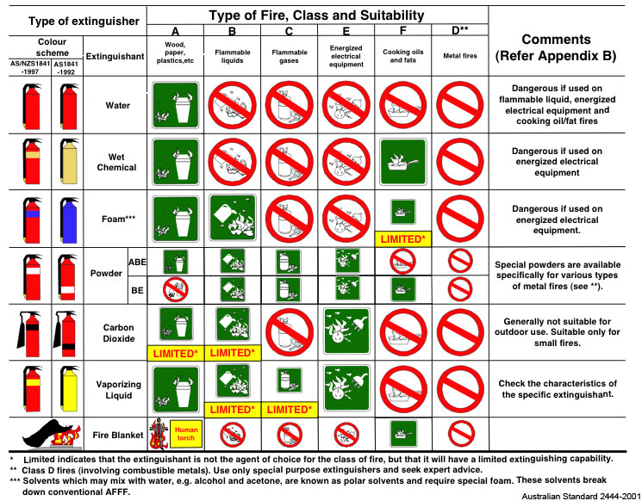

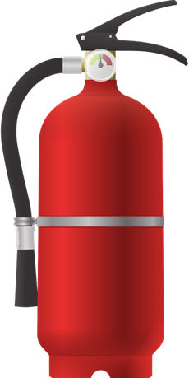
How to use a fire extinguisher:
Pull the pin at the top of the extinguisher
Aim low pointing the extinguisher nozzle at the base of the fire
Squeeze the handle to release the extinguishing agent
Sweep from side to side at the base of the fire until the fire is extinguished

