Humanities, Arts & Social Sciences Research Seminar

Note earlier time - 9.00-10.00am Friday 30 August 2019

Stephen Hodkinson presents

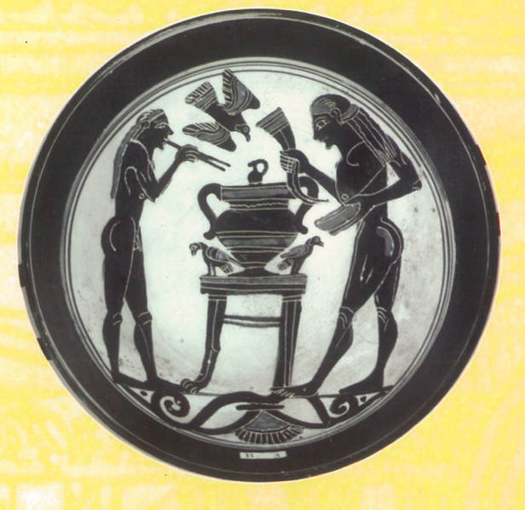

Lakonian cup ‘Komatis around a krater’, British Museum. Cover of Whitby, M. (ed, 2002) Sparta, Edinburgh University Press.

Re-evaluating Spartiate life: A grassroots perspective

This is a wide-ranging talk examining the everyday lives of the Spartiates. It adopts a new perspective that swims against the tide of previous approaches, ancient and modern, which have typically viewed Spartiate life from the top down: in antiquity from the perspective of Sparta’s legendary lawgiver Lykourgos, in recent scholarship from that of the ‘Spartan state’. In contrast, Prof. Hodkinson attempts to view Spartiate life from the standpoint of rank-and-file Spartiates, focusing on the operation of diverse groups and gatherings – public and private, formal and informal, large and small – in which Spartiates spent their daily lives. He argues that adult Spartiate life was not closely controlled from above: that Spartiate life included large amounts of leisure time to conduct one’s private affairs, that the multiplicity of groups led to a diffusion of official control; and that the self-regulating character of many of these groups provided all citizens, and especially the wealthy, with considerable scope to shape the precise character of their everyday lives.
Stephen Hodkinson wrote his Cambridge PhD dissertation on ‘Explorations in Classical Spartan Economy and Society’ under the supervision of Moses Finley and then Paul Cartledge. From 2003 until his retirement in 2018, he was Professor of Ancient History at the University of Nottingham, where he was a director of both the Centre for Spartan and Peloponnesian Studies and the Institute for the Study of Slavery. His areas of special expertise include: archaic and classical Sparta, especially its social, economic, and military organisation; Sparta in modern politics and popular thought; slavery; and the agrarian economy of ancient Greece. Professor Hodkinson has published and edited a good number of books, mainly on aspects of Spartan social and political history, and is now widely acknowledged as one of the world’s most insightful commentators on ancient Sparta. In 2010 he was awarded Honorary Citizenship of the city of Sparta.
Note venue: A2 lecture theatre, Arts Building
Followed by morning tea - all welcome
Enquiries to: Karin von Strokirch - kvonstro@une.edu.au

