This plan is enacted when a Sexual Assault Incident is disclosed and there is an immediate level of risk to personal safety. This plan relates to the response of staff and students to this critical incident and supports the Emergency Management Plan (EMP).
UNE can help you if individuals have been sexually assaulted, or have experienced threatening or inappropriate behaviour. All members of the UNE community, are strongly encouraged to report the incident.
Emergencies
If any person feels at risk, or considers a situation to be an emergency call:
- The Police and/or Ambulance on ‘000’;
- Campus Safety and Security - if any person is concerned and on campus, alert Campus Safety & Security on (02) 6773 2099 (24 hours);
- Help phones are also located around campus, which provide a direct line to Safety and Security. They are located on a map located here – please click on “help phones” within Safety & Security on the legend; and/or
- Police officers will come to you or you may visit the station at 96/98 Faulkner Street Armidale PH: (02) 6771 0699. Click here for map or see below.
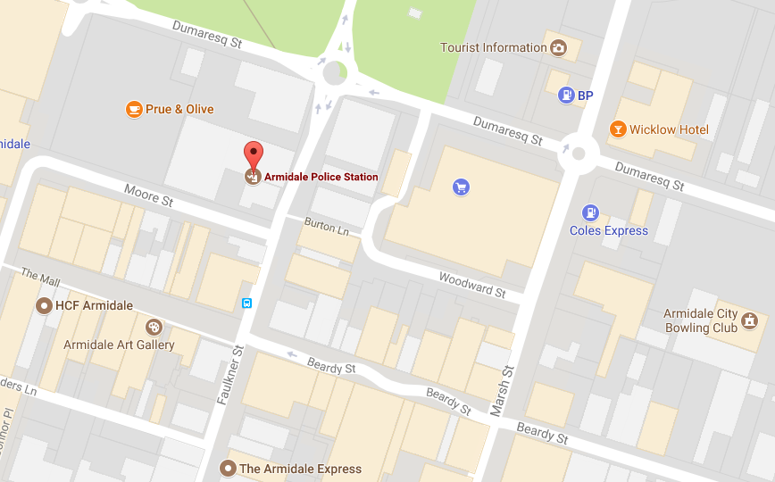
Emergency Related Response
• If anyone is in immediate danger call 000 (ask for Police) and then call Safety & Security (02) 6773 2099. Please note that Safety and Security can escort emergency vehicles to obscure locations on campus, saving valuable time.
• If anyone is requiring immediate medical treatment call 000 (ask for Ambulance) then get help from a UNE First Aider until the ambulance arrives. (First Aiders are identified on all WHS Notice Boards within buildings).
• If Police have been called do not touch or move anything unless it is presenting as an immediate danger.
• Do not physically touch the victim. You can still be supportive without touching the person.
• Do not ask the victim details of what happened. Let the person talk at their own pace.
• Listen, in a non-judgemental way.
• Do not leave the victim alone. If possible, ensure more than one person is always with them.
• Listen to what the victim is asking for and assist where possible (e.g. they may request the assistance of a female or male helper while awaiting emergency services).
• Police and/or ambulance staff can contact a sexual assault crisis worker who can help the person understand all their options.
On Campus Support
Student Support
UNE college students are encouraged to speak to staff members and support staff in their college.
UNE has a free, confidential, on-campus Counselling Service that caters for both on and off-campus students and is available Monday to Friday, 9:00 am – 4:00 pm. Please call (02) 6773 2897. Please note the Service is not a 24/7 crisis service but will assist where possible. If the matter is urgent, a 24 hour sexual assault service should be considered (see 24-hour contact numbers below).
For more information please refer to UNE Student Counselling http://www.une.edu.au/current-students/support/student-support/counselling
Speak to the Student Grievance Unit (SGU) for confidential help, guidance and information on options available. Services of the SGU are anonymous. The Student Grievance Unit can be contacted by calling (02) 6773 3994 or (02) 6773 4260 or go to the web site http://www.une.edu.au/current-students/support/student-support/complaints-compliments-and-feedback
You are in control
- We will listen to what you want and will not take any action unless you want us to, except if there is an immediate threat of danger to you or someone else. We will try to discuss this with you first.
- We will ask you your needs, your immediate circumstances and concern/s and we will listen carefully.
- It’s up to you to decide which option is most appropriate for you. To support you in your decision making, we will explain options, how they may help and what each path would look like for you, for example, “Should I report this to police?”.
- Where possible, we will only ask you to tell us what happened once.
UNE will put your safety first
- We will do everything we can to ensure you are safe.
- We will get any help that you may request including medical care, counselling and police if you wish.

We will talk with you anonymously
- You do not have to tell us who you are. However, we may be able to assist you better if you tell us your name.
Staff Support
- The Employee Assistance Program (EAP) is a professional, independent and confidential counselling service arrangement with Centacare New England North West. The counselling offered is intended to be short-term, solution-focused and to explore practical strategies for dealing with issues in a supportive and non-judgmental environment.
- All UNE staff members and, where appropriate, their immediate family members can access the counselling services provided through the Employee Assistance Program. UNE funds up to six (6) counselling sessions per year per employee, at no cost to the staff member.
- Call Centacare (8am–5pm Mon-Fri): 02 6738 7200
- Call Lifeline (24/7 service): 131114
Local Area Health Services – 24/7, confidential, free support
You can contact your local hospital or local sexual assault service based in your Area Health Service for help with crisis counselling as well as medical and ongoing counselling needs, help in reporting a sexual assault to the police, and preparing for any court hearing or making a victim impact statement.
Hunter New England Health | NSW Health Sexual Assault Services
Armidale Rural Referral Hospital  226 Rusden Street Armidale  (02) 6776 9500  (02) 6776 9622 (24 hours Accident and Emergency) | Armidale Community Health Centre  Claire House  Corner Butler and Rusden Street  Armidale, NSW, 2350  (02) 6776 9600  (02) 6776 9716 (24 hours)

NSW Services
NSW Government Victims Services Contacts List:
http://www.victimsservices.justice.nsw.gov.au/sexualassault/Pages/sexual_assault_contactus.aspx#NSW
24 hour contact numbers:
- In an emergency, call ‘000’
- In a non-emergency, you can contact the NSW Police Force Customer Assistance Unit on 13 14 44
- NSW Rape Crisis: 1800 424 017
- NSW Rape Crisis online counselling: www.nswrapecrisis.com.au
- Child Protection Helpline: 13 21 11
- Lifeline: 13 11 14
- Youthline: (02) 9951 5522

Australian Services
The following link through the Australian Human Rights Commission gives a list of sexual assault services nationally:
https://www.humanrights.gov.au/list-sexual-assault-services

