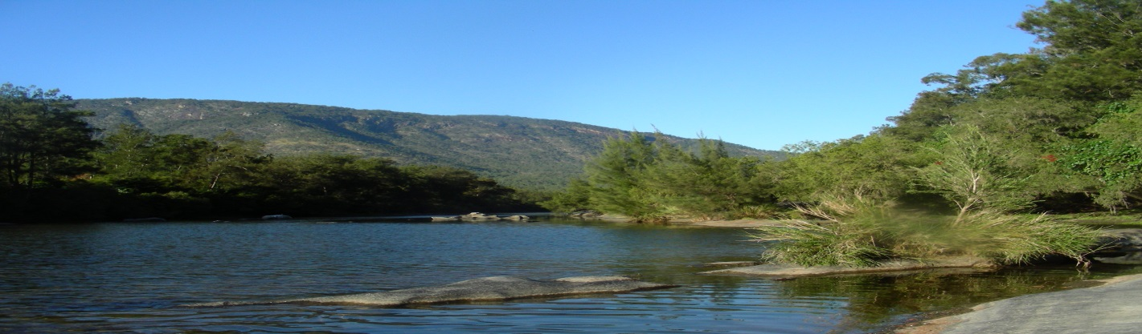

jklarne2
University of New England
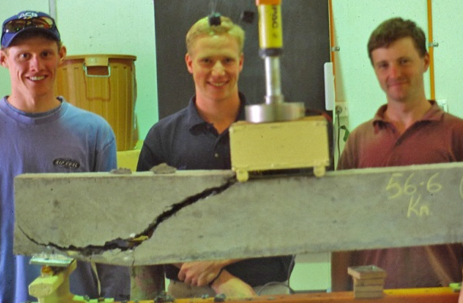
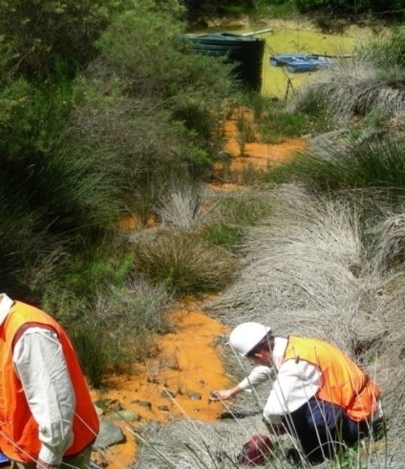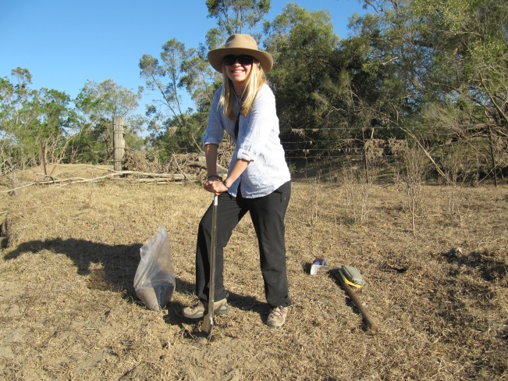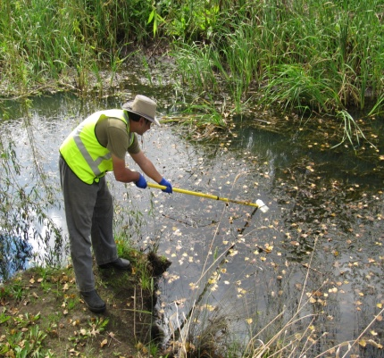
ERS381/581 Project Handbook for Environmental and Rural Science Students

Summary

This Handbook provides guidelines for Environmental and Rural Science students at UNE undertaking this dedicated project unit in their final year of study. It will also prove a useful guide for supervisors in designing/supervising project work for students.
The aim of this project is to synthesise both theoretical and practical components of the degree in a variety of areas. A unit of this nature is termed a ‘capstone’ unit in that it caps off or completes a range of other study areas, as well as providing a unifying effect in order to successfully undertake an integrated aspect of environmental or rural science. In particular it is meant to adopt a holistic approach in terms of providing a particular solution(s) that contribute(s) to the body of environmental or rural science work.
Undertaking an independent project is a vital component of learning that will benefit students and give them invaluable skills for the workplace. A properly structured project will supplement and integrate academic studies at UNE with practical application. The combined benefit of both forms of education (theoretical and practical) will enhance student experience and expertise for the benefit of all concerned.
This Handbook provides details of what is expected of students, as well as some suggestions as to suitable project work that can be undertaken and how it can be obtained. The Handbook will also be useful for supervisors to see what is expected of students so that they can structure such project work to produce beneficial outcomes for all concerned.

Contents
Summary i
1. Introduction 1
2. Rationale 1
3. Eligible Projects 1
4. Unit Objectives and Learning Outcomes 2
5. Unit Coordinator 3
Contact details 3
6. Roles and Responsibilities 3
6.1 The Student 3
6.2 The Supervisor 3
6.3 The Unit Coordinator 4
Key dates and milestones 5
7. Undertaking a Project 6
7.1 Project Plan and Timeline Form 6
7.2 Literature Review/progress report as appropriate 6
7.3 Project Report submission and assessment 7
7.4 ERS581 Students 7
7.5 Assessment 8
7.6 Withdrawal from the Unit 8
7.7 Special Extension of Time (SET) 8
7.8 Attendance Requirements for External Students 8
8. Format for Project Reports 9
8.1 General Format for Project Report 9
8.2 Typical Preliminary Pages of the Project Report 10
8.3 Tables Graphs, Maps and Photographs 11
8.4 Word Limit 12
8.5 Page Layout 12
8.6 Page Numbering 12
8.7 Referencing and Reference list 12
9. Administration and Forms 12
9.1 Forms 12
9.2 Plagiarism 13
9.3 Fraudulent misrepresentation and appeal process 14
9.4 Insurance 14

Introduction
This document provides the rationale and administration processes for undertaking a project in ERS381/581.
The Project unit provides students with the opportunity to produce substantive individual work. This unit is an important final-year unit in that it encourages students to demonstrate their investigative potential, ability and skills by working on a topic area that is of interest to them and to deliver outcomes in a timely manner.
The choice of topics must be made in consultation with an academic supervisor(s) and the Unit Coordinator before students enrol in the unit. It is the responsibility of the student to identify and confirm an academic willing to supervise their project. Key considerations in topic selection and approval are relevance to the degree and its learning outcomes and that it is a key area of interest for the student. Suggestions will be provided at the end of this document to provide students with some idea of the type and extent of projects.

Rationale
This unit is intended as a ‘capstone’ unit, which is meant to integrate a number of key knowledge areas of study undertaken up to this point. Such project work will afford candidates the opportunity to demonstrate their initiative, integration of skills and application of knowledge gained from the degree.

Eligible Projects
Eligible projects can range from a wide variety of areas, but must encompass aspects of the particular award (e.g. Environmental or Rural). In choosing a project, students should be mindful that the project has to be undertaken and completed in one trimester (by the end of trimester teaching weeks). Therefore, projects likely to be of longer duration or uncertain outcomes within the timeframe should not be undertaken.
An eligible project should be one that contributes to the body of knowledge. It should not merely be a report or a regurgitation of what others have done and applied to particular circumstances.
Typical projects could involve any or more of the following:
- Undertake an audit and prepare a management plan.
- Undertake a critical literature review.
- Undertake a monitoring programme.
- Provide a unique solution/investigation for a particular problem.
- Design and develop a tool to satisfy a particular problem.

Unit Objectives and Learning Outcomes
The objective of the Project is to provide students with the opportunity to demonstrate their capacity for research, independence, problem-solving, managerial and communication skills.
Upon completion of this unit, students will be able to:
ERS381
- demonstrate a broad and coherent theoretical and technical knowledge in the area of study;
- analyse, evaluate and interpret information and data in the area of study;
- communicate knowledge, skills and outcomes of research in the area of study; and
- demonstrate autonomy, sound judgement and responsibility in conducting and reporting on original research.

ERS581
- demonstrate a sound and coherent theoretical and technical knowledge in the area of study;
- analyse, evaluate and interpret information and data in the area of study to advanced level;
- clearly communicate knowledge, skills and outcomes of research in the area of study; and
- demonstrate autonomy, advanced judgement and responsibility in conducting and reporting on original research.

Unit Coordinator
The Unit Coordinator is responsible for approving topics proposed by students and supervisors, assisting in the arrangements for supervision, organising seminars if appropriate, and submission and collation of grades. The actual content and research undertaken is the responsibility of the student in consultation with the approved supervisor(s).

Contact details
Dr Martin Brummell mbrummel@une.edu.au

Roles and Responsibilities
Students need to maintain regular and frequent contact with all parties involved in their project, more so than what they may have done in previous units. Supervisors and students may find it convenient to schedule regular meetings, particularly in the early developmental stages, and then during data analysis and report preparation. Students should not hesitate in arranging appointments with their supervisor(s) and vice-versa.

6.1 The Student
It is the student’s responsibility to attend to the administration of this unit (milestones, deadlines, etc.) making this a priority. This involves the preparation of the literature review, final report etc. as well as submitting them to the supervisor(s) in reasonable time for comments to be made in time for submission by the due dates. Please ensure that a draft(s) of the final report is/are submitted to your supervisor in a timely manner to provide constructive feedback well before the final submission date. It is the student’s responsibility to ensure that an appropriately edited final report is submitted. If it is not edited adequately then you could be asked to re-submit a compliant report. You may have to get a third party to proof-read and edit your report before submitting.
Each student will find it necessary to negotiate with supervisors, technical and other staff to obtain advice, approval, booking of laboratory space, etc. in the performance of this unit. This is useful experience and practise for real-world situations that involved multiple points of contact and coordination with personnel with varying levels of responsibility and priority.

6.2 The Supervisor
The signing of Form A obliges the supervisor(s) to provide appropriate assistance to students and to ensure that every opportunity is provided for a student to complete the project report by the due date. To this end, the supervisor(s) must be satisfied that the topic is workable, achievable, generally self-contained and is likely to produce results, without exceeding the guidelines for time commitment for the unit.
Students are likely to be inexperienced in many aspects of project initiation, data collection and analysis of results. Consequently, supervisors should keep the following points in mind:
- Ensure the availability of equipment, resources, technical staff assistance etc. so that each student may use her/his time effectively throughout the teaching period;
- Be available for regular consultations and provide advice, criticism, direction and encouragement to each student;
- Ensure a clear marking framework is provided to the student suitable to the project in alignment with the generic marking rubric uploaded to Moodle, and
- Return the draft report to student with appended comments in a timely manner.
The supervisor(s) is/are required to comment on the literature review /progress report and draft final report in a timely manner for submission by the student by the due dates. The supervisor is required to request a suitable academic (internal or external to UNE) to mark the final assessment items. The marker should be in your discipline, ideally with experience with 3rd-year student assessments (ERS381) or postgraduate assessments (ERS581), and who can return the marks and feedback within 2 weeks. The marker should not be the supervisor.

6.3 The Unit Coordinator
The Unit Coordinator is responsible for all administrative matters and student affairs. The Coordinator shall approve the topic and arrangements for supervision, but is not responsible for the academic content and work load undertaken by each student.
The Unit Coordinator will:
- Facilitate students to find academic supervisors and projects. If students have difficulties finding projects or supervisors then they will be recommended to discuss this with employers, course coordinators and other ERS academic staff.
- Approve student enrolment in the unit, once the selected topic has been certified as acceptable by a supervisor(s) and the completed FORM A is submitted to the unit coordinator and then with your enrolment;
- attend to issues related to student experiencing any problems in relation to administration, issues with or for supervisors, or completing the unit by the due date;
- attend to applications for special extension of time and withdrawals;
- collation and submission of grades.
The Unit Coordinator may also arrange group meetings for students throughout the trimester to provide advice and information on unit administration, and for students to interact and update each other on progress.

Key dates and milestones
Item | Milestones – dates
Project plan and timeline (Form B) | End of Week 2 of teaching – submitted to Moodle site
Draft literature review or progress report as directed by supervisor | End of Week 5 of teaching – submitted to supervisor
Project report (Assessed item) | Last of Week trimester teaching (submitted to Moodle site by 5 pm on last day of that week)
ERS581 ONLY  Further work proposal (Form C) (Assessed item) | Last of Week trimester teaching (submitted to Moodle site by 5 pm on last day of that week)

Undertaking a Project
The objectives of the Project Report are to provide students with the opportunity to study a topic in depth, with emphasis on the completion of an experimental/investigative program; extensive data analysis or review; and to effectively communicate the outcome.

7.1 Project Plan and Timeline Form
Enrolment in this unit will be accepted only when the student has selected a topic, and gained approval (Form A) from an academic supervisor, the Unit Coordinator and their course coordinator. Enrolment must be completed at the commencement of the trimester for which enrolment is intended and FORM A completed, fully signed (by student, supervisor, and course coordinator), emailed to the unit coordinator and attached to your enrolment.
The Project Plan and Timeline Form (Form B) requires the student to provide the research question to be answered; a working title of the project; and an outline of what is envisaged for the proposed project, how this will be achieved and the associated timelines. The outline need not be specific at this stage; it is intended to show that the student has devised a project topic and considered both the content and direction of the project. Sufficient information should, however, be provided so that the supervisor can assess the workability of the project, estimate the amount of effort required and the time involved in achieving the objectives.
The Project Plan and Timeline form (Form B) must be signed by the student and project supervisor(s) and submitted to the Moodle site by the end of Week 2 of teaching. The intention of the form is to inform the Unit Coordinator that each student has a project defined and the supervisor agrees with this before it is too late in the trimester. Failure to submit a form by the due date will result in cessation of student enrolment.

7.2 Literature Review/progress report as appropriate
Many projects require some component of literature review (this may in fact be the purpose of your whole project). This is intended to familiarise students with the literature on theoretical and practical aspects of their project. The review should be a critical account of the literature pertinent to the project area, and should satisfy the following criteria:
- Introduction to the topic
- coverage of literature
- critical analysis of current status of the problem
- appropriate referencing.
Students are expected to consult current primary reference material such as journal articles and conference papers. The literature review is expected to be approximately 15-20 A4 pages at one and half spacing. For students whose project is a full critical literature review, then a progress report should be submitted at this stage.
In some cases a literature review is not appropriate and a progress report should be prepared as a measure of outcomes at this stage. Please inform the unit coordinator if and why a literature review is not appropriate for your project.
The literature review/progress report should be submitted electronically to the Supervisor for feedback. This is due at the end of Week 5 of teaching but can be submitted earlier. This not assessed but used by the supervisor to provide project feedback to the student.

7.3 Project Report submission and assessment
All students are required to submit one electronic copy (pdf) (6000 words) to the Moodle site by the due date (end of last week of trimester teaching). The supervisor may also request the electronic copy and the word version but that is on an individual project basis. Process for late submission is in accordance with School policy – links can be found on Unit moodle homepage.
The project report will be examined by an academic identified by the supervisor and the mark, grade and feedback (which could include marked up reports) submitted to Moodle in a timely manner. Assessment is undertaken in accordance with UNE Assessment Policy guidelines and may include the following matters:
- Abstract or summary
- adequacy in defining the aim or objectives
- value, accuracy and criticism offered in the literature review or background to the study, including failure to cite key research papers
- experimental and/or survey design (where applicable)
- originality of approach and analysis (where applicable)
- data analysis and presentation of results
- discussion of findings and justification of conclusions
- adequacy of proof-reading
- correctness of reference citations, and/or
- overall organisation and presentation.
A marking rubric for ERS 381 and for ERS 581 is provided on the unit Moodle page and this will be considered as appropriate to project by the marker. Project Reports, like other units within the degree, will be graded with a % mark and a grade from HD through to N. A failure may result, not only from poor work, but also from application of a penalty for late submission.

7.4 ERS581 Students
ERS581 - Students enrolled in this unit as ERS581 will be assessed on a second item that will consist of a Project Proposal for Further Work (1500 words) (Form C). This will provide a synthesis of the project work undertaken and its outcomes, a proposal for future work needed to address remaining knowledge gaps and the significance of this. This must be prepared on the template provided (Form C) and submitted to the Moodle site electronically.
This will be marked by a suitable academic (but not supervisor) in accordance with UNE Assessment Policy guidelines and will take into account:
- the student's ability for advanced understanding of the topic, its significance and knowledge needs and to apply expert, specialised cognitive skills in assessment;
- ability to critically evaluate and reflect on their topic;
- high level communication skills for a specialist and non-specialist audience.

The assessment will be graded with a % mark and a grade from HD through to N. A marking rubric is provided on the unit moodle page.

7.5 Assessment
Students enrolled in this unit will be assessed on the basis of one (ERS381) or two (ERS581) graded assessment items. Contribution to overall assessment for the unit will comprise:
- ERS381 Project Report (100%)
- ERS581 Project Report (80%); Future Work Proposal (20%).

7.6 Withdrawal from the Unit
Students are permitted to withdraw from the unit without failure, provided they do so according to UNE policy and timelines.

7.7 Special Extension of Time (SET)
Each application for a Special Extension of Time (SET) lodged with the Student Administration Centre must be supported by appropriate documentation (e.g. medical certificates, statements from supervisors confirming circumstances beyond the student's control only). Assessment will follow UNE policy.

7.8 Attendance Requirements for External Students
There are no formal residential schools or attendance requirements, but experience has shown that the greater the degree of contact between academic staff and students the better the overall project. The frequency of visits to UNE for external students will depend to a large degree on the nature of the project itself. Students may consider on-campus visits at other key times during the unit. Suggested critical periods could be:
- just before data collection begins (to verify proposed procedures are appropriate);
- during data analysis (particularly if students are uncertain as to the appropriate techniques or are considering using UNE laboratory or computer facilities); and
- during report preparation (to discuss results and seek advice on the most appropriate ways for presenting the results and the report as a whole).

Format for Project Reports

8.1 General Format for Project Report
Project reports may take the form of a scientific report; a scientific paper, a management plan, or a literature review. A project report is usually presented in chapters with each chapter starting on a new page but it is not necessary to follow this format for every project. In some cases the body of work could be presented in a form suitable for submission to a peer reviewed journal (e.g. developing a new technology) accompanied by the final literature review submitted as a combined final document. The most appropriate format is a matter between the student and the supervisor.
Remember a literature review must not be a simple reproduction of the ideas of others, but it must be reviewed and compared. The material from sources may be examined in relation to good points and strengths; bad points and weaknesses; omissions; obscurities and ambiguities; and biases due to viewpoint.
The body of the text should be presented in chapter/section form with sub-sections identified by appropriate sub-headings. This procedure will aid students to achieve a logical presentation of their material. Chapters/sections should be numbered in sequence, preferably using a decimal system.
A typical project report could comprehensively cover (but need not be limited to) the following points:

(1) About the project:
- Introduction – what the project is about, how it came about
- Detailed scope statement of project(s) and tasks to be undertaken
- Background to the project, including literature review
- Aims and objectives
- Plan of approach to undertaking the project,

(2) What was done and how it was done:
- Equipment used
- Techniques used
- Procedures used (where these are not confidential)
- How did these fit with the original plan? Were changes necessary, if so, what and why?
- Supporting material such as photographs (as necessary).

(3) What the outcomes were:
- Results of the project
- Discussion of the results and application
- Conclusion
- What have you contributed to the body of knowledge?

8.2 Typical Preliminary Pages of the Project Report
Title Page
The title page is the first page after the cover. It is not numbered.
The title page must show the following information:
- title of the project
- full name of the student
- month and year of submission
- the award statement.
A [insert unit code] project report submitted in partial fulfilment of the requirements for the [insert award title in full] at the University of New England.
Declaration Page
The next page after the title page is the declaration page. It is not numbered.
I certify that the substance of this project report has not already been submitted for any degree or diploma and is not being currently submitted for any other degree or diploma.
I certify that, to the best of my knowledge, any help received in preparing this project report, and all sources used, have been acknowledged in this report.
I certify that this project report does not exceed (insert word limit for the unit) for the text, excluding tables, figures, appendices and reference list.
____________________________
(Signed and dated)
Completion of the Academic Integrity Module may be considered as a declaration of the above - see 10.2
Acknowledgements
The Acknowledgements is numbered as a preliminary page and commences with page i.
Students may wish to acknowledge those people and organisations that have assisted them in their project report and work associated with their studies. The style and format is flexible and is at the discretion of each student.
Table of Contents
The Table of Contents commences on page ii.
Single line spacing may be used for the Table of Contents.
Chapter 1 Chapter Heading
1.2 Section headings called subheadings
1.2.3 Lesser titles called sub-subheadings
The last chapter is the references cited. Appendices follow the References.
The Table of Contents need not show items below sub-subheading level (in other words, three levels of headings).
Include the following lists (if relevant) at the end of the Table of Contents
- Appendices
- List of Tables
- List of Figures.

Abstract
In about 350 words (No more than 500) summarise the whole report. That is, say:
- why the study was undertaken (i.e. the problems and issues being addressed, placing them in the wider context or "setting the scene” for the study and ending with a brief statement of the purpose of the study);
- how it was undertaken (i.e. a brief statement about the methods used in the study);
- what were the main findings (i.e. the results); and
- the significance of those findings (i.e. the conclusions).
An abstract needs to be concisely informative and encourage the reader of the abstract to continue with reading of the report. You should avoid expressions such as "is discussed" and "is described" because they do not provide the reader with the sufficient detail.
The abstract should be restricted to about one page in length for a report of this size.

8.3 Tables Graphs, Maps and Photographs
Data and results may be presented in either tabular or graphical form, but the same results must NOT be presented as both tables and graphs as this represents duplication. It is often preferable to present data as figures rather than tables as the former usually allow the examiner/reader to obtain a quicker understanding of the results. Graphs must be clear with axes labelled with the name of the variable, its unit and magnitude. If you are in doubt as to the most appropriate form for data presentation, consult your supervisor. Try to avoid presenting masses of numbers in large tables as they often take a great deal of time to comprehend. Several small tables may provide a more appropriate format and are often much more effective. Raw data are unacceptable in the body of the report. Only synthesised data are to be presented, that is data that has been analysed, preferably statistically.
Each figure or table must be accompanied by a caption that must be reasonably self-explanatory without having to refer to the text. The usual convention is to have the caption at the top for tables and at the bottom for figures.
Tables, figures, photographs etc. should be inserted in the report as they occur. The convention adopted is to have tables and figures on separate pages immediately following the first mention in the text and not within the body of the text itself.

8.4 Word Limit
The word limit for the project report is 6000 words, excluding tables, figures, appendices and the references. You may be penalised if you go over the word limit significantly.

8.5 Page Layout
In terms of format, the margin on the left-hand side must be 25 mm. All other margins must be 20 mm. Line spacing in the body of the text must be 1.5 line spacing using Times New Roman size 12. The reference list may be single spacing with hanging indents. Line spacing in tables may be varied so that large tables can be placed on one page. Try to avoid splitting tables between pages.
Ensure maps are reproduced well and graphs easy to read.

8.6 Page Numbering
All pages (not including the title page) shall be numbered consecutively; in lower case Roman for the preliminary pages, in Arabic for the main text (i.e. from the Introduction to the end of References). Tables are traditionally numbered and labelled with the caption above the table, while figures are labelled with the caption below the figure. Appendices are often labelled with upper case letters (not numbers) to distinguish them from pages; pages, tables, figures etc. are numbered separately in each appendix.

8.7 Referencing and Reference list
Citations and references must be formatted in an appropriate style agreed with the supervisor. This may be APA style or a specific journal style.

Administration and Forms

9.1 Forms
All forms referred to in this document (A to C) are available on the Moodle site under ERS381/581 Project Report in Environmental and Rural Science.
The completed project proposal form (Form A) should be lodged through the Unit Coordinator and with your enrolment. It is important that students get their application form in before the intended trimester for the project so that proposals and supervisors can be approved. Form A is available preceding unit enrolment from the Unit coordinator and at the Project Handbook link in ERS381/581 Unit Information on the Course and Unit Catalogue on the UNE website.
Unsatisfactory forms and proposals will be returned to the student for rewriting until an acceptable outcome is achieved. Such rewriting could delay student progress and enrolment.

9.2 Plagiarism
There are several resources available to help students understand what plagiarism and academic misconduct are. These may be found at:
http://www.une.edu.au/current-students/resources/academic-skills/plagiarism
The Student Coursework Academic Misconduct Rule states that students have a responsibility to complete the Academic Integrity Module (AIM), which covers the rules of academic integrity, essential for successful and ethical study practices at UNE. The AIM educates students about these rules, what the University means by the term “plagiarism”. Completing the AIM is one small step towards achieving and demonstrating the UNE graduate attribute of social responsibility, which involves behaving with personal and professional integrity in academic and other contexts.

Access to the AIM is provided alongside other units on students’ Moodle My home page. The link to the AIM site will remain on students’ Moodle pages while they are enrolled at UNE to allow continued access to the information.
All assessment items for ERS381/581 must be submitted through the University’s e-Submission system at the link provided on the Unit Moodle page. You cannot submit your assessment items unless you have completed AIM. Please be aware that when you submit an assignment through the University’s e-Submission system you are deemed to have signed a plagiarism declaration form agreeing that for the assignment you have complied with the UNE Academic Misconduct Rule policy.

9.3 Fraudulent misrepresentation and appeal process
The Student Coursework Academic Misconduct Rule and Procedures (http://www.une.edu.au/current-students/resources/academic-skills/plagiarism) describes the process followed if a student is detected as fraudulently misrepresenting the project work submitted for assessment.

9.4 Insurance
Details of student insurance coverage are available from the Unit Coordinator, School Academic Coordinator or School web page under ‘For our students’. Supervisor will also advise on procedures and insurance required for the type of project.

