This plan is enacted when a BUSH FIRE situation is declared and the level of risk to personal safety, property or environment is an immediate risk to escalate. This plan relates to the response of staff and students to a critical incident and supports the Emergency Management Plan (EMP) that exists for the individual buildings.

The University of New England’s’ Academic and Bellevue Campuses are located on Armidale’s North Western urban fringe on 500 acres. In addition to this UNE has 7 farms (Kirby, Laureldale, Maxwelton, Newhome, Tullimba, Trevanna and Toombs) totalling 8,600 acres, located north and to the west of Armidale.
The topography ranges from flat to steep hilly country with varying fuel loads dependant on the seasons and stocking rates. In recent years extended dry spells have seen high curing rates which can exacerbate fire danger potential as represented by frequently high Fire Danger Index (FDI). As with the nature of the University environment, not all farms are stocked to their potential at all times and this can also lead to higher fuel loads.
Immediate Actions:
Alert Phase
During a bush fire, Alert Levels are used to give stakeholders an indication of the level of threat from a fire.
During the designated “Bush Fire Season” all UNE staff should remain alert for the potential of a bushfire impacting upon the University and/or surrounding community.
Remember – don't wait for a warning. Some fires start and spread so quickly there may not be any time for a warning. If you get a Bush Fire Alert, you must take it seriously. Failure to take action can result in death or injury to you or your family members.

There are three levels of Bush Fire Alerts that the NSW Rural Fire Service use:
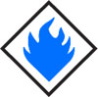
Advice
A fire has started. There is no immediate danger. Stay up to date in case the situation changes.
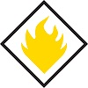
Watch and Act
There is a heightened level of threat. Conditions are changing and you need to start taking action now to protect you and your family.
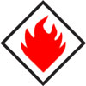
Emergency Warning
An Emergency Warning is the highest level of Bush Fire Alert. You may be in danger and need to take action immediately. Any delay now puts your life at risk.
For some fires, you may hear a warning message over your radio or television, such as a siren, or you may receive an Emergency Alert text message or phone call. Other fires may start so quickly that there will be no time for any warning at all.
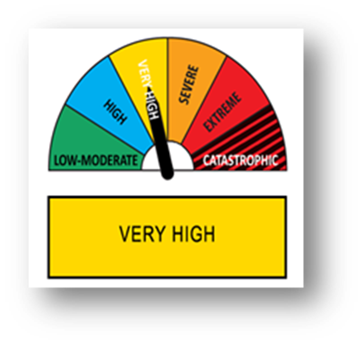
Fire Danger Ratings are rated as LOW-MODERATE, HIGH, VERY HIGH, SEVERE, EXTREME or CATASTROPHIC for the area potential of bushfire within the local government area.

Evacuation or Stay & Defend
Bushfire conditions can create a danger to human life and/or property; this may be from direct heat or from by- products such as smoke and poor air quality.
Following consultation with the appropriate combat agencies, Fire and Rescue NSW (FRNSW), NSW Rural Fire Service (NSWRFS) and Police, the level of response may be escalated to Evacuation by the Chief Warden.
Bushfire activity may be such that it is more dangerous to evacuate than to stay and defend. If the facility is under immediate threat follow directions from the Chief Warden and combat agencies.

Evacuation
The decision to evacuate a facility will be made in direct consultation with the Chief Warden, and FRNSW, NSWRFS, Incident Controller or the Police.
There will be many factors that will influence the decision to evacuate UNE, they include the following:
- Location of the Bushfire in relation to the University Campuses or UNE Farms.
- Road access and road closures (actual or potential) www.livetraffic.com/desktop.html
- Fire Danger Rating.
- Predicted weather conditions www.bom.gov.au/nsw/forecasts/armidale.shtml
- Current Bushfire Alert (Alert – Watch & Act – Emergency Warning) www.rfs.nsw.gov.au/fire-information/fires-near-me
- Availability of transport www.armidale.info/transport.htm
- Availability and reliability of essential infrastructure e.g. water & power supply.
- Advice of Emergency Services (FRNSW, NSWRFS and Police) through media.
Information sources include:
NSW Rural Fire Service Website: rfs.nsw.gov.au
Fire Danger Ratings: rfs.nsw.gov.au/fdr
radio, local ABC/emergency broadcaster frequency, TV, newspapers
facebook.com/nswrfs
twitter.com/nswrfs
Note: The order to evacuate may also come direct from the Local Emergency Operations Controller (LEOCON) and/or District Emergency Operations Controller (DEOCON).
Each work area at UNE may have different threat levels depending on the surrounding environment. For example;
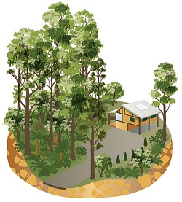 | I work in an area surrounded by bush  What to expect:  - Fires in dense bushland can be very hot, intense and fast moving. Burning embers may be blown from the bush, landing on property and starting spot fires or setting fire to your property. Embers may lay and burn for many hours, even after the main fire front has passed. Smoke and fire may affect roads, making it difficult to leave. The radiant heat from a fire nearby may set fire to your building or surrounds.
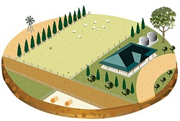 | I work close to grassland or paddocks  What to expect:  - Grass fires can start easily and spread quickly, not only destroying buildings but also crops and endangering livestock. Grass fires are very hot and can produce huge amounts of heat which can kill anyone out in the open. As grass dries out or cures, it can catch fire more easily. Fires in tall grass will have tall flames that may burn across trails, roads or fire breaks. Grass fires can move much faster than a bush fire, catching people off guard.
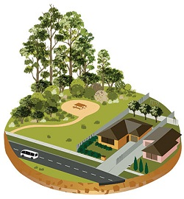 | I work in an area where the bush or grasslands meet built-up areas  What to expect:  Fires can spread quickly from parks and reserves, threatening your office, fences or gardens. Thick smoke from the fire might make it difficult to see or breathe. Even if you work a few streets back from the bush, you are at risk from ember attack.

Neighbourhood Safer Places
Neighbourhood Safer Places are a place of last resort during a bush fire emergency. They are to be used when all other options in your bush fire survival plan can't be put into action safely.
You should be aware of any Neighbourhood Safer Places in your area. You should also know how to get there, as well as alternate routes in case the road is blocked or too dangerous to drive on.
Not all areas will have a Neighbourhood Safer Place. If there is no Neighbourhood Safer Place in your area, you should identify other safer locations you can go to as a last resort. This might include a nearby building which is well prepared, or oval which is well away from the bush.
A Neighbourhood Safer Place is designed as a Place of Last Resort in bush fire emergencies only. Please note that travelling to, or sheltering at a Neighbourhood Safer Place does not guarantee your safety.

On Site Safer Places
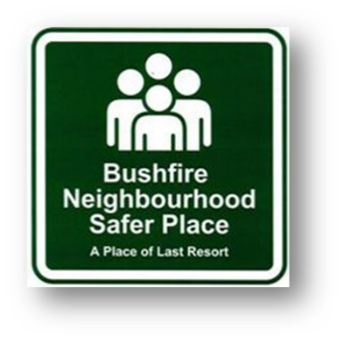
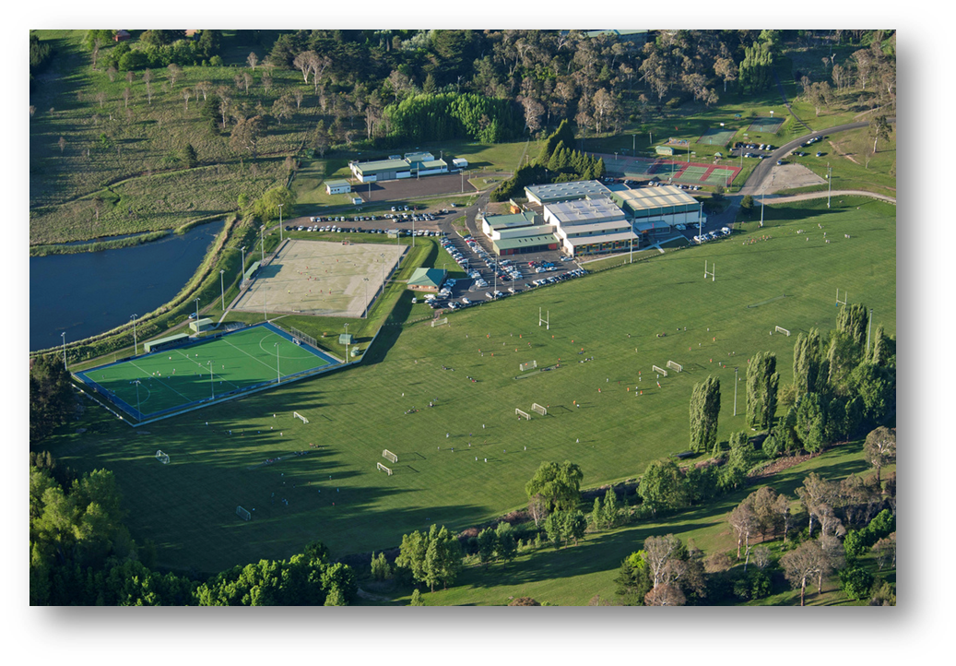

Title | Campus | Location | LGA
SportUNE | Academic | Sports Union Rd, Armidale | Armidale Regional
Bellevue Cricket/AFL Oval | Bellevue | Meredith Rd, Armidale | Armidale Regional
Bellevue Rugby Oval | Bellevue | Meredith Rd, Armidale | Armidale Regional

Off Site Safer Places

Title | Type | Location | LGA
Armidale Showground | Open Space | 5 Dumaresq St, Armidale | Armidale Regional

Protect the life of your fellow student or staff member
Ring ‘000’ and Safety and Security 6773 2099.
Alert others in your immediate area to the danger, and act together for the benefit of everyone. Try to identify the safest escape route.

Stand Down
Once the threat to persons and property is no longer deemed to be high risk, and following consultation with the appropriate combat agencies (FRNSW, NSW RFS & Police), the Chief Warden will decide to return to the facility.
In the event that the facility or surrounding area has been impacted upon by bushfire it may be necessary to have a full site evaluation completed prior to returning to the area. This may include consultation with FRNSW, NSW RFS and Facilities Management Services.

NB: Some Images and information from NSW Rural Fire Service Website www.rfs.gov.au

