University of New England

Title
HDR Candidate’s full name
Academic Qualifications of the HDR Candidate: Degree and University/Institution

A thesis submitted for the degree of <award for which the thesis is submitted e.g., Doctor of Philosophy> at the University of New England in <year>
Optional - School of <name of enrolling school>

<All candidates in receipt of Australian Stipend and/or Tuition Fee Offset must include the following> - This research has been conducted with the support of the Australian Government Research Training Program Scholarship

Abstract
<Brief summary (approx. 300-400 words) of research findings including research question/objectives, methodology, and a statement of argument and contribution to the field >

Declaration/Certification by Author
This thesis is composed of my original work, and contains no material previously published or written by another person except where due reference has been made in the text. I have clearly stated the contribution by others to jointly-authored works that I have included in my thesis.
I have clearly stated the contribution of others to my thesis as a whole, including statistical assistance, survey design, data analysis, significant technical procedures, professional editorial advice, and any other original research work used or reported in my thesis. The content of my thesis is the result of work I have carried out since the commencement of my higher degree by research candidature and does not include a substantial part of work that has been submitted to qualify for the award of any other degree or diploma in any university or other tertiary institution. I have clearly stated which parts of my thesis, if any, have been submitted to qualify for another award.
I acknowledge that an electronic copy of my thesis must be lodged with the University Library and, subject to the policy and procedures of the University of New England, the thesis be made available for research and study in accordance with the Copyright Act 1968 unless a period of embargo has been approved by the Dean of the Graduate Research School.
I acknowledge that copyright of all material contained in my thesis resides with the copyright holder(s) of that material. Where appropriate, I have obtained copyright permission from the copyright holder to reproduce material in this thesis.

_______________________ _____________________
Candidate Name Date

Publications during candidature

Publications included in this thesis

Contributions by others to the thesis (names and percentage)
Author’s Name (please print clearly) | % of contribution

Statement of parts of the thesis submitted to qualify for the award of another degree – if applicable

Acknowledgements

Table of Contents

Abstract i

Declaration/Certification by Author ii
Publications during candidature iii
Publications included in this thesis iii
Statement of parts of the thesis submitted to qualify for the award of another degree – if applicable iii

Acknowledgements iv

Table of Contents v

Chapter One: Introduction 1
Subheading 1 (numbered 1.1) 1
Subheading 2 2

Chapter Two 4

References 5

List of Figures (Table of Figures) 6

List of Tables 7

Appendices 8

TIP: The Table of Contents should update automatically but if it doesn’t, go to the tab ‘References’ and click ‘Update Table’. Select ‘Update entire table.’ For more information about a Table of Contents in Microsoft Word please follow the link below.
https://support.microsoft.com/en-us/office/insert-a-table-of-contents-882e8564-0edb-435e-84b5-1d8552ccf0c0

Chapter One: Introduction
This template uses Microsoft Word Styles to maintain consistent formatting. Chapter titles are formatted using the style called ‘Chapter title’. You can click on the heading and modify to suit your thesis chapter titles.
This body text is formatted in the style called ‘Normal.’ You can copy and paste your text into this template and then apply the ‘Normal’ style to it. Alternatively, you can use this template and type directly into it.
You can add and modify these Styles to suit your disciplinary norms and the nature of your research project. To learn more about applying and modifying Microsoft Word styles, please the resources below.
Learn how to apply Styles: https://support.microsoft.com/en-us/office/apply-styles-f8b96097-4d25-4fac-8200-6139c8093109
Customise and modify Styles: https://support.microsoft.com/en-us/office/customize-or-create-new-styles-d38d6e47-f6fc-48eb-a607-1eb120dec563#:~:text=On%20the%20Home%20tab%2C%20right,or%20to%20all%20future%20documents.
Section breaks are used to keep spacing between sections and chapters consistent. More information about section breaks can be found here: https://support.microsoft.com/en-us/office/insert-a-section-break-eef20fd8-e38c-4ba6-a027-e503bdf8375c
If you would like to see where sections breaks are in this document, go to the ‘home’ tab and click on the ‘non-printing character’ icon, which looks like a backwards ‘P.’

Subheading 1 (numbered 1.1)
Subheading 1 is formatted using the style called ‘Subheading 1’. Return to normal text to type body paragraphs under your subheading.

Subheading 2
Subheading 2 is formatted using the style ‘Subheading 2’.

Subheading 3
Subheading 3 is formatted using the style ‘Subheading 3.’
Figure 1.1
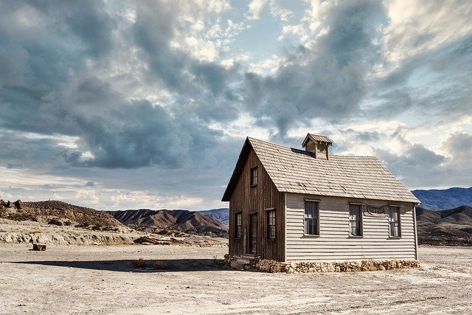
Captions for images must be provided and be informative with adequate definition of characters, symbols, etc. used in the table or figure. Figure captions (ie for diagrams, photographs or other illustrations) are always placed below the figure. Recommend font size should be no less than nine (9) points. This will visually separate these items from the main content. Don’t forget to include a reference if your image comes from elsewhere. This caption uses the ‘captions for images and tables’ Style. The title uses the ‘Figures and Tables title’ Style.

Table 1.1
Table captions are always placed above the table, the table text can have a font size ranging from 10 to 12 depending on volume of content within the table.

Chapter Two

References

List of Figures (Table of Figures)

List of Tables

Appendices

