Research in the School of Law at the University of New England

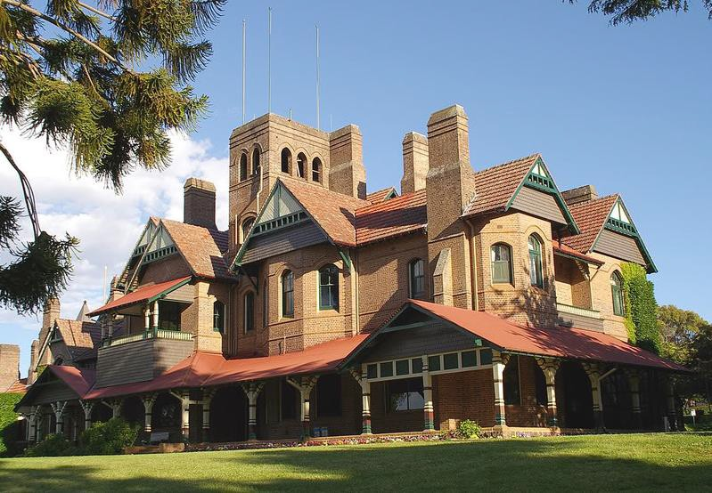The University of New England, with its roots going back to the 1920s as a University College of the University of Sydney, has a long tradition of scholarship and research being carried out by its academic staff. The School of Law takes pride in continuing this tradition. Members of the School are engaged in innovative research in a variety of doctrinal, historical, theoretical, and law and policy research areas. Many members of the School have national and international
reputations in their fields and more junior members are encouraged to present their work in both journals and at conferences. At the School of Law, research is no add-on: it is fundamental to what we do. Because of our location and our status as Australia’s first regional university, a major strand of research has a strong connection to areas of interest to regional communities and is highlighted in a separate document.

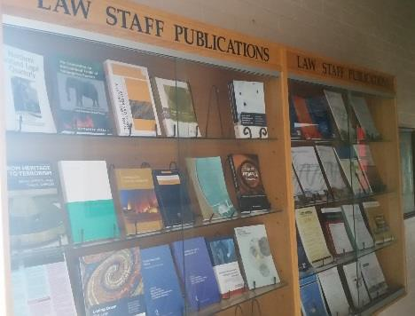Outside of the Centre for Agriculture and Law, the School has research strengths in many areas. One such area is legal history where one UNE researcher has been Chief Investigator on three Australian Research Council grants since 2011. UNE researchers are invited presenters at legal history conferences nationally and internationally (e.g. the Forbes Legal History Lecture, the leading legal history lecture in Australia, and international legal history symposiums). This research expertise is spread across staff at all levels and across a wide spectrum.

University of New England, Armidale, AUSTRALIA
CRICOS Provider Code: 00003G

Our staff have international reputations in many areas including intellectual property, legal education, legal ethics, information technology law, family law, international law, torts, constitutional law, regulatory law, and military and maritime law. This strength is evidenced by the international awards and grants made to, and roles undertaken by, UNE researchers in
these areas: these include Marie Curie and Max Weber Fellowships, appointments as stream leaders at major international organisations such as the British Socio-Legal Studies Association, and Research Fellowships and visiting appointments at leading research centres in Australian universities (such as the Centre for Media and Communications Law, University of Melbourne, and RegNet at the ANU). UNE researchers also hold memberships of prestigious scholarly societies (e.g. as the only Australian member of the World Tort Law Society), are invited witnesses to legislative review committees (e.g. COAG Committee on Counter Terrorism Legislation) and have been part of successful research teams awarded funding by international bodies (e.g. CAD$1.6 million from Canadian research agencies including the Natural Sciences and Engineering Research Council, for interdisciplinary law and computer science research). Our staff are also regularly invited to present at international conferences. Our staff also act regularly as reviewers for leading Australian and international law journals and act as assessors for Australian and international grant awarding agencies.

Further details are available here http://www.une.edu.au/about-une/academic-schools/school-of-law/research.

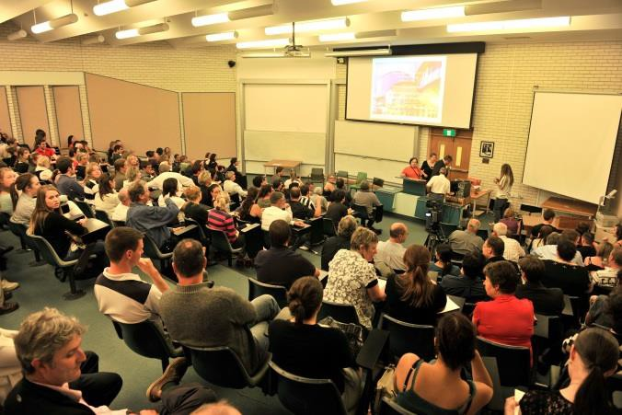A number of UNE staff have been invited to present lectures at overseas universities
e.g. in India, Sri Lanka, Thailand, and China. For instance, in China these include Renmin University, China University of Political Science and Law, Fudan University, Sichuan University, East China University of Political Science and Law, Jilin University, and Huazhong University of Science and Technology Law School.

The School of Law welcomes expressions of interest from students wishing to study for an LLM or PhD and from any scholar interested in collaborative research.

School of Law, University of New England Phone: 61 2 6773 4578
Armidale NSW 2351 Email: law.enquiries@une.edu.au
Australia www.une.edu.au/about-une/academic-schools/school-of-law

