Humanities, Arts & Social Sciences Research Seminar

9.30-10.30am Friday 4 October 2019

Giulia Torello-Hill presents

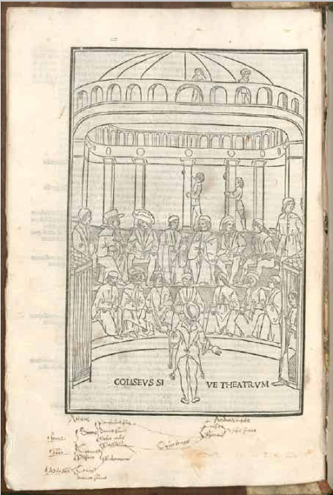

Terence, Comedies (Venice, Lazzaro de’ Soardi, 1499), 2 Inc.c.a. 3548, fol. 6v, Bavarian Library, Munich

Illustrating Terence:
Lazzaro de’ Soardi and the legacy of his Venetian edition

The first Italian illustrated edition of the comedies of Roman playwright Terence appeared in Venice in January 1497 at the press of Giacomo Pencio. The mastermind and financier of this enterprise was Lazzaro de’ Soardi, who printed subsequent editions of Terence in 1499, 1504, 1508 and 1512. Considered merely a replica of the better-known Lyon Terence (1493), these Venetian imprints have received very little attention from scholars. This paper outlines the aspects of originality of this edition and explores its legacy on the Italian and French sixteenth century markets. The appearance of the printed editions of Terence coincides with the revival of classical drama at the court of Ercole I in Ferrara and with a resurgence of interest in ancient performance practice that paved the way to the development of Italian early modern drama. This study demonstrates how the illustrative tradition of Terence that draws upon a cycle of magnificently illuminated Carolingian manuscripts kept thriving and developing in the fifteenth and sixteenth centuries through the competitive and transnational printing market. A detailed study of illustrated printed editions of Terence can give us an insight into how classical drama was understood, read and performed in early modern Italy and France.

Giulia Torello-Hill is a Lecturer in Italian at the University of New England. Her research explores the interplay between exegesis of ancient texts, iconographic tradition and performance practice in Renaissance Italy. She has held fellowships from Villa I Tatti the Harvard University Centre for Italian Renaissance Studies in Florence (2015-16) and the Renaissance Society of America and Kress Foundation (2018). Her current book project is an interdisciplinary study of the illustrated printed edition of the plays of Terence published in Lyon in 1493 (co-authored with Andrew J. Turner). Funded through an ARC discovery project this monograph study is due to appear in Brill’s Drama and Theatre in Early Modern Europe series in 2020.

Oorala lecture theatre, Oorala centre
Followed by morning tea - all welcome
Enquiries to: Karin von Strokirch - kvonstro@une.edu.au

