Humanities, Arts & Social Sciences Research Seminar

9.30-10.30am Friday 27 September 2019

Katie Chambers presents

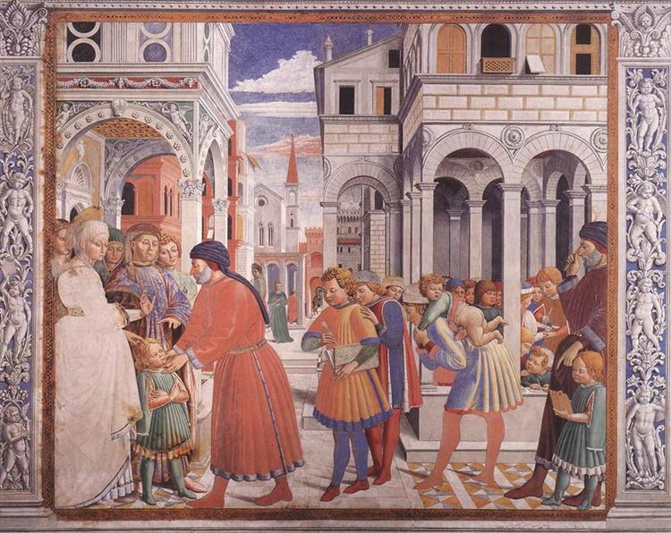

The School of Tagaste, Benozzo Gozzoli (1464-65), Church of Saint Augustine, San Gimignano, Italy
Source: wikiart.org, Visual Art Encyclopedia, Public Domain.

Faith and philosophy: Augustine of Hippo and Neoplatonism

Augustine, Bishop of Hippo, was born in 354CE in Thagaste, now Souk Ahras, Algeria. This part of North Africa had been part of the Roman Empire for about five hundred years. With the conversion of the Emperor Constantine to Christianity in 312 and the Council of Nicaea in 325, the tide had turned in favour of Christianity in the Roman world. The Emperor Theodosius issued the Edict of Thessalonica in 380 which made Christianity the Empire’s official religion. Augustine himself, however, only converted to Christianity in 386 at the age of 32. Spending almost his entire life in North Africa, he became arguably the most influential Christian thinker in the Latin West, shaping Christian thought in late antiquity and the Middle Ages, and respected by Protestant and Catholic theologians alike in the modern period. His ideas continue to be seriously studied, debated and reworked today. His best-known works are Confessions and City of God. This paper looks at Augustine’s attitude towards non-Christian philosophies, particularly Platonism, which underwent a revival in the third and fourth centuries in the Greek-speaking part of the Empire under the influence of the philosophers Plotinus and Porphyry. I am particularly interested in Augustine’s ethics and in reading Augustine as a defender of the idea of natural morality, meaning the idea that morality exists independently of God. This reading stands in opposition to the prevailing view of Augustine among modern scholars, who either love or loathe him for his defence of a Christ-centred morality which made virtue dependent on Christian faith and divine grace. For many scholars, to call Augustine a defender of natural morality is to convict him of Pelagianism, the heresy that he spent the last twenty years of his life combatting! This paper explores an alternative reading of Augustine’s ethics and asks what it meant for his view of Stoicism, Manicheanism and particularly Platonism, the ancient philosophy which he admired most.

Katie Chambers holds a Ph.D. from the Divinity Faculty, University of Cambridge. In recent years she has lectured at the University of Winchester, UK, and the University of Notre Dame, Sydney. She works casually for the School of HASS at UNE and is studying a Master of Teaching (Secondary) at UNE. She is writing a monograph: Augustine of Hippo on the Nature of Sin and Virtue.

Oorala lecture theatre, Oorala centre
Followed by morning tea - all welcome
Enquiries to: Karin von Strokirch - kvonstro@une.edu.au

