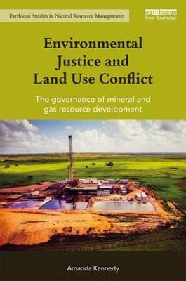
Natural resources conflict
Conflict over resources and interests is pervasive, and the law is often involved. However the sources and dynamics of rural conflict are surprisingly little researched, and institutional arrangements are often ineffective. Our research in this space is focused upon innovations to avoid or manage such conflicts, including shared governance arrangements, more effective methods of community engagement and public participation.
Associate Professor Amanda Kennedy leads the Centre’s research on managing land use conflict, largely funded by an Australian Research Council Discovery Early Career Researcher grant, and more recently, a Discovery Grant (in conjunction with UNSW and Griffith University). Her research findings have been presented at a range of international conferences, including the IUCN Academy of Environmental Law Annual Colloquium, the International Rural Sociology Conference, and the Global Network for the Study of Human Rights and the Environment Symposium. Associate Professor Kennedy has recently published a book on case studies of land use conflict from the perspective of environmental justice, ‘Environmental Justice and Land Use Conflict: The Governance of Mineral and Gas Resource Development’, with Routledge.

Study opportunities

Further to our research projects, we also offer a number of postgraduate study opportunities for students, including:

- Master of Natural Resource Governance
  - For students from a range of disciplines, provides an opportunity to focus on the law and institutional arrangements relating to natural resource governance. This unique program, whilst grounded in law, also looks to the social context of natural resource law and policy. It has a strong focus on strategy and strategic thinking, and encourages students to think critically about the role of the law in regulating natural resource use. In addition to foundation subjects in law, students have the ability to specialise in a range of areas relevant to natural resource management and policy, including various biophysical sciences, environmental advocacy and education, and environmental psychology.
- Master of Laws (LLM) (Major in Natural Resource Governance)
  - For both Australian and international law graduates, provides an opportunity to specialise in natural resource governance law and policy.
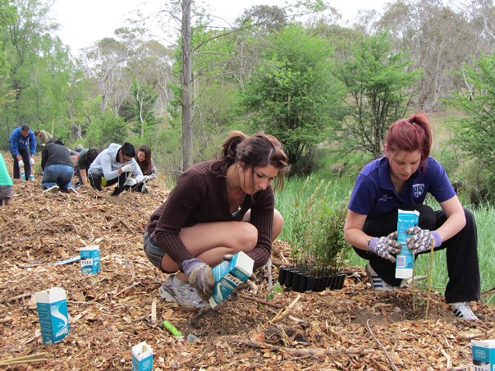
- PhD
  - There are also opportunities for higher degree research students to conduct comparative studies of natural resource governance. Shared interests in areas such as agricultural land use provide a unique opportunity for students.

University of New England, Armidale, AUSTRALIA CRICOS Provider Number 00003G

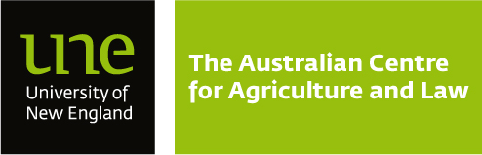

The Australian Centre for Agriculture and Law
The Australian Centre for Agriculture and Law specialises in researching the rules and governance arrangements that affect rural industries, people and the environment. The Centre is particularly focused on natural resource governance, conflict, social welfare (particularly of Indigenous people) and the governance of rural innovation. The team at the Centre supervise doctoral and masters research topics, and work closely with research collaborators in many countries.
The current team is 3 staff researchers, 4 postdoctoral researchers and an administrator. As well as doctoral students, we have an effective team of adjuncts and collaborators from industry, government and civil society, who work closely with us.
Recent funded projects address the future of natural resource governance, the control of invasive animals, natural resources conflict, Indigenous people’s welfare, and research methods to improve natural resource governance.
This document highlights just some of our key research areas, and study opportunities. Further details can be obtained from our website at www.une.edu.au/aglaw.

Key Research Areas

Implementing the Biodiversity Convention
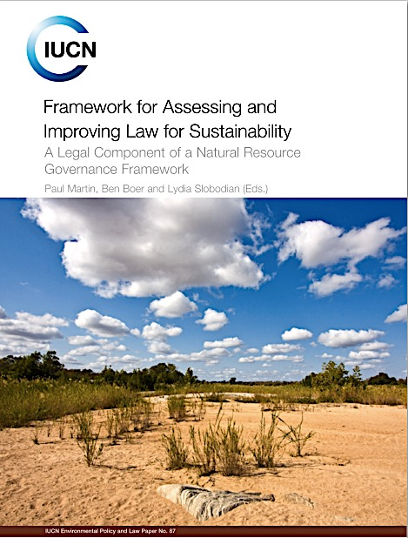
Australia is one of many countries that are parties to the Convention on Biological Diversity (the ‘CBD’). Like many countries that still have substantial intact ecosystems, Australia continues to suffer decline. Our research projects in Australia and internationally, led by Professor Martin from the Centre, focus on more effective implementation of CBD commitments.
The effective implementation of CBD principles: this is an IUCN fostered international collaboration. Professor Martin led the design of the method to conduct an international evaluation which was carried out in Australia, Brazil, China, New Zealand, and South Africa. A more in-depth project is underway involving collaborators from a number of countries
Governing for mega-diversity: this is a collaborative research program involving colleagues from Australia, Brazil and Argentina. It will extend the initial work from the IUCN project.
Within Australia, the national strategy for biodiversity conservation highlights the control of invasive plants and animals as the fundamental concern for meeting CBD obligations to protect in situ biodiversity. The Centre has been a leading law and policy researcher on this issue, and currently leads a multi-year large scale multi-disciplinary collaboration on the implementation of the national ‘shared responsibility’ policy. This also involves behavioural experts, and collaborators from across the country. A feature of the collaboration is close involvement with researchers from Penn State University in the USA.

The governance of food systems
In May 2014 the University of New England, School of Law co-hosted a major international conference in China with the Beijing Foreign Studies University (BFSU) on ‘The Governance Challenges of Food Systems’. Conference organiser and Deputy Director of UNE’s AgLaw Centre, Associate Professor Amanda Kennedy, said that the quality and expertise of the conference attendees made for an extremely productive event.
“The speakers and contributors at the conference were very international, and included representatives from government and non-governmental organisations, as well as a range of leading experts and academics from BFSU, UNE and elsewhere,” Associate Professor Kennedy said.
“Amongst the topics discussed in depth were food consumption, equitable distribution and supply, food safety, the environmental factors of feeding populations, and the challenges that exist in maintaining efficient food systems. The risks of modern-day technologies and how they might be governed was also addressed, as were the human rights of global food governance.
“Obviously these are some of the major questions of our times, and discussing them in the backyard of the world’s largest consumer, China, made the conversation all the more relevant.
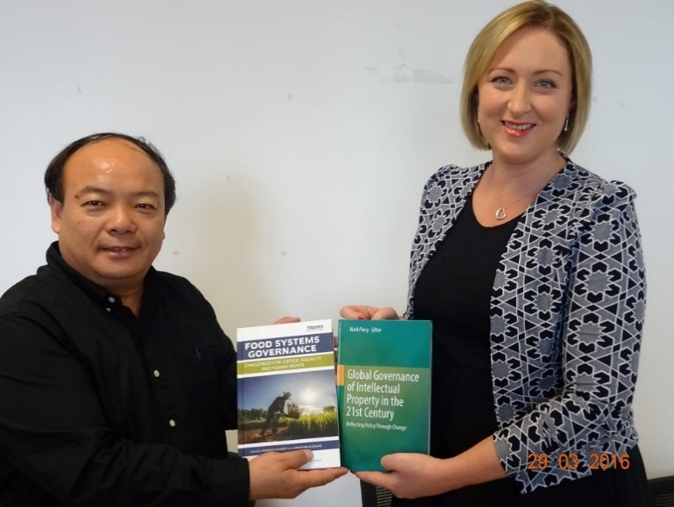
“The world population is increasing at such a rapid rate that we need to reassess everything we know about food production and consumption.”
Following the conference, Associate Professor Kennedy and Dr Jonathan Liljeblad produced an edited volume of the conference proceedings, ‘Food Systems Governance: Challenges for Justice, Equality and Human Rights’, published with Routledge. Associate Professor Kennedy is pictured here presenting Dean Wan Meng of Beijing Foreign Studies University Law School with a copy of the book.
The Centre has continued to strengthen its research links with China in the area of food systems governance. In 2016, Associate Professor Amanda Kennedy and Dr Jacqueline Williams participated in the first Sino-Australian Agricultural Law Forum, jointly organised by the AgLaw Centre and Yantai University. Associate Professor Kennedy has also presented on food systems governance issues to the Agricultural Law Research Centre of China’s Ministry of Agriculture.

Managing invasive species
In Australia, invasive animals still continue to pass through the strict national biosecurity system that exists to protect agricultural values and citizens from health risks. There are more than 50 feral animals, such as feral cats and dogs, rabbits and foxes, that every year affect the wellbeing of millions of Australians in regional and rural communities. Biological infestations from invasives destroy food crops every year and kill domestic livestock. They also have devastating psychological consequences on farmers and damage natural habitats and species, which are part of our national heritage.
Drawing on its expertise on the institutional and legal dimension of natural resource management as well as its previous work on invasives, the AgLaw Centre is working with communities to equip them with new tools and better understand the institutional and human dimension of the invasive animal challenge. Led by Professor Paul Martin, the AgLaw Centre has, in close collaboration with the Invasive Animals CRC, the Department of Behavioural, Cognitive and Social Sciences of UNE, and community engagement experts from Penn State University in the USA developed a transdisciplinary research program that aims to integrate front-line people knowledge, experiences and skills into the research process. Program 4 ‘Facilitating Effective Community Action’, which is part of the Invasive Animals CRC, is working with communities to equip them with new tools and better understand the institutional and human dimension of the invasive animal challenge. It aims to propose (with the support of community groups and front-line practitioners) reforms that will reduce legal and administrative barriers to citizens taking action on invasive animals.

Governing organic farming
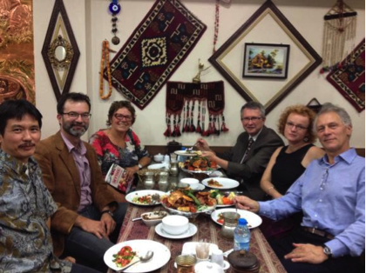
Postdoctoral research scholar, Andrew Lawson, participated in the 18th IFOAM Organic World Congress Istanbul, Turkey, October 2014. There were around 1,000 delegates from 81 countries, including farmers, agronomists, traders, certifiers, researchers, thinkers, and activists who participated in nearly 100 conference sessions and workshops. Istanbul is home to more than 14 million people, the capital of ancient empires, and a trend-setter for a country experiencing the excitements and shortcomings of rapid development.
Congress participants - left to right: Vital Panyakul (Green Net, Thailand; alumni of UNE), Andrew Lawson (UNE), Liz Clay (Organic Trust Australia), Gerald Herrmann (Organic Services, Germany; former IFOAM president), Ann-Helen Meyer von Bremen (Uttryck, Sweden) and Gunnar Rundgren (Grolink, Sweden; former IFOAM president)
Andrew was a panellist on the ‘Institution Building’ session. He also addressed questions related to this PhD research (supported by Australian Organic, one of Australia’s organic certification organisations). He discussed major sustainability initiatives, their characteristics, and their implications for the organic movement. He contrasted the perspectives from his doctoral research with ideas within the organic movement.

Rural social justice
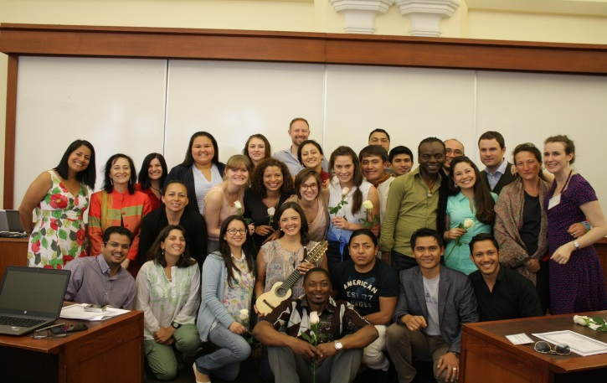
A particular area of concern in rural communities in Australia and in many other countries is the welfare and the interests of Indigenous people. The Centre has an ongoing program of research on these issues including the protection of cultural interests, secrecy, and interests in water. Recent work has included a collaboratively funded research program on Aboriginal Australian interests in bush food commercialisation, led by Professor Martin with Dr Kylie Lingard who attended the Indigenous Studies Summer at the Centre for Race and Ethnicity at Columbia University, New York. Kylie presented a paper on Aboriginal and Torres Strait Islander people’s interests in the commercial development of Australian native plants. The presentation is available at:
Indigenous study group, New York
http://www.slideshare.net/Ninti_One/lingard-k-aboriginaltorresstraitislanderinterestscommercialisationnativeplantsissp2014

