1. Overview
2. Use this guideline to safely manage hazards associated with any work requiring the use of gases
3. Gases are chemicals that can, dependent on their chemical composition, present a range of health and physiochemical hazards
4. The way that gases are supplied, often compressed in cylinders at high pressure or reticulated from larger external storage vessels, also presents particular hazards.
5. Moving heavy gas cylinders around is a difficult task, the failure of gas equipment can result in high pressure leaks, and the use of gases inside buildings and structures has the potential to result in asphyxiation, toxic exposure or fire and explosion.
6. Staff and students working with gases must be aware of the relevant hazards and associated risk controls.
7. Any incidents or hazards related to the use of gases or associated equipment must be reported in the UNESAFE electronic reporting system
8. Scope
9. This guideline has been developed to support UNE’s management of hazardous substances
10. Faculties, schools, directorates and professional services units are encouraged to use this document as a primary reference when developing local procedures to safely manage work with gases.
11. Guideline
12. ***Classification***

Gases are classified in accordance with the Australian Dangerous Goods Code and the Globally Harmonised System for the Classification and Labelling of Chemicals (GHS). The common classifications and associated classification criteria is summarised in Appendix A.

*(9.1) Compressed gases*

The majority of the gases we use at UNE are compressed gases. When compressed at room temperature these gases do not become a liquid, even at very high pressures. These are sometimes referred to as permanent gases. Nitrogen, air, oxygen, helium, hydrogen and argon are examples of commonly used compressed gases.

*(9.2) Liquefied gas*

Some gases will change from a gas to a liquid under high pressure. These gases are usually supplied inside a cylinder in liquid-vapour equilibrium. Initially the cylinder is almost full of liquid, with gas filling the space above the liquid. As gas is removed from the cylinder, a small amount of liquid evaporates to replace it, keeping the pressure in the cylinder constant. Anhydrous ammonia, Liquefied Petroleum Gas (LPG), chlorine, propane, nitrous oxide and carbon dioxide are examples of liquefied gases.

*(9.3) Dissolved gas*

Some gases are chemically unstable, even at room temperature and pressure. These may be supplied as dissolved gases. Acetylene is an example of a dissolved gas that is routinely stored and used safely in cylinders at high pressures. This is possible because acetylene cylinders are fully packed with inert, porous filler. The filler is saturated with acetone or other suitable solvent. When acetylene gas is added to the cylinder, the gas dissolves in the acetone. Acetylene in solution is stable. An acetylene cylinder should **NEVER** be laid on its side.

*(9.4) Refrigerated liquefied gas*

Some gases will change from a gas to a liquid at low temperatures. These refrigerated liquefied gases or cryogens include liquid nitrogen, argon or helium. Dry ice or solid carbon dioxide will sublime to carbon dioxide gas.

1. **Hazards from scientific gases**

*(10.1) Asphyxiating gases*

Many gases are colourless, odourless and cannot be detected with human senses. When released in an enclosed space an asphyxiating gas will displace an equivalent volume of air and effectively decrease the available oxygen concentration.

The percent of oxygen in the air we normally breathe is approximately 20.9%. A safe oxygen level in air is between 19.5% and 23.5% by volume at normal atmospheric pressure. Below 19.5% oxygen in air is considered oxygen deficient. People entering oxygen deficient areas below 18%, can become dizzy, disorientated, lose consciousness or possibly die from asphyxiation.

Examples of potential asphyxiating gases are nitrogen, carbon dioxide, helium, and argon.

Some gases are heavier than air and will displace oxygen at low levels (see table 1). These gases disperse less readily than gases which are lighter than air and may pose a greater risk as oxygen concentration is more quickly depleted at the breathing zone (see table 2).

|  |  |
| --- | --- |
| ***Heavier than air*** | ***Lighter than air*** |
| Argon (x 1.4) | Hydrogen (x 0.07) |
| Propane (x 1.5) | Helium (x 0.14) |
| Carbon dioxide (x 1.53) | Methane (x 0.55) |

*Table 1: Common gas weights relative to air*

The following example illustrates how the air can become oxygen deficient when a G size cylinder of nitrogen empties into a 5 m x 5 m x 3 m room. This example assumes an even dispersion of the nitrogen gas within the room and a rapid release of gas with no ventilation.

• The room volume is 75 m3 and contains 20.9% oxygen in air

• One G size cylinder will release 7.35 m3 of nitrogen gas at room temperature

• The 7.35 m3 of nitrogen will displace 7.35 m3 of air

The % 02 available after release = [(Room volume- Expanded Volume) / (Room volume)] x 20.9%

= [(75-7.35) / 75] X 20.9%

= 18.9%

*10.1.1 Carbon dioxide*

Carbon dioxide (CO2) presents a different risk and symptoms when compared to other simple asphyxiant gases. It is not classified as a toxic gas but CO2 does have health effects at high concentrations with the following exposure limits.

• Time Weighted Average (TWA) over 8 hour day for 5 days: 5,000 ppm or 0.5% v/v

• Short Term Exposure Limit - 15 minute TWA (STEL): 30,000 ppm or 3% v/v

• Immediate Danger to Life and Health (IDLH): 40,000 ppm or 4% v/v

The effects of decreased oxygen levels are exacerbated by the physiological effects caused by increased carbon dioxide concentration (Table 2).

|  |  |  |  |
| --- | --- | --- | --- |
| ***% Oxygen*** | ***Symptoms*** | ***% Carbon dioxide*** | ***Symptoms*** |
| 19 – 15 | Decreased ability to work strenuously; Breathing and pulse rate increase; May impair coordination. | 0.5 – 3 | Respiration and blood pressure increases with increasing C02 concentration; fatigue with prolonged exposure. |
| 1. – 11 | Poor judgment; abnormal fatigue upon exertion; disturbed respiration; blue lips. | > 3 – 10 | Respiration difficulty and increased blood pressure. |
| 1. - 6 | Nausea and vomiting, inability to move freely, possible loss of consciousness, inability to move or cry out even though aware of circumstances. Recovery possible after 4-5 minutes, 50% fatal after 6 minutes. Fatal after 8 minutes. | > 10 | Unconsciousness, possible death. |
| < 6 | Coma in 40 seconds, convulsive movements, gasping respiration; respiration stops and a few minutes later, heart stops. |  |  |

*Table 2: Symptoms caused by oxygen depletion and high carbon dioxide concentrations*

*10.1.2 Dry ice*

Carbon dioxide gas can also be released from its solid form, ‘dry ice’. Dry ice is commonly used in the laboratory to cool or freeze, particularly when transporting biological specimens. Dry ice is at -78 oC and will sublime, change from solid to gas, rather than melt. 1kg of dry ice will produce 0.45m3 of gas.

The rate of sublimation is slow in comparison to a gas release from a compressed gas cylinder.

Dry ice should not be used or stored in confined, unventilated spaces such as cold rooms. Serious consideration needs be taken when transporting dry ice in lifts, cars or other areas where CO2 may build up to a dangerous concentration. Dry ice should never be stored in sealed (air-tight) containers or coolers, particularly if made from glass. Storage in a sealed container can result in rupture or explosion of the container from over-pressurization. Handling this very cold material (at -79°C) with unprotected hands may also result in cold burns.

*10.1.3 Cryogens*

All personnel working with cryogens must undergo specific cryogen handing training before use.

Cryogens, also known as refrigerated liquefied gases, are an increased asphyxiating hazard because there is a large volume of gas which can be generated from a relatively small amount of liquid. A large ratio of expansion in volume from cryogenic liquid to gas can rapidly change the composition of the atmosphere in a room (Table 3). Cryogens also produce a low temperature gas which initially settles at ground level and does not readily disperse.

|  |  |
| --- | --- |
| ***Cryogenic liquid*** | ***Expansion factor*** |
| Carbon dioxide | 553 |
| Liquid nitrogen | 696 |
| Liquid helium | 757 |
| Liquid argon | 847 |
| Liquid oxygen | 860 |

*Table 3: Expansion factors of various cryogens*

For example, one 50 L Dewar of liquid nitrogen will produce 34.80 m3 of nitrogen gas. The available oxygen in a 10 m x 10 m x 3 m laboratory is reduced to life threatening levels when a 50 L Dewar of liquid nitrogen catastrophically releases nitrogen gas into the room (refer to Table 4).

|  |  |  |  |  |  |
| --- | --- | --- | --- | --- | --- |
| ***Height (m)*** | ***Volume of air (m3)*** | ***Liquid nitrogen (l)*** | ***Volume liquid nitrogen release (m3)*** | ***% Oxygen available after release*** | ***Risk level*** |
| 3 | 300 | 50 | 34.8 | 18.5 | Medium |
| 1.8 | 150 | 50 | 34.8 | 16.9 | High |

*Table 4: Initial asphyxiation risk assessment from liquid nitrogen*

Table 4 demonstrates the importance of considering the temperature and dispersion of the nitrogen gas produced from liquid nitrogen. The first row, with height at 3 m assumes an even dispersion of the nitrogen gas within the room. However cold nitrogen gas would sink to the lower levels in the room and first displace available oxygen in the breathing zone (height 1.8 m). The calculation to assess oxygen depletion is further illustrated in Appendix B. The gas risk calculations are addressed in the specific training on cryogens.

The other major risk associated with the use of cryogens is injury through cold burns and rupture or explosion from over-pressurization of containers. Gloves suitable for cryogens must be used for handling cold items. Face shields are mandatory for decanting.

Liquid oxygen can cause an oxygen enriched environment as can liquid nitrogen and helium which have significantly lower boiling points than oxygen. If liquid nitrogen is exposed to the atmosphere, atmospheric oxygen will condense into a liquid. These cryogens should not be stored for long periods in an open system i.e. lab flask. Generally, only open small Dewars or containers, not greater than 5 L liquid nitrogen, should be used in a laboratory.

* 1. *Flammable gases*

Flammable gases, such as acetylene, butane, ethylene, hydrogen, methane, methylamine, propane, silane, germane, carbon monoxide and vinyl chloride, can burn or explode under certain conditions. The ease at which a flammable gas can ignite in air depends on:

• **Gas Concentration** – For a gas to ignite the concentration of the gas in air must be between its lower explosive limit (LEL) and upper explosive limit (UEL). For example, the LEL of hydrogen gas in air is 4 % v/v and its UEL is 75 % v/v (at atmospheric pressure and temperature). This means that hydrogen can be ignited when its concentration in the air is between 4 % v/v and 75 % v/v. A concentration below 4 % v/v is too "lean" to burn. Hydrogen gas levels above 75 % v/v are too "rich" to burn.

• **Ignition Source -** For a flammable gas to ignite, an ignition source must be present. There are many possible ignition sources within a workplace including open flames, sparks, hot surfaces, electrical and electronic equipment that is not intrinsically safe or grounded. Flammable gases must never be used near ignition sources and spark-proof tools should be used when working on a compressed gas cylinder system containing flammables gases. Some highly flammable gases, such as hydrogen can even be ignited through static electricity, which may be generated from a gas leak out of piping.

• **Auto-ignition** – The auto-ignition temperature of a gas is the minimum temperature at which the gas self-ignites without any obvious ignition sources. Some gases have very low auto-ignition temperatures. For example, phosphine's auto-ignition temperature of 100°C is low enough that it could be ignited by a steam pipe or a light bulb. Some compressed gases, such as silane and diborane, are pyrophoric and will ignite spontaneously in air.

Many flammable compressed gases are heavier than air. If a cylinder leaks in a poorly ventilated area, these gases can settle and collect in low areas such as basements, trenches, depressions or sewers. The gas can spread far from the cylinder and if the gas contacts an ignition source, the fire produced can flash back to the cylinder.

* 1. *Oxidising gases*

Oxidising gases are non-flammable, but in the presence of an ignition source and fuel can promote and accelerate combustion. Examples of oxidising gases include oxygen, nitrogen oxides such as nitrous oxide and halogen gases, such as chlorine and fluorine. Oxidising gases can react rapidly and violently (causing fire and explosion) with the following combustible materials:

• **Organic (carbon-containing) substances** e.g. most flammable gases, flammable and combustible liquids, oils, greases, many plastics and fabrics

• **Finely-divided metals** e.g. iron, nickel and aluminium

• **Easily oxidisable substances** e.g. hydrazine, hydrogen, hydrides, sulphur or sulphur compounds, silicon and ammonia or ammonia compounds.

Nitrous oxide is an oxidising gas that has additional risk. When nitrous oxide is heated in an enclosed container, auto-decomposition can lead to explosion. Inhalation of low concentrations of nitrous oxide can lead to euphoria, while higher concentrations mixed with air can induce anaesthesia.

* + 1. *Compressed oxygen*

Oxygen enrichment is an oxygen concentration greater than 23.5% v/v in air. This can cause combustible materials, including clothing and fabrics, to ignite more easily and fire to spread quickly, burn faster and be very hard to extinguish. A leak from a compressed oxygen cylinder can cause oxygen enrichment.

It is recommended that the following additional precautions be observed when using or storing compressed oxygen:

• Ensure all equipment and regulators are suitable for oxygen use.

• Maintain hoses and other equipment in good condition. Leak tests can be carried out easily using a proprietary spray or liquid solution that is certified for use on oxygen systems.

• Use only equipment that has been delivered from the manufacturer cleaned, sealed and certified as being suitable for use with the oxidising gas. If on-site fabrication is performed, a competent person must select, assemble, clean and certify the equipment as being suitable for use with that gas.

• Do not use oil, lubricants and sealants in connections, as most are not compatible. If essential, use only products certified as being oxygen-compatible. A warning sign “OXYGEN - USE NO OIL may be useful.

• Do not use oxygen as a substitute for compressed air.

* 1. *Corrosive gases*

Some compressed gases are corrosive. These gases can burn and destroy living tissue, generally when in direct contact with skin and eyes or via inhalation. Corrosive gases can also corrode metals used in piping and apparatus. Common corrosive gases include ammonia, hydrogen chloride, chlorine boron trifluoride, hydrogen sulphide, sulphur dioxide and methylamine.

Specific recommended practices for corrosive gases are:

• Remove regulators after use and flush with dry air or nitrogen,

• Check equipment and lines frequently for leaks, metals become brittle when used in corrosive gas service,

• Use a diaphragm gauge or check with the gas supplier for recommended equipment. Regulators for use with noncorrosive gases are usually made of brass and may not be suitable for a corrosive gas. Corrosive gases will destroy some materials.

* 1. *Toxic gases*

Toxic gases cause adverse health effects with exposure through inhalation, eye or skin contact. Health effects may include severe respiratory, skin or eye irritation through to pulmonary oedema, neurotoxicity, or death. Highly toxic gases are extremely dangerous and may cause significant acute health effects at low concentrations. Examples of toxic gases used in the laboratory are carbon monoxide, nitric oxide, chlorine, arsine and germane.

Some toxic gases have more than one hazard for example, chlorine is also corrosive and requires a number of extra precautions. Hydrogen sulphide is flammable, toxic and corrosive, while carbon monoxide and ethylene oxide are flammable and toxic

In addition to the general work practices for working with gases, when using toxic gases the following must be implemented:

• Conduct all work in a fume cupboard or with appropriate ventilation to prevent exposure by inhalation.

• Use gas monitoring to detect leaks and unexpected release.

• Lock rooms containing toxic gases when not occupied.

• Ensure the main valve on all toxic and highly toxic gas cylinders is closed at all times when the cylinder is not in use.

• Clearly placard that a toxic gas is present at the entrance to the work area

• Provide respiratory protection if there is a risk of exposure to a laboratory worker which exceeds exposure limits.

• **Do not** work with toxic or highly toxic gases alone, have a buddy.

• **Do not** store toxic gases within the laboratory when not in use. Depending on their toxicity and expansion factors some of these gases must be stored in a continuously ventilated cabinet or be reticulated into the laboratory

* 1. *Dangerously reactive gases*

Some pure compressed gases are chemically unstable. If exposed to slight temperature or pressure increases, or mechanical shock, they may readily undergo an uncontrolled chemical reaction, such as polymerization or decomposition. These reactions may result in fire or explosion. Some dangerously reactive gases have inhibitors added to prevent these hazardous reactions.

Common dangerously reactive gases are acetylene, 1,3-butadiene, methyl acetylene, vinyl chloride, tetrafluoroethylene and vinyl fluoride. Pyrophoric gases, which ignite spontaneously on contact with air at temperatures 54.4oC or below, include silane, disilane, diborane, and phosphine. Toxic and dangerously reactive gases should only be purchased from vendors who will agree to take back the empty cylinder.

Wear appropriate personal protection equipment (PPE) to prevent eye and skin contact. For highly reactive and toxic gases: laboratory coats must be worn at all times; appropriate gloves (nitrile, vinyl gloves, or heavy duty rubber gloves) and safety goggles must be used.

1. **Hazards from a compressed gas cylinder**

*11.1 Pressure*

Laboratory gases are often supplied in high pressure compressed gas cylinders (13.7 MPa) or as liquefied or dissolved gases under pressure (30MPa). Gas can be released accidentally and rapidly disperse from broken or leaking valves, faulty regulators, connections or tubing. Even at a relatively low pressure, gas can flow rapidly from an open or leaking cylinder.

High pressure inside a gas cylinder is a hazard. Damaged cylinders can become uncontrolled projectiles can cause severe injury and damage. These incidents have happened when unsecured cylinders have fallen causing the cylinder valve to break and high pressure gas to escape rapidly.

Note that **a gas cylinder is never completely empty of gas** as a certain amount of gas will remain in the cylinder at room pressure and temperature. “Empty” cylinders should therefore be given the same precautions as full cylinders.

The gas cylinder valve contains the contents of the cylinder that is under high pressure. It is the primary safety mechanism on a gas cylinder and must not be tampered with.

A cylinder valve tap opens in an anticlockwise direction and closes in a clockwise direction. The valve should not be opened without a regulator attached. Always open a cylinder valve slowly.



*11.2 Manual handling*

A gas cylinder can be hazardous due to its size and weight. The average weight of a full G size carbon dioxide cylinder is over 80 kg (32 kg for the gas and approximately 50kg for the tare weight of the bottle). This weight combined with the tall, elongated cylinder shape can increase the risk of a cylinder to falling.

Many accidents or injuries involving compressed gas cylinders happen when moving or manually handling the cylinder. A large gas cylinder (e.g. G cylinders) can be bulky, heavy and awkward to handle. Extreme caution should be taken when manoeuvring bottles and in some cases two people should undertake this task.

*11.3 Temperature*

The integrity of gas cylinders can be compromised if stored at high temperatures. Excessive heat (>65oC) results in an increase in internal pressure. Some gas suppliers fit cylinders with a test tag that is heat sensitive (see below). **DO NOT** use a cylinder if the test tag shows evidence of heat exposure (right hand picture below).

**

1. **Risk controls**

Different controls can be employed based upon the risk of activity and gas being used within the workspace. Risk assessments, which must be documented for all high risk activities involving gases, should consider:

• Hazardous properties of gas (toxic, corrosive, flammable, high reactive)

• Volume of gas stored or transferred;

• Location of gas;

• Density of gas

• Ventilation in place (laboratory air changes per hour, use of fume cupboard )

• Room dimensions

• Accidental release and emergency actions

In purchasing equipment that requires a gas to be connected, if feasible, it is ideal to have:

• An Emergency Shut Off (ESO) valve and/or,

• An air actuated cylinder valve in the gas control box, and

• A visual and audible alarm to alert users of an unsafe situation.

*12.1 Ventilation*

Hazardous gases in a workspace or dangerous goods store must have adequate ventilation.

*12.1.1 Compressed gases and cryogenic liquids*

Mechanical or natural ventilation should be at a sufficient rate to keep oxygen levels above 19.5% in the event of a major leak, for example in the event of the largest cylinder catastrophically discharging its contents into the room. If this is not possible, alternative controls should be considered (e.g.: gas monitoring or redesign).

• A ventilation failure alarm is recommended for some situations.

• Maintenance to ventilation systems should include an annual calibration of the ventilation airflow or if applicable airflow sensors.

*12.1.2 Toxic, flammable and highly reactive gases*

Ventilation systems must be capable of maintaining exposure levels below recommended workplace exposure standards or in the case of flammable gases, the lower explosion limit. A possible example of local area mechanical ventilation for the use of toxic, flammable and highly reactive gases could be a ducted ventilated gas cabinet (see below). Fume cupboards can be used for lecture bottles. A gas cabinet is a ventilated enclosure for gas cylinders and is equipped with an automatic gas shut off when leaks are detected or when gas flow exceeds pre-set levels. All gas cabinets must be clearly labelled with contents and hazard information.

Flammable, pyrophoric and highly reactive gases should be stored within a flammable gas cabinet equipped with water sprinklers or other appropriate fire suppression systems. Cabinets for highly reactive and toxic gases must be installed with purge facilities.



*12.1.3 Exhaust and ducting*

Gases emitted from exhaust systems can pose a risk to rooftop workers. Some gases may require treatment prior to discharge, e.g. scrubbing or dilution. Alternatively, small amounts of a toxic gas exhaust could be diluted with an inert gas.

Significant emissions are defined as, duct concentrations above exposure standards near exhaust fan stacks or levels that result in duct corrosion (in the case of corrosive gases). These concentrations may be determined by release modelling. Seek expert advice when designing these systems.

If there is the possibility of a hazardous gas release, warning signs must be installed at the roof access point.

*12.2 Reticulation*

Reticulating gas from an external ventilated area to points of use inside a building is the recommended option for laboratory gas supply. In a reticulated system instead of having a single line from a gas cylinder, a centralised bank of cylinders or manifold is stored external to the laboratory (see below).

Reticulated gas systems must be of the proper design for the gas they are to contain, and be at the appropriate temperature, pressure and flow. Considerations include:

 Incorporating step down regulators enabling gases to enter the laboratory at a lower pressure.

• Using fixed tubing compatible with the type of gas and, where possible, incorporate flow restrictors, fail-safe gas control outlets and automatic control panels. High and low pressure cut-off devices protect against disconnection of equipment or failure of the regulator.

• Having a ventilation failure alarm and/ or gas monitor with an alarm. If power to the mechanical ventilation is lost gas may accumulate and therefore gas flow should be automatically stopped (via interlock).

• Periodically inspecting and testing for leaks and keeping records of maintenance tests.

• Capping off a reticulated gas supply that is not required



A reticulated system using a bank of cylinders provides a continuous gas supply; has less reliance on cylinder deliveries; is especially useful when high volumes are required and acts to save space within the laboratory. Plans for safe and secure reticulated gas supplies can be incorporated into proposals for new equipment requiring compressed gases and meet long-term aims to house cylinders outside buildings.

Manifold systems must be designed and constructed taking into consideration the hazard of the gas. For example, a manifold for flammable gases requires flash arrestors, check valves, pressure relief valves, spark proof components and intrinsic safety features as necessary considerations. Copper piping must never be used for acetylene or ammonia gas delivery systems. Compression fittings should not be used with flammable or toxic gases. Before installation consultation with the gas supplier is recommended.

*12.2.1 Flashback arrestors*

A flashback can occur in an open system when a flammable gas and air mixture ignites .If not stopped, fire can travel into hoses, regulators and gas cylinders. A flashback arrestor (see below) is designed to prevent the penetration of a flame into lines and equipment. Always purchase a flashback arrestor that meets Australian Standards. Replace every 12 months, or arrange testing by a competent person.



*12.3 Gas monitoring*

A comprehensive laboratory gas monitoring system may detect gas leaks, gas releases, ventilation failures, and power failures. Ideally, the gas detector will interface with a control system so that:

• A process can shut down automatically

• An alert message is sent to University Security or key personnel

• Ventilation is boosted

• A distinct audible and visible alarm notifies workers locally, giving them the opportunity to evacuate the area.

Gas detection can be used to detect asphyxiating, flammable or toxic gases (examples shown in table below). Oxygen depletion sensors are used where asphyxiating gases may reach dangerous levels. Continual gas monitoring is important when toxic gases are used in a high concentration, large quantity, or if the gas has poor physiological warning properties (odour or irritation) making it only noticeable above harmful concentrations. Combustible gas detectors are designed to alarm before a potential explosive condition occurs.

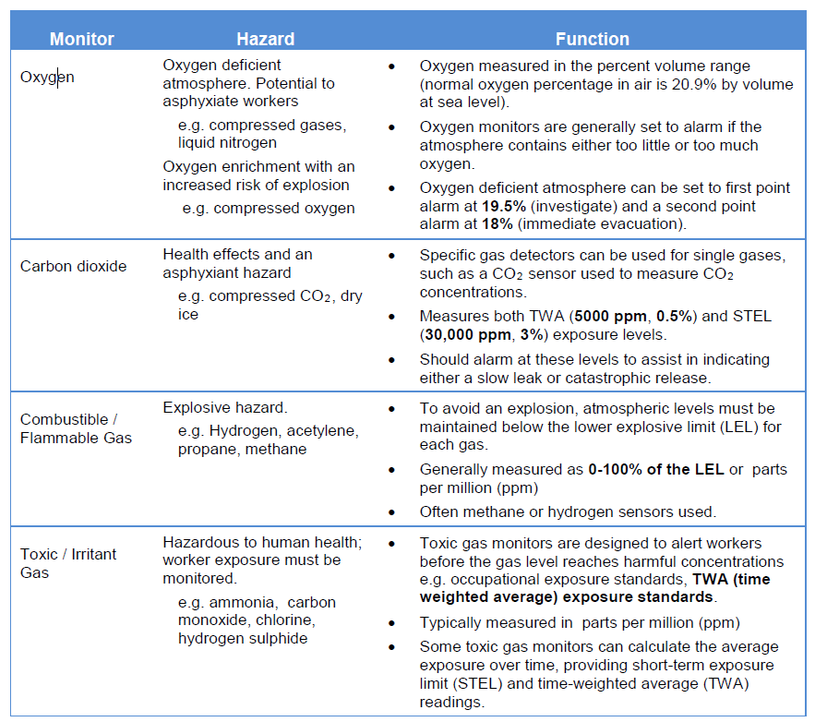

*12.3.1 Monitors*

Gas Monitors can be installed as fixed, portable or transportable, single gas or multi-gas devices:

• A **fixed monitoring system** is permanently installed in the workplace (stationary). The detecting sensor may be hard wired, or use wireless signals to a central reporting station. Most come with an auditory alarm. The type of sensor will be defined by the system, as well as the gas or gases to be detected.

• **Portable or personal gas detection** refers to gas detectors which are worn or carried by an individual. Typically battery operated, portable monitors are used for toxic or combustible gas detection, as well as for oxygen deficiency monitoring in confined spaces. Portable monitors should be functionally verified prior to each use.

• A **transportable unit** offers area monitoring detection and the benefits of a multi-gas fixed system in a transportable unit. These units are designed for short-term work where fixed gas systems may not be suitable.

The requirement for a monitoring system is decided on a case by case basis and fixed monitoring may be more appropriate for continuous operations, long term research situations or where more than one gas needs to be monitored. For a fixed monitoring system there should be connection to an emergency power source. In the event of a power failure, the detection system should continue to operate without interruption, or the gas systems should automatically shut down at the source.

*12.3.2 Sensors*

A gas sensor should be installed in close proximity to where a leak would most likely occur and is dependent on the density of the gas and activity carried out. Asphyxiating gases with density greater than air (CO2, cold nitrogen gas from liquid nitrogen) have monitor sensors located at lower levels. Room ventilation exhaust is also located at a lower level. Less dense asphyxiating gases (e.g. helium) have monitor sensors within the breathing zone. A flammable gas less dense than air, such as hydrogen, may have the sensor near the ceiling.

The display should be easily accessible and visible. An alarm status and gas concentration readout panel (or mimic panel) should be located outside the gas room. Seek advice from the manufacturer in regards to correct setting of sensor levels, necessary calibrations and replacement.

*Challenge tests* should always be performed when new monitors are installed or after sensor replacement to ensure proper response. Regular *bump testing* is recommended. This is where the monitor is exposed to a known concentration of the gas to ensure that it is functioning correctly. Bump testing does not take the place of routine calibration. All sensor changes, calibrations and test results should be recorded in a maintenance logs. Gas detectors do have a limited life span and be replaced when specified by the manufacturer.

*12.3.3 Alarms*

Local alarms should be heard and visually observed both inside and outside the room. It is recommended that monitor be connected to building management systems (BMS) where automated ventilation controls can be activated to restore safe atmospheric conditions (i.e. a boost to the ventilation rate to exhaust leaking gas). A BMS system can also control access to an area, for example lockout particular workspaces to prevent workers entering an unsafe environment.

*12.3.4 Maintenance*

The required maintenance schedule on monitors will vary depending on the manufacturer and may involve electronic checks, challenge tests using known gas concentrations, or full instrument calibration. Check maintenance protocols with the manufacturer. Calibrations will need to occur at least annually or even 6 monthly for some types of gas sensors. Calibrations and tests should be recorded. These records must be available for inspection if required.

*12.4 Hierarchy of control*

The risks posed by gases are controlled in a variety of ways. Some ‘controls’ (elimination, substitution, isolation and engineering controls) are more effective than others (administrative controls and personal protective equipment) and should be used preferentially, although may require longer term planning and resourcing.

|  |
| --- |
| **Elimination** |
| • Eliminate the use of gas from the workspace, e.g. outsource the task |
| **Substitution** |
| • Use a less hazardous gas  • Use a safer alternative method |
| **Isolation** |
| • Reticulate gas into the laboratory at a low pressure from an external storage area  • Use ventilated gas cabinets for storage of toxic, flammable, corrosive or pyrophoric gases. |
| **Engineering** |
| • Mechanical ventilation  • Flow restriction on the gas supply  • Fixed continual gas monitoring - installed and appropriately maintained.  • Back-up power supply for gas monitoring and mechanical ventilation.  • Gas sensors located strategically to allow for early detection of gas leaks.  • Gas monitoring display and controls located outside the areas (at entrance).  • Gas detection automatically triggers audible alarms inside and outside the area.  • Interlocking of gas alarms with ventilation, e.g. alarm triggers automatic ventilation boost or room purge.  • Interlocking of gas alarms with gas supply, e.g. alarm triggers automatic shutdown of gas supply.  • Interlocking of gas alarms with access controls, e.g. alarm trigger automatic restricted access.  • Interlocking of gas alarms with electricity supply, e.g. alarm triggers automatic shut-down of potential ignition sources in response to LEL detection.  • Emergency stop buttons to manually shut-off gas supply.  • Gas lines holding toxic or highly reactive gases are able to be purged with an inert gas.  • Gas lines are made of appropriate material. |
| **Administration** |
| • Establish safe work procedures.  • Provide training to workers who access the areas.  • Minimise the volume of gases stored and used.  • Control the procurement of high-risk gases, e.g. Head of School approval required.  • Purchased gases from a supplier who will take back empty or partially full cylinders.  • Check gas lines and connections are regularly.  • Regularly inspect, test and replace gas regulators. |
| **Personal Protective Equipment** |
| • Use appropriate PPE, e.g. faces shield, cryogen gloves and non-permeable covered shoes for liquid nitrogen decanting. |

1. **Safe Work Practices**

*13.1 Storing compressed gas cylinders*

Recommendations for the storage of compressed gas cylinders are as follows:

|  |  |
| --- | --- |
| **Do** | **Do not** |
| • Store only minimal volumes appropriate for the rate of use.  • Return a compressed gas cylinder to the supplier if it is unlikely to be used, even if part full. Rent is charged per cylinder and the amount of money saved keeping the gas is often outweighed by the rental charges.  • Allow only trained, authorised people to enter a gas storage area.  • Inspect storage areas and carry out visual inspections of cylinders regularly, checking for any damage, leaks or poor housekeeping.  • Properly restrain all compressed gas cylinders, during storage and transport, if empty or in use. Secure upright, to a fixed structure at approximately 2/3 the height of the cylinder (a second strap 1/3 the height of the cylinder is even better, see opposite).  • Ensure there is no danger of mechanical or physical damage to a cylinder.  • Keep an up to date and accurate inventory of all compressed gases stored and in use.  • Store empty gas cylinders separately from full cylinders, in a clearly marked area or clearly label the cylinder “empty”.  • Protect the markings on cylinders that identify the contents. **NEVER** alter markings, labelling or colour coding. If the cylinder contents cannot be clearly identified, **DO NOT** use it. Return it to the supplier.  • Report any non-compliance with the cylinder and labelling to the supplier. Cylinders are a rented item and the integrity and compliance of the gas cylinder is the supplier’s responsibility. | • Do not store gas cylinders for excessive periods of time.    • Do not store gases in exits or egress routes.  • Do not store gas cylinders on cylinder transport trolleys.    • Do not restrain a cylinder at the neck or through a regulator. It is recommended to use fit-for-purpose racks with chains or straps to secure a cylinder.  • Do not use a gas cylinder that shows evidence of damage or corrosion. The gas cylinder is a rented item; its integrity is the responsibility of the gas supplier. |

In a gas store, consideration should be given to how multiple cylinders are placed.

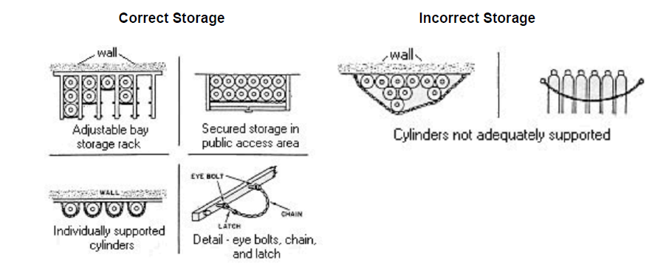

*13.1.1 Gas cylinder stores*

Large volumes of compressed gas cylinders are stored in a minor gas store. Ideally, this store is located outside a building, secured from unauthorised access, ventilated and protected from sunlight and heat. A secure gas ‘cage’ with a roof is typically used for storage.

Ensure gas storage areas provide adequate space to store full, empty and spare cylinders. Outdoor minor gas stores must be separated from other dangerous goods stores by a minimum distance of 3 m and must be greater than 1 m from any door, window, air vent or duct. For further information on the design and construction of stores, refer to *AS4332-2004: The Storage and handling of gases in cylinders*.

Indoor storage of cylinders is not recommended unless the building has been designed for that purpose with appropriate fire rated walls, ventilation and when necessary monitoring. A risk assessment must be conducted and documented prior to an anticipated indoor storage or use of gases. Further safety considerations and control measures may need to be implemented.

Gas storage areas which are naturally ventilated must be designed or located so as to prevent the build-up of escaped gases. Where gas cylinders are stored inside a building, a mechanical ventilation system is required.

*13.1.2 Segregation*

Different dangerous goods classes of gas cylinders within a store must be segregated (as per table below). Compatible gases (e.g. Class 2.2, without subsidiary risk) may be placed between incompatible gases. For example, a compressed nitrogen cylinder could be placed between a flammable gas such as hydrogen and a toxic such as carbon monoxide.

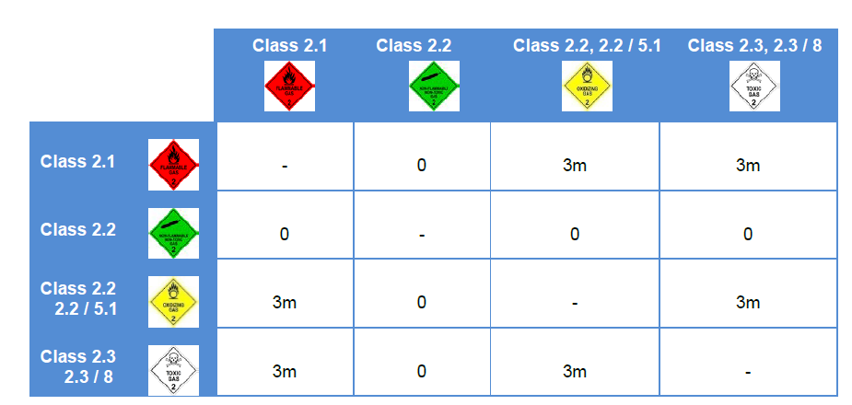

Gas cylinders must also be stored at least 3 m away from combustible materials and debris (e.g. timber, cardboard, packaging materials). Appropriate barriers can also be used to assist in segregation



*13.2 Transporting gas cylinders*

Handling a gas cylinder requires special care and equipment so that it does not fall or cause injury.

|  |  |
| --- | --- |
| **Do** | **Do not** |
| • Use a fit-for-purpose cylinder trolley. Trolleys with four wheels are preferred as they offer better balance and support than those with only two wheels (see below).  • Secure the cylinder on the trolley with chain or strap.  • Manoeuvre a cylinder a short distance by rotating along its round bottom edge and gripping the neck of the bottle **below** the valve. If necessary have a second person assist in the move.  • Prevent damage to cylinders from impact from other objects (e.g. other cylinders).  • Wear protective footwear and safety glasses. Gloves when handling cylinders. | • Do not lift, drag or roll a cylinder.  • If a lift is used to transport a cylinder between floors, ensure that no one occupies the lift while the cylinder is being transported. Ideally a placard should be placed across the entrance of the lift to prevent others entering the lift while the cylinder is in transit.  • Do not lift cylinders with magnets or rope slings.    • Do not place a gas cylinder of any kind in the  passenger compartment of a vehicle.  • Do not drop or knock cylinders. Some cylinders (e.g. acetylene) may react violently after being excessively shaken, heated, knocked or laid on side. |

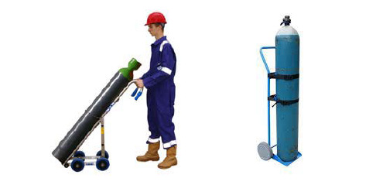

*13.3 Using a gas regulator*

The regulator is an important safety device which must be used and maintained correctly. The regulator must be fitted to a gas cylinder before use as it will allow the high pressure of the cylinder contents to be brought down to a safe usable working pressure.

For information on how to install a regulator, see appendix D.

Regulators are constructed from different materials, mainly brass or stainless steel. Regulators are designed to be fitted directly to the cylinder valve. No other fittings, connections or lubricants are used to connect a regulator to a gas cylinder valve.

Regulators on all gas cylinders except flammable gases have a right hand thread. Regulators for flammable gases are left hand threaded and have a notch cut out of each face. The thread size of an Air or Nitrogen cylinder valve differs from Oxygen.

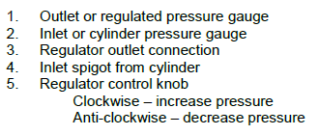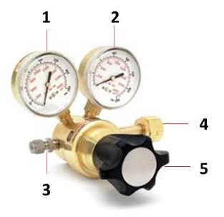

The following FAQs outline recommendations when using gas regulators (from Gascon). More gas regulator FAQ’s in appendix C.

**Are brass regulators OK with all gases?**

Choice of regulator depends on the type of gas, gas cylinder pressure and size of the cylinder. Stainless steel body regulators are required for corrosive gases and or harsh external environments. Gas threads, configurations and valve outlets are different for each dangerous goods class to prevent mixing of incompatible gases.

Lecture bottles are an exception and use universal threads and valves, some of which are interchangeable, so special caution should be taken to prevent mixing of incompatible gases. If you are unsure of which kind of regulator to use consult your gas supplier.

**There is an old regulator sitting in the cupboard, can I use it?**

Know the regulator maintenance history before use. Regulators can fail and should undergo periodic maintenance and repair as per manufacturer’s recommendations. Do not try to assemble a regulator from existing old regulator parts. Gas cylinder fill pressures have increased over the years. Accidentally using an old regulator or a regulator designed for a lower inlet pressure cylinder may result in a serious incident. Get the right regulator for each gas cylinder. Do not change a regulator from one gas service to another without seeking advice from the manufacturer.

**What precautions should I take attaching a regulator?**

• Be sure the regulator pressure control valve is closed before attaching it to a cylinder.

• **Do not** stand in-line with the regulator and valve outlet when attaching the regulator to the cylinder. Stand to one side in case gas is accidentally released under high pressure.

• After the regulator is attached, carefully and slowly open the cylinder valve. Pressurize the regulator slowly and ensure that valve outlet and regulator is pointed away from all people when the cylinder valve are opened.

• Use fit-for-purpose tools if required. If a cylinder wrench is needed, leave the wrench in place on the cylinder valve so it is present and readily accessible to open or close the main cylinder valve (especially important in an emergency).

• Most regulators have two gauges; one of which indicates bottle pressure and the other delivery pressure. The gauge that shows **bottle pressure** should have a maximum deflection reading of at least 150% of the **filled pressure** which is marked on the bottle e.g. G2 bottles of Helium are **filled to 20.0 MPa**. A gauge marked to **30,000 kPa** should be used. Older gauges marked to 20,000 kPa may fail if connected to one of these bottles.

**Gas is flowing out of the pressure relief valve on my regulator, what should I do?**

There is a problem with the regulator, close the cylinder valve and remove the regulator from cylinder valve. Seek further advice about having it tested and/or serviced. Do not attempt to fix the problem by removing, capping or increasing the setting of the pressure relief valve.

**How can I check if there is grease or oil near my compressed oxygen gas system?**

Fluorescent light can be used to check for grease or oil in regulators and Oxygen cylinder valves.

**Will my pressure regulator control the gas flow from the cylinder?**

No. Pressure regulators control gas pressure not flow. A flow valve or flowmeter, in combination with a regulator, will be needed to control gas flow.

**Why does my gas regulator hum sometimes?**

Regulator hum indicates that the seat and stem dampers are worn or inoperative. It is also possible that you are using an improperly ranged regulator. The regulator may need servicing.

*13.4 Using a gas cylinder*

A cylinder in use has a regulator attached and is connected to a gas delivery system, such as an instrument, and is where the gas is used at least monthly.

|  |  |
| --- | --- |
| **Do** | **Do not** |
| • Ensure that equipment is compatible with cylinder pressure and the nature of the gas.  • Use only approved valves and equipment required for each gas type (refer to gas supplier/manufacturer for details).  • Be sure pressure gauges on regulators are correct for the pressure of the gas cylinder used.  • Label all associated equipment, reticulated gas lines and piping with the gas name to prevent unintentional mixing of incompatible materials.  • Leak test gas systems immediately after assembly and before each use.  • Keep piping, regulators and other apparatus gas tight to prevent gas leaks. Release pressure from systems before connections are tightened or loosened and before any repairs.  • Use the recommended inlet and outlet pressure.  • Place the cylinder as close as possible to point of use.  • Only ‘in use’ compressed gas cylinders and the smallest size practicable should be kept in the laboratory. | • Do not apply excessive force when trying to open the cylinder valve. If the cylinder valve is difficult to open, discontinue use and contact supplier. Forced freeing of “frozen” or corroded valves should NOT be attempted.  • Do not partially open a cylinder valve (“crack” the cylinder) to remove dust or debris.  • Do not use adapters, home-made fittings or exchange fittings between cylinders and regulators.    • Do not use Teflon tape on fittings (straight thread) where the seal is made by metal-to-metal contact. Use of Teflon tape causes the threads to spread and weaken, increasing the likelihood of leaks. Small pieces of tape can also become lodged in the valve mechanism resulting in possible valve failure.  • Do not install shut-off valves between pressure relief devices and the equipment they protect. This can cause high pressures and damage equipment.    • Do not allow a gas cylinder to become part of an electrical circuit.  • Do not keep spare or empty cylinders in a laboratory |

*13.4.1 System shutdown*

 Close valves on gas cylinders when a system is not in use.

• Remove all pressure from regulators not currently used (by opening equipment valves downstream after the regulators are closed).

• Vent relief valves to a fume hood or ventilated gas cabinet, when using flammable or toxic gases.

• Cylinders that are no longer required should be disconnected from the gas delivery system and returned to the gas store.

*13.5 Maintenance*

A maintenance program is important to prevent incidents associated with gas cylinders and also to extend the service life of gas systems and maximise performance.

*13.5.1 Visual checks*

 **Complete a visual check of gas line components** regularly (e.g. valves, seals, pipes and hoses) to detect any damage, cracks or corrosion. Replace as needed to prevent failure resulting in a gas leak. This process should be completed often if the gas is highly reactive, toxic or corrosive or used continuously. Valves that pass visual inspection are still subject to failure. It is critical that toxic gases are used in ventilated enclosures and have local exhaust ventilation in place for downstream pressure relief valves.

• **Check all cylinder-to-equipment connections**, before use and periodically during use,. Be sure they are tight, clean, in good condition and not leaking.

• **Keep regulators and valves free of moisture.** Systems should be purged with dry inert gas (e.g. helium, nitrogen, argon, etc.) before the gas is introduced and capped when out of service.

• **Undertake a commissioning check** for any new equipment installations which use gas. If the gas to be used is flammable, oxidizing or highly toxic, check the delivery system first for leaks with an inert gas (nitrogen or helium) before introducing the hazardous gas.

*13.5.2 Leak check*

Use only compatible leak test solutions or leak test instruments to check for gas leaks within the system. Have the regulator under pressure (both high and low pressure side) and check all connections using a gas leak detector or solution. If a leak is detected, shut down the gas source, reduce pressure to atmospheric and tighten or redo connection. Then retest. In a closed system the regulator should not lose pressure if the cylinder is closed at the valve.

*13.5.3 Creep test*

Regulator ‘Creep’ is when there is an increase in outlet pressure above a set point. Creep can occur in two ways;

• Changes in the springs within the regulator when gas flow is stopped

• Foreign material lodged in the seat of the regulator (most common)

To prevent foreign material causing creep, ensure that the regulator connections, when not in use, are capped to prevent dirt entering the regulator. Tubing should also be flushed to remove foreign material. A pressure relief valve installed downstream of the regulator will also protect against creep.

To undertake a creep test:

• Close the regulator outlet valve or instrument valve to isolate the downstream side of the regulator.

• Close the regulator by turning the pressure adjustment knob counter clockwise until it reaches ‘stop’ or rotates freely.

• Slowly turn on the gas supply. When the regulator inlet gauge registers the full cylinder delivery pressure, shut off the gas supply.

• Turn the regulator adjusting knob clockwise until delivery pressure gauge reads approximately half scale.

• Close the regulator.

• Note the reading on delivery pressure gauge.

• Wait 15 minutes and recheck the setting on delivery pressure gauge. If there is any rise in delivery pressure during this time then the regulator is defective. Remove and replace regulator.

*13.5.4 Regulator purging*

It is extremely important to purge regulators and gas distribution lines when using pyrophoric, toxic, corrosive, flammable and oxidising gases. It can also be important for non-reactive gases, particularly in analytical processes, if there is a new gas supply or new piece of gas distribution equipment introduced into the system.

The best way to purge is to alternately pressurise and depressurise the regulator with an inert gas such as nitrogen. This is a more effective way to purge a system that may contain ‘dead pockets’ than by simply flowing gas through the system.

*13.5.5 Service, repair and replacement*

Valves and regulators should only be serviced and repaired by qualified individuals. Consult valve and regulator manufacturers, gas supply companies, or valve and regulator specialty shops for these services. All regulators should be removed from service periodically and inspected with an overhaul if necessary. If the life expectancy of the regulator has been exceeded, it should be replaced to prevent failure. Regulator failure will vary considerably based on conditions of use.

Regulator maintenance or replacement can vary with the types of gases used, the length of use, and conditions of use. Manufacturers can give an indication of the life expectancy of a particular regulator and recommended valve and regulator maintenance schedules, particularly for toxic and corrosives applications. The table below based on the Scott speciality gas handbook, gives a general guide as to regulator maintenance:

|  |  |  |  |  |  |
| --- | --- | --- | --- | --- | --- |
| ***Service*** | ***Leak check*** | ***Creep test*** | ***Inert purge*** | ***Overhaul*** | ***Replace*** |
| *Non corrosive* | Monthly | Annually | N/ A | 5 years | 10 years |
| *Mildly corrosive* | 2 x month | 6 months | At shutdown | 2 years | 4 years |
| *Corrosive* | 2 x month | 3 months | At shutdown | 1 – 2 years | 3 – 4 years |

Note:

• In corrosive atmospheres, more frequent overhaul or replacement may be required.

• Neoprene diaphragms may dry out and require more frequent replacement.

• If regulators are not properly installed or used, or a poor grade of gas is used or purging not properly done, overhaul and replacement may be required more frequently.

1. **Emergency management**

The Emergency management section of UNE Safety Hub contains emergency response plans (ERP’s) specifically related to possible scenarios. These include gas explosion and HAZMAT. It is essential all users are familiar with the content.

*14.1 First aid*

If it is suspected that a worker is unconscious due to asphyxiation, **DO NOT ENTER the area**. Call an ambulance (000) and then call Safety & Security (6773 - 2099) to assist with directing emergency personnel to the correct area. A First Aider may also be called to assist. If the worker is not unconscious remove the casualty to fresh air but only if it is safe to do so. Keep the casualty warm and monitor their condition.

In a confined space with a suspected gas leak a rescue should only be made by those trained in the use of self-contained breathing apparatus. **Never enter a room when a gas alarm has triggered.**

If there is exposure to toxic or corrosive gas via:

* Inhalation move to fresh air and monitor
* Skin exposure remove contaminated clothing, immediately flush exposed area for at least 15 minutes
* Eye contamination remove any contact lenses, flush eye at eye wash unit with water for at least 15 minutes

Seek Medical attention. The safety data sheet for the toxic or highly reactive gas should be taken to the hospital to assist in treatment.

*14.2 Emergency response*

Always respond to alarms. In some works areas there may be both a high level alarm (evacuate immediately) and a low level alarm (investigate, shutdown and leave)

If a monitor detects high, unsafe gas levels an emergency condition exists:

• Evacuate the room immediately and close door.

• Do not enter the room while the alarm is sounding

• If an unconscious person is present, immediately request an ambulance.

• Immediately, inform others in potential danger and notify your supervisor and/or first aider

• Call UNE Safety & Security 6773-2099

• Wait for the emergency responders at the building entrance and inform them of situation.

If a low level alarm sounds:

• Control the source of the leak only if it is possible and safe to do so

• Ask others to leave the workspace

• Shut down equipment as appropriate

• Gather essential items and leave the room

• Contact Laboratory Supervisor or Area Service Manager

If you are outside of the work area:

• Do not enter the room

• Check the gas levels on the monitor display outside of the room

• From outside of room check for occupants

Many alarms return will cease sounding when the room has been ventilated to safe levels. A room should not be re-entered until an all clear has been given and the alarm has stopped.

If a faulty sensor is suspected:

• Relocate cryogenic or gas processes to another laboratory where monitoring is available until the defective sensor is replaced or

• Suspend use of potential asphyxiating, toxic gas or cryogenic liquid until the sensor is replaced or an appropriate alternative control is implemented.

• Have the room tested and the sensor replaced or checked as soon as possible.

As part of the laboratory maintenance program have regular and recorded testing of safety features controlling the gas hazards, including checks of the low flow sensors, alarms, gas supply shut off and room lock out in event of emergency response by personnel.

1. **Useful references**

NSW Work Health and Safety Regulation 2017

AS/ NZS 4332 The storage and handling of gases in cylinders

AS 1894 The storage and handling of cryogenic and refrigerated liquids

AS/ NZS 2022 Anhydrous ammonia – storage and handling

AS/ NZS 2927 The storage and handling of liquefied chlorine gas

AS/ NZS 2243.6 Safety in laboratories Part 6: Plant and equipment aspects

AS/ NZS 2243.10 Safety in laboratories Part 10: Storage of chemicals

AS/ NZS 4041 Pressure piping

AS/ NZS 60079.10.1 Explosive atmospheres – classification of areas – explosive gas atmospheres

Air Liquide design and Safety handbook

BOC cylinder safety booklet

MSA gas detection handbook

Gascon: Operating instructions for compressed gas regulators

Scott Speciality gas handbook

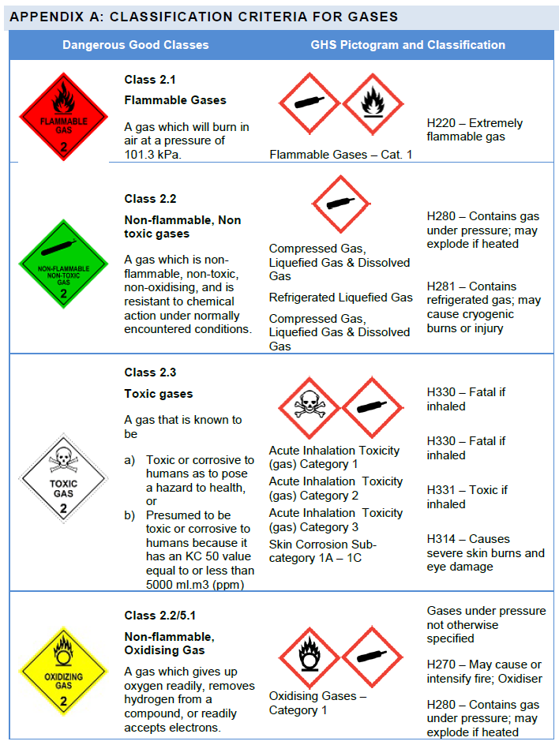

**Appendix B: Cryogenic liquid storage calculations**

Calculate the ratio of cryogenic gas volume to room volume (using Equation 1 and Equation 2). If the ratio is >0.015, then special precautions or ventilation are required.

**Equation 1: Amount of cryogenic gas produced from the volume of cryogenic liquid present**

Example: 50 L Dewar of liquid nitrogen

Liquid nitrogen expansion factor = 696

Gas Release (m3) - Vg = Cryogenic Liquid volume (L) x Cryogenic Liquid Expansion Factor / 1000

= 50 x 696 / 1000

Vg = 34.8 m3

**Equation 2: Change cryogenic gas volume to room volume**

Percentage Oxygen (%O2) = 20.9 x (Vb – Vg) / Vb where

Vg = gas release (in m3)

Vb = volume air in breathing zone (in m3)

For example Laboratory length = 10 m, width 10 m and height 3 m. The height used in the calculation is 1.8m as at this height cold gas would be expected to dissipate within the breathing zone.

Vb = 180 m3

Release of 50L Dewar of liquid nitrogen Vg = 50 x 696 /1000 = 34.8 m3

Percentage Oxygen (%O2) = 20.9 x [(Vb – Vg) / Vb ]

= 20.9 x [(180 -34.8) / 180]

%O2 = 16.9%

For medium and high-risk levels, the WHS team must be contacted for further discussion.

Risk rating Cryogenic liquids

|  |  |  |  |
| --- | --- | --- | --- |
|  | ≥ | 19.5% | Low risk |
| 19.4% | to | 18.0% | Medium risk |
|  | ≤ | 17.9% | High risk |

**Appendix C: Additional regulator FAQ’s**

**If the outlet pressure gauge shows 1000kPa, why won't it deliver to 1000kPa**?

Regulators have springs inside that control the maximum delivery pressure possible. The pressure gauge does not dictate the maximum delivery pressure of the regulator. Most pressure gauge manufacturers do not recommended that their gauges are constantly operated at their full scale pressure.

**Can I set an outlet pressure of 20kPa when the rated outlet pressure of the regulator is 800kPa?**

Not reliably. The regulator will actually fluctuate greatly if the rated outlet pressure is too high. It will probably allow the flow of gas, but the pressure will not be stable. As a rough guide regulators do not operate reliably at set pressures below 10% of the rated outlet pressure.

**How tight should my cylinder connection be**?

Tighten enough so that it does not leak. If the connection keeps leaking, check for damage to the face of the inlet fitting or for debris in the cylinder valve connection. A sealing washer or O-ring could be missing as well. Do not use multi-grip pliers to tighten the inlet connection. It will ruin the nut and most likely leak, thus requiring the regulator to be repaired.

**When I turn the knob counter-clockwise (reduce pressure) on my regulator the delivery pressure does not change**?

Most laboratory regulators are designed not to be self-relieving. The regulator will not reduce its delivery pressure unless the gas is flowing through the regulator. If the downstream segment of the system is static, the pressure will not drop unless you vent the system. However, the pressure will increase if you dial in a higher pressure when the system is static.

**Do I need to use Teflon® tape on the cylinder valve for regulator connection?**

No, all cylinder connections are designed to connect without the use of Teflon® tape. Some connections use flat washers or O-rings, but many connections use metal-to-metal contact to form a leak free connection. The use of Teflon® tape is not necessary.

**If I have to fit a new outlet fitting to the regulator should I use some form of thread sealant?**

Yes. The majority of regulators use threaded connections which require a form of sealant. Oxygen cleaned virgin Teflon® tape that has a green tint is the recommended sealant. It is not recommended to use other types of Teflon tapes (ie. white=plumbers, pink=water, yellow=natural gas), Teflon® pastes, Loctites® or other products without approval from the manufacturer.

**Does my regulator require any maintenance or servicing?**

Like all pieces of equipment a gas regulator should be periodically inspected, tested and serviced. As a minimum, regulators should be checked annually for obvious damage, external leaks and pressure control performance. Contact the manufacturer for further information.

**Appendix D: How to install a regulator**

1. Make sure your cylinder is properly secured, that you have the correct regulator and that you are aware of any special hazards of the gas you are working with.
2. Remove the cylinder protective valve cap (counter clockwise – flammable and toxics gases only). Place it somewhere nearby. Check threads and sealing face for damage or debris.
3. Carbon dioxide regulators (on lecture bottles and certain corrosive gases) require a Teflon® or lead washer to be inserted between the tank outlet and regulator.
4. Make sure that the regulator outlet valve (**A**) is shut. Screw it clockwise until it seats. Do not overtighten it or you can damage the valve seat.

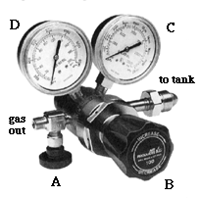

1. Make sure that the regulator control valve (**B**) is shut. Screw it **counter clockwise** until it is almost completely unscrewed. If you unscrew it completely, just put it back in. Most regulators only have the regulator control valve.
2. On the regulator cylinder connection (labelled *to tank*), check threads and sealing faces (metal-to-metal seal) and/or O-rings are in good condition and free of debris.
3. Screw the regulator onto the tank by hand until it is almost finger tight. Teflon tape is not required, DO NOT USE TEFLON TAPE OR OTHER SEALANTS AS THESE MAY CAUSE EXPLOSION.

FOR NITROGEN AND ARGON CYLINDERS:

* + If you don't need to purge out the "dead volume" of air in the regulator body, simply tighten the regulator firmly with a wrench

1. Open the tank valve slowly (counter clockwise) to ¼ or ½ open. Watch the tank pressure on the regulator (**C**).
2. Slowly turn the regulator control valve (**B**) until the regulator pressure (**D**) is at the desired level.
3. Open the regulator outlet valve (**A**). You can regulate flow with this valve, but the ultimate pressure depends on the setting of the regulator control valve!
4. Check your system for leaks using a solution of surfactant or some soapy water. If you find leaks and tightening the connections does not help ask a technical staff member for assistance.

**Reminder**: Do not use Teflon® tape on Swagelok ferrule compression fittings.

DISCONNECTING A REGULATOR

1. Shut the tank valve on the gas cylinder.
2. Slowly open the outlet valve (**A**) on the regulator.
3. Watch the pressure gauges **C** and **D** drop to zero.
4. Close regulator control valve (B) (anticlockwise).
5. If you were using a corrosive gas, purge the system with a dry inert gas.
6. Using a wrench (not pliers!) disconnect the regulator from the gas cylinder. Replace the protective cylinder cap immediately.
7. If your cylinder is empty, it must be properly labelled and then returned to gas storage area or distributor (in many cases, this is your school or company stockroom). Do not store empty gas cylinders in the laboratory.

**Reminder**: Make sure the tank valve is closed whenever you are not dispensing gas through the regulator.

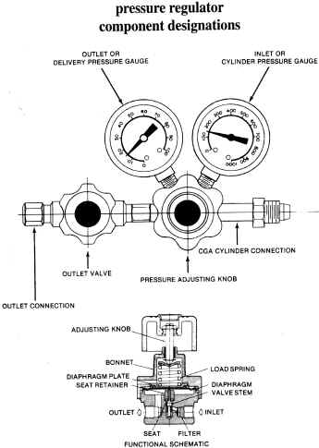

**Common Facts about Gas Regulation Equipment**

|  |  |
| --- | --- |
| Single Stage vs. Two Stage | Two stage regulators control pressure better and don't really cost much more.  Single stage regulators tend to increase delivery pressure as cylinder pressure decreases (not much though).  Most equipment manufacturers recommend and sell two stage regulators. |
| Brass vs. Stainless Steel | Brass regulators are acceptable for Ultra- high purity applications.  Stainless steel bodies do not make regulators cleaner in regards to the gas flow.  Stainless steel diaphragms are used in all high purity regulators regardless of their body material.  Stainless Steel body regulators are needed for corrosive gases and harsh external environments. |
| If the gauge shows 200 lbs, why won't it deliver to 200 lbs? | Regulators have springs inside that control the maximum delivery pressure possible. The gauge does not dictate the maximum delivery pressure. |
| Can I dial in 2 psi when the gauge goes all the way up to 200 psi? | Not reliably.  The regulator will actually fluctuate greatly if the range is too high.  It will probably flow gas, but the pressure will not be stable. |
| Will my regulator control gas Flow? | Not well.  Pressure regulators control pressure not flow.  A flow valve will be needed to control flow. |
| Why does my gas regulator hum sometimes? | Regulator hum indicates that the seat and stem dampers are worn or inoperative.  It is also possible that you are using an improperly ranged regulator. |
| Can I use any old regulator for my application? | Don't go into that drawer full of old regulators and assemble a regulator that fits.  Gas cylinders have up to 30000 kPa of pressure.  Accidentally putting a CGA fitting into a line regulator will result in a serious problem as cylinder pressure was increased from 20000 kPa.  This could result in gas rupturing an old regulator. |
| Does CO2 require a washer | Yes, a small nylon or Teflon washer is required for CGA 320 (CO2).  If the washer is not present or severely deformed, the connection will leak. |
| Do I need to use Teflon tape for my cylinder to regulator connection? | No, all cylinder connections are designed to connect without the use of Teflon tape.  Some connections use washers (320, 330,660), but most connections use metal-to-metal contact to form a leak free connection.  The use of Teflon tape is not necessary, but it does not hurt anything. |
| How tight should my cylinder connection be? | Tight enough not to leak.  If the connection keeps leaking, check for damage to the face of the CGA fitting or debris in the cylinder valve connection.  A washer could be missing as well (320, 330,660).  Try not to use channel lock pliers to tighten your regulator - it will ruin the nut and most likely leak! |
| When I turn the knob counter-clockwise (reduce pressure) on my regulator the delivery pressure does not change? | Most laboratory regulators are designed to be non-self relieving.  The regulator will not reduce its delivery pressure unless the gas is flowing through the regulator.  If the downstream segment of the system is static, the pressure will not drop unless you vent the system.  However, the pressure will increase if you dial in a higher pressure when the system is static. |