Humanities, Arts & Social Sciences Research Seminar

9.30-10.30am Friday 12 July 2019

Ms Saffaa presents

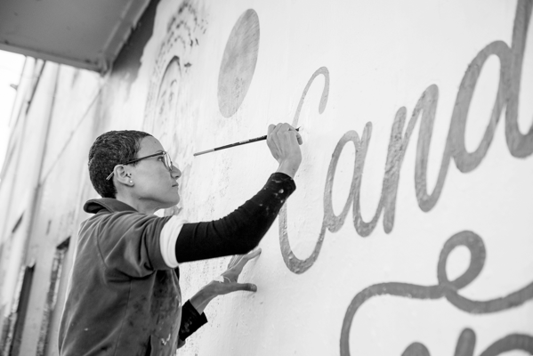
Image credit: Nicola Bailey

I Am My Own Guardian: Resistance, Agency, and Art

In 2012, Sydney-based Saudi artist Ms. Saffaa produced a series of works entitled, I Am My Own Guardian (ana waliyyat amri). It featured an image of a woman wearing the Saudi traditional male headdress and the phrase “I Am My Own Guardian,” drawing attention to the male guardianship system that requires all Saudi women to have a male guardian, without which women cannot travel, rent an apartment, enrol in university, get a job, have elective surgery, or leave a shelter (e.g. after seeking refuge from domestic violence) or jail. In 2016, a conservative Saudi man discovered her artwork and started abusing and shaming her in a series of public tweets. A flood of criticism and support from other Saudis followed. Soon the hashtag “I Am My Own Guardian” was trending and the image went viral. This paper offers a self-reflexive analysis of the ongoing home-grown grassroots Twitter movement “Saudi Women Want the Fall of Guardianship Laws.” It provides a critical interrogation of the confluence of art, politics, and activism on social media.

Ms. Saffaa is an artist and activist from Saudi Arabia. She was reported to the Saudi authorities when one of her artworks went viral in 2016 and has since become a political dissident. Her work was recently on display at the US Congress. She is shortlisted for the Index on Censorship Freedom of Expression award. She is a PhD candidate at the University of Sydney.

Oorala lecture theatre, Oorala centre
Followed by morning tea - all welcome
Enquiries to: Christina Kenny – ckenny3@une.edu.au or Karin von Strokirch - kvonstro@une.edu.au

