Humanities, Arts & Social Sciences Research Seminar

9.30-10.30am Friday 2 August 2019

Jane Ahlstrand presents

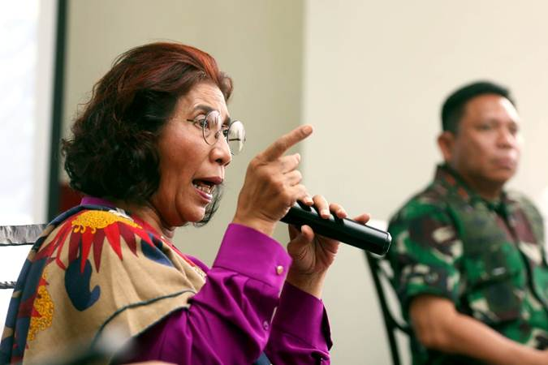

Menteri Kelautan, Binis.com, 25 February 2019, https://ekonomi.bisnis.com/read/20190226/99/893335/menteri-susi-geram-penangkapan-kapal-ikan-vietnam-dihalangi

Authoritarian women in a democratic era:
Representations of Indonesian female politicians in online news

In post-authoritarian democratic Indonesia, the news media, and more recently, the online news media, have transformed several female political actors into public icons. As traditional outsiders in the political domain, they gain immediate visibility, and are transformed into subjects of diverse discourses of power in the news media. Female politicians therefore represent a key point of enquiry in the study of Indonesia’s shifting dimensions of power in the news media of the democratic era. This paper presents findings from a broader study conducted of the positioning of three prominent female politicians within a dynamic hierarchy of political power in the contemporary Indonesian online news media. Using critical discourse analysis as a theoretical and methodological framework, this study focuses on the linguistic patterns employed in news discourse that contribute to the practice of maintaining the women’s relationship with power. Analysis reveals that while seemingly presenting the women as empowered leaders, and breaking down a gender binary of soft, feminine, and hard masculine power, the discourse subtly reproduces an authoritarian model of power. The women are positioned in a dominant, top down exercise of power, in contrast to the subordinate portrayal of members of civil society. The representation of a vague, threatening Other further legitimises the need for their dominant stance, while appealing to both populist and nationalist sentiment. This study contributes to understanding of the multifaceted role of women in politics, and the influence of online news media discourse in contexts of political transition.
Jane is an early career researcher specialising in the areas of critical discourse analysis, Indonesia, power relations, gender, and the news media. She recently completed her PhD thesis at the University of Queensland titled: A critical discourse analysis of women, power, and social-political change in the Indonesian online news media. Jane is a lecturer in the Indonesian discipline at UNE, where she encourages students to engage with the process of language learning with an awareness of Indonesia’s social, political and cultural context.

Oorala lecture theatre, Oorala centre
Followed by morning tea - all welcome
Enquiries to: Karin von Strokirch - kvonstro@une.edu.au

