Bachelor of Laws (3 Years)
CRICOS Code: 016049G

2017

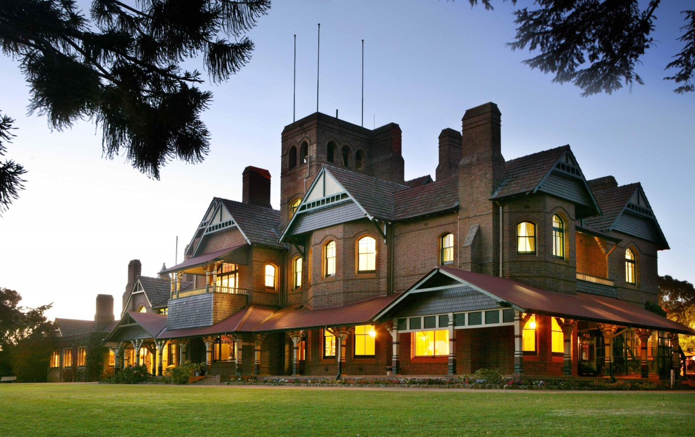

University of New England, Armidale, AUSTRALIA
CRICOS Code: 00003G

Why study the Bachelor of Laws (3 Years) at UNE?
UNE boasts one of Australia's largest law schools outside a capital city, as well as being an early adopter of innovative technology in the delivery of its law programs. The Bachelor of Law (3 years) encourages both a critical and progressive approach to the existing law and legal system; ensuring that students understand both the law and the context.
The Bachelor of Laws is accredited by the Legal Practitioners Admission Board of NSW for admission as a legal practitioner in NSW and mutual recognition legislation extends admission to other Australian jurisdictions.
After completion of academic qualifications there are a range of employment options from which to choose. Graduates who wish to be admitted to practice as a solicitor, barrister or legal practitioner anywhere in Australia will also have to undertake a course of professional legal training (PLT). This can consist of approximately half a year's full-time training, undertaken internally or externally, or of equivalent part-time training. In some jurisdictions, it may be possible to do articles of clerkship instead. Because the system adopted varies from jurisdiction to jurisdiction, enquiries should be made to the admission authority in the state or territory in which you intend to practice; this is usually a committee of the Supreme Court of that State or Territory or a special body set up to administer admissions to the legal profession. Additional information can be found on the School of Law page.
To qualify for the award of the degree with Honours, a graduate entry student must have successfully completed the Honours Pathway made up of LAW490 and LLM500. There are three levels of Honours: First Class Honours, Second Class Honours and Third Class Honours. Honours result will be calculated as follows: 60% LAW490 plus 40% of the GPA of LLM500, LAW400, LAW480, LAW455. An undergraduate entry student will not have access to Honours within this award.

Career Opportunities
The Bachelor of Laws (LLB) degree is accredited by the Legal Practitioners Admission Board of NSW. Upon completion of the LLB, graduates may complete a period of practical legal training (PLT) and be qualified to apply for admission as an Australian Lawyer. After admission you are then eligible to apply for a practising certificate as a solicitor from the Law Society of NSW or undertake further studies to obtain a practising certificate as a barrister from the Bar Association of NSW.
Additionally, a law degree is relevant to a large range of careers including: working in legal aid agencies, advocacy organisations, commercial firms, government departments, banking, commerce, management and a wide range of businesses.
Official Abbreviation | LLB
Course Type | Undergraduate
CRICOS Code | 016049G
Commencing | Responsible Campus Admission Period Mode of Study  Armidale Trimester 1 Off Campus  Armidale Trimester 1 On Campus  Armidale Trimester 2 Off Campus  Armidale Trimester 2 On Campus  Armidale Trimester 3 Off Campus
Course Duration | - 3 Years Full-time  - Up to 10 years Part-time
Fees | CSP / International
Total Credit Points | 144
How to Apply | New domestic students to UNE apply to study on campus through UAC or QTAC  For more information, click here  New domestic students to UNE apply to study off campus direct to UNE and  Former and current domestic UNE students apply to study on or off campus direct to UNE  For more information, click here  International students apply direct to UNE through UNE International  For more information, click here
Intensive Schools | There are no mandatory intensive schools in the Bachelor of Laws (3 Years).
Entry Requirements | (a) A graduate candidate shall hold at least a three year degree (AQF Level 7) of a recognised university or equivalent.  (b) An undergraduate candidate shall be qualified for admission (see Admission Undergraduate and Postgraduate (Coursework) Rule and Admission Undergraduate and Postgraduate (Coursework) Procedures).  This course from 2016 will be available to Year 12 applicants with an ATAR or equivalent of at least 90.00. Assumed knowledge is any two units of English. Year 12 applicants who completed prior to 2015 may apply as well as applicants who have undertaken a Diploma or above qualification with sufficient grades. Please note that Regional Bonus Points do not apply to this course.  A sound knowledge of English is essential.
Advanced Standing | Candidates are referred to the University Policy on Advanced Standing.  It is not possible to award advanced standing on the basis of work experience due to professional accreditation rules or to studies that were completed in a course other than one leading to admission as a legal practitioner or to a unit that is not listed in a course leading to admission as a legal practitioner.
Scholarships | The University offers a number of faculty/college and country scholarships available to Australian citizens and permanent residents.
Academic Colours | Ultramarine (BCC 148)
Further Information | You can find instant answers to many of your questions or contact UNE directly via AskUNE

Bachelor of Laws (3 Years)
For candidates admitted under Rule (b)
Program of Study |  | Course cps
Core Units  Complete the following units: |  | 108 cps
Unit Code | Unit Title | Unit cps
LAW100 | Introduction to Legal Systems and Methods | 6
LAW101 | Law in Context | 6
LAW161 | Criminal Law | 6
LAW171 | Law of Contract I | 6
LAW220 | Constitutional Law | 6
LAW231 | Law of Torts I | 6
LAW232 | Law of Torts II | 6
LAW251 | Corporation Law | 6
LAW272 | Law of Contract II | 6
LAW281 | Property Law I | 6
LAW282 | Property Law II | 6
LAW312 | Criminal and Civil Procedure | 6
LAW313 | Evidence and Proof | 6
LAW320 | Professional Conduct | 6
LAW340 | Equity and Trusts | 6
LAW400 | Administrative Law | 6
LAW455 | Jurisprudence | 6
LAW480 | Advanced Research, Writing and Advocacy | 6
Listed Units  Complete 36 credit points from the following units: |  | 36 cps
Unit Code | Unit Title | Unit cps
LAW157 | Alternative Dispute Resolution | 6
LAW164 | Indigenous Australians and Law | 6
LAW201 | Sports Law | 6
LAW270 | Interviewing for Advocacy | 6
LAW301 | Succession | 6
LAW305 | Taxation of Capital Gains | 6
LAW307 | Comparative Corporate Governance Law | 6
LAW314 | Advanced Criminal Law | 6
LAW315 | Criminal Process, Sentencing and Punishment | 6
LAW318 | Law of the Sea | 6
LAW321 | Conveyancing | 6
LAW323 | Intellectual Property Law | 6
LAW325 | International Trade Law | 6
LAW326 | Human Rights | 6
LAW332 | Industrial Law | 6
LAW336 | Local Government Law | 6
LAW337 | Innovation Law | 6
LAW338 | Biotechnology Law | 6
LAW339 | Law of Neuroscience | 6
LAW341 | Environmental Law | 6
LAW342 | Medico-Legal Issues | 6
LAW343 | Contemporary Issues in Health Law | 6
LAW344 | Banking and Finance Law | 6
LAW345 | Animal Law | 6
LAW346 | Law and Crisis: The Use of Emergency Powers | 6
LAW352 | Taxation Law | 6
LAW358 | Natural Resources Law | 6
LAW359 | Advanced Torts | 6
LAW360 | Conflict of Laws | 6
LAW361 | Public International Law | 6
LAW370 | Family Law | 6
LAW375 | Competition and Australian Consumer Law | 6
LAW377 | Information Technology Law | 6
LAW379 | Commercial Law | 6
LAW389 | Legal Practice in Rural and Regional Communities | 6
LAW390 | International Arbitration | 6
LAW396 | Special Studies in Law (A) | 6
LAW397 | Special Studies in Law (B) | 6
Candidates who have completed 96 credit points of the course with a Grade Point Average (GPA) of 5 or better may select one LLM unit in which to enrol, not being LLM520, LLM522 or LLM533.
Total |  | 144 cps

