Humanities, Arts & Social Sciences Research Seminar

9.30-10.30am Friday 23 August 2019

Cameron Moore presents

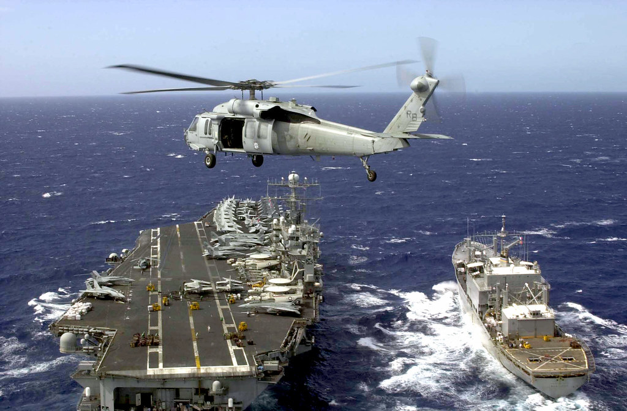

030124-N-8794V-006 by Photograph Curator is licensed under CC PDM 1.0

Freedom of navigation and the law of the sea:
Warships, states and the use of force

China is contesting the right of the United States and other nations to navigate in parts of the South China Sea, Iran has threatened to close the Strait of Hormuz and Russia has become much more assertive at sea. The increasing prominence of these issues invites a fresh consideration of the law on these questions. This talk will consider the heightened risk of clashes at sea between warships asserting rights to navigate and states asserting sovereignty over coastal waters. It will assess the extent to which states can use force to prevent passage by warships, and also the extent to which warships can use force to assert rights to navigate.

Associate Professor Cameron Moore is the Deputy Head of the School of Law at the University of New England. He is also an Honorary Principal Research Fellow at the Australian National Centre for Ocean Resources and Security (ANCORS) at the University of Wollongong and a visiting Associate Professor with the Centre for Military and Security Law and the Centre for Public and International Law at the Australian National University. His publications include the books Crown and Sword: Executive Power and the Use of Force by the Australian Defence Force (2017) and ADF on the Beat: A Legal Analysis of Offshore Enforcement by the ADF (2004), as well as other articles and chapters on the Australian Defence Force and maritime security. Between 1996 and 2003, Cameron was a Royal Australian Navy Legal Officer. Cameron is still an active Navy reservist, with the rank of Commander. He had a brief deployment to Afghanistan in 2010.

Oorala lecture theatre, Oorala centre
Followed by morning tea - all welcome
Enquiries to: Karin von Strokirch - kvonstro@une.edu.au

