Accessing the Student Document Repository
To access relevant placement information that you may need throughout your course, please follow these steps.
- Log in to InPlace using your single-sign on authentication details (these are the same login details you use to log in to MyUNE and Moodle.
- Click on the Document Repository icon at the top left hand corner (between the Calendar icon and Placement menu item)
- Click “View” to open the document(s).

Student Details
To view your student details, please follow these steps.
- Log in to InPlace using your single-sign on authentication details
- On the Student’s home screen, you will see their enrolment details and upcoming placement details
- Click on the silhouette icon in the top left-hand corner to navigate to ‘My Details’
- The Student’s details page display
- Navigate to the “Placement” tab where you (as a Student) will see your upcoming placement details

Submitting a Self-Placement
To submit a Self-Placement application, please follow these steps (this needs to be competed at least two weeks prior to the start of your placement, otherwise this may not count towards your placement course requirement).
- Log in to InPlace using your single-sign on authentication details
- On the Student Home screen, scroll down to the Allocation Group under ‘Placement Requirements’
- Click on the “Submit Self-Placement” button – a ‘Register Self-Placement’ pop-up appears
- Populate the ‘Register Self-Placement’ form by following these steps
Note: All items with a red asterisk (*) are mandatory to complete the application
  - Add the Start Date and End Date of your placement
  - Select the Experience and add the duration (in DAYS)
Note: The experience indicates a type of enterprise. Each different enterprise you are completing a placement for must have a different number selected (i.e. if you have previously completed a placement for Grazing Sheep that you marked as Enterprise 1, and this placement is also for Grazing Sheep, then mark this placement as Enterprise 1. However, if this placement application is for a different enterprise, select Enterprise 2, and so on.

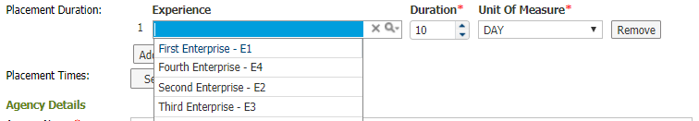

  - Add the Agency Name and Agency Address in as much detail as possible
  - Add an Agency Contact (this can be the person that you have been in direct contact with)
  - Add your Supervisor Details (if this will be the same person as your agency contact, please tick the box indicating so).
  - Select the Enterprise Type from the dropdown menu
  - Add your Position Title (i.e. Field Hand)
  - Select whether this is a paid or unpaid position, adding any relevant information in the comment box.
  - Finally Add your Student Declaration and Original ERS Work Placement Agreement to the application by:
    - Ticking the checkbox
    - Clicking ‘Choose File’
    - Selecting the relevant file and clicking Open
    - Clicking Upload
  - When you are happy with your submission, please click Submit. If you need to come back to this submission before submitting, please click Save draft.
- Once the self-placement registration form has been completed, the Self Placement Submissions widget will appear on your homepage showing the status of the self-placement submission(s).
- If you are submitting a Certificate please tick the box as per below.
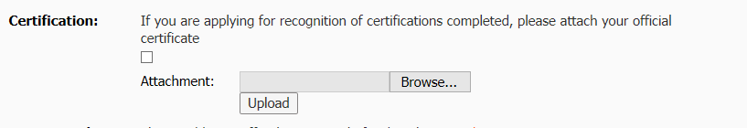

Viewing Placements
To view your placement list, please follow these steps.
- Log in to InPlace using your single-sign on authentication details
- On your home screen you will see your enrolment details
- Click on the silhouette icon in the top left-hand corner to navigate to ‘My Details’
- Your Student details page will display
- Navigate to the “Placement” tab where you will see all of your ‘Confirmed’ or ‘Completed’ placement detail.

- Placements will remain in ‘Confirmed’ status until your timesheet has been confirmed, whereupon your placement will be placed in ‘Completed’ status and will be counted towards your courses’ placement requirement.

Submitting a Timesheet

- Log in to InPlace using your single-sign on authentication details
- On your home screen you will see your enrolment details
- Click on the silhouette icon in the top left-hand corner to navigate to ‘My Details’. Your Student details page will display.
- Scroll down to view the collection of information labelled ‘Time Sheet Submissions’.
- Click on the appropriate upload option e.g. ERS – Upload of Time Sheet – E1. Choose your previously uploaded time sheet by clicking on ‘Choose File’ and navigate to your saved file.
- Click ‘Upload’ and ‘Save’. You must do both of these. If you click ‘Upload’ without clicking ‘Save’, the file will not attach.
- Please ensure the timesheet has been signed by your supervisor before submitting it to us.

