This plan is enacted when a FLOOD is declared and the level of risk to personal safety, property or environment is an immediate risk to escalate. This plan relates to the response of staff and students to a critical incident and supports the Emergency Management Plan (EMP) that exists for UNE.

The University of New England (UNE) is located at Armidale NSW. Streams from the Dumaresq Creek catchment drain through the Campus.

Significant flooding across the Dumaresq Creek catchment has occurred on a number of occasions. This flooding has caused disruption and inconvenience with flood waters impacting directly on the Campus across Consett Davis Oval at SportUNE cutting off causeways and pathways between the Academic and Bellevue Campuses.

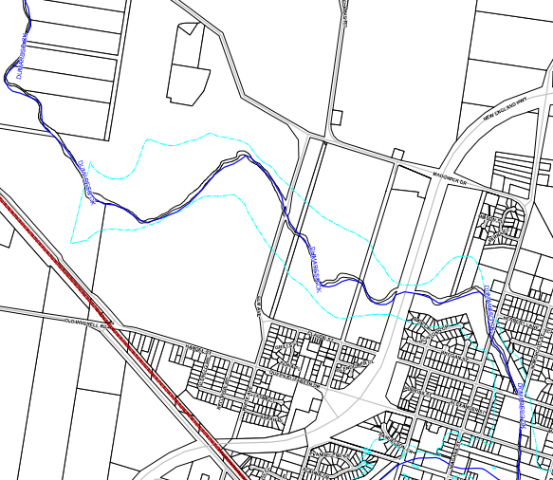
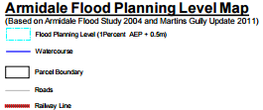
Armidale Dumaresq Council has prepared a flood study for the area as part of their Floodplain Risk Management Programs, which aims to reduce the impact of flooding on the community and better prepare against significant flood damage and possible loss of life. While UNE has overall responsibility for the campus, the site is shared with a range of education providers, government departments and businesses. More information about flood response can be found at

http://www.armidaleregional.nsw.gov.au/living-here/your-neighbourhood/floods-fires

Immediate Actions:
Flood Response Triggers
The triggers which indicate that flooding may occur include:
- The Bureau of Meteorology (BOM) issuing a Severe Weather Warning, Severe Thunderstorm Warning indicating a likelihood of flash flooding or the issuing of a Flood Watch.
- The State Emergency Service issuing a Flood Bulletin.
- Local heavy rainfall at the campus or within the Dumaresq Creek catchment area causing a rise in water levels.
- Reference against Dumaresq Council indicators for a trend towards flood.

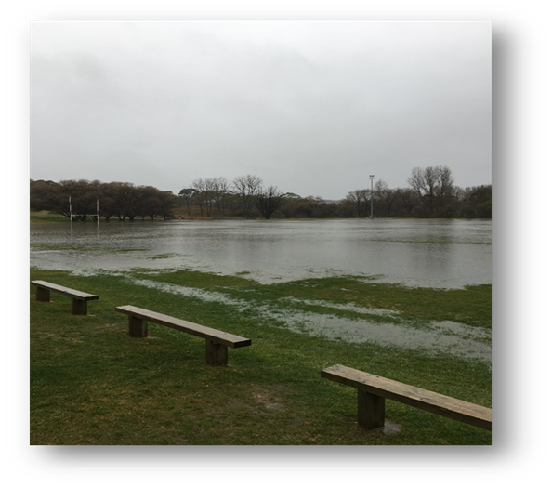
Pre-Incident Plan
Due to its location (proximity to the water course and location of site drainage) previous flood events at UNE have resulted in damage to SportUNE’s Consett Davis Oval from water inundation.
Based on information received from staff taking into consideration the flood response triggers, the Chief Warden may elect to implement its Pre Incident Plan to limit flood water damage.
The pre incident plan will involve actions from Facility Management Services and Security Services who will ensure adequate communication where staff, students and the community are notified about any potential for disruption to roadways, pathways and services.

Traffic Management Plan
The traffic management plan will indicate preferred traffic directions and exits in the event that a campus evacuation is required. Should causeways and pathways be impacted by flood waters, signage/barricades will be erected. Armidale Dumaresq Council is responsible for Elm Ave and will enact their own Traffic Management Plan should this road be impacted.

Protect your own life
In the absence of any direction from the University, use your best judgement to remove yourself from danger, either by taking shelter-in-place within your building or by evacuating to a safer place.
Protect the life of your fellow student or staff member
Ring ‘000’ and Safety and Security 6773 2099. Alert others in your immediate area to the danger, and act together for the benefit of everyone. Try to identify the safest escape route.
