This plan is enacted when a GAS/FUMES/EXPLOSION/FIRE situation is declared, and the level of risk to personal safety, property or environment is an immediate risk to escalate. This plan relates to the response of staff and students to a critical incident and supports the Emergency Management Plan (EMP) that exists for the individual buildings.
There are a number of gas bottles located around the University including large commercial tanks on the corner of Madgwick Drive and Clarks Rd. The most common cause of gas explosions are due to leaking hoses, defective control valves, gas connectors or leaking tanks in the presence of an ignition source. Even if the gas tank isn’t faulty, it can still explode if the gas stored inside is heated up to a point where the pressure from the boiling liquid inside ruptures the gas container. This is commonly referred to as a BLEVE (Boiling Liquid Expanding Vapour Explosion). Recommended evacuation distances from various sized gas containers are listed in a table below.
Threat Description |  |  | LPG Mass/Volume¹ | Fireball Diameter² | Safe Distance³
Liquid Petroleum Gas (LPG ) |  | Small LPG Tank | 9 kg/19 l | 12 m | 48 m
 | 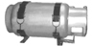 | Large LPG Tank | 45 kg/95 l | 21 m | 84 m
 | 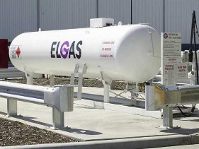 | Commercial LPG Tank | 907 kg/1,893 l | 56 m | 224 m
 | 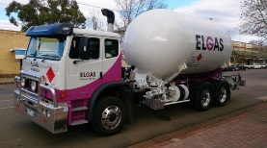 | Small LPG Truck | 3,630 kg/7,570 l | 89 m | 356 m
 | 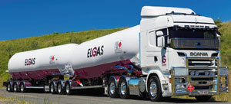 | Semi tanker LPG | 18,144 kg/37,850 l | 152 m | 608 m

¹ Based on the max amount of material that could reasonably fit into a container or vehicle. Variations possible
² Assuming efficient mixing of the flammable gas with ambient air
³ Determined by U.S. firefighting practices wherein safe distances are approximately four times the flame height.

The University has no ability to fight a gas explosion or fire beyond automatic sprinkler systems or first response measures such as hose reels and portable fire extinguishers. Firefighting can only be carried out by Fire and Rescue NSW or NSW Rural Fire Service, depending on jurisdiction. Whether fire services are available, delayed or unable to attend, the priorities for the University are as follows.
Immediate Actions:
Protect your own life
In the absence of any direction from the University, use your best judgement to remove yourself from danger by evacuating to the designated assembly area or a safer place.
Protect the life of your fellow student or staff member
Ring ‘000’ and Safety and Security 6773 2099.
Alert others in your immediate area to the danger, and act together for the benefit of everyone. Try to identify the safest escape route.
Evacuate
- Evacuate the building/area as instructed to do so by a Warden.
- Wardens will be the primary vehicle for ensuring everyone is out of danger through visual checks (in rooms, toilets, stairwells and halls) on exiting and a situational awareness of who would generally be in the building and where.
- Walk quickly and calmly to the assembly area. This area should be uphill and upwind to avoid gas (you may need an alternative assembly area).
- Remain in the assembly area in groups until instructed to leave by a Warden, Emergency Response Team, Emergency Control Organisation or Fire and Emergency Services personnel.
Fire fighting
A gas explosion has the ability to start secondary fires by lighting surrounding combustibles such as vegetation and buildings.
The University does not expect staff or students to fight a fire unless you have no alternative, your exits are blocked and your personal safety is compromised. If so then ensure:
- It is safe to extinguish the fire.
- That you always use the correct fire extinguisher if you do attempt to extinguish the fire.
- Control the spread of fire. This is primarily a Fire Service function. However, there are limited actions that can be taken in the absence of an adequate fire service response.
- Remove loose combustible material between buildings.
- Close windows in adjacent buildings.
- Extinguish or remove embers and debris when they fall.
- Apply water to surrounding area.
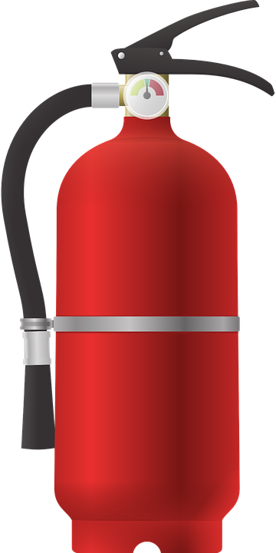
How to use a fire extinguisher:
Pull the pin at the top of the extinguisher
Aim low pointing the extinguisher nozzle at the base of the fire
Squeeze the handle to release the extinguishing agent
Sweep from side to side at the base of the fire until the fire is extinguished

